Activity 5.2.2 The Radius-Tangent Theorem

In Activity 5.4.1 we concluded that it appeared that if a line is tangent to a circle then it is perpendicular to the radius at the point of tangency. Our task is now to prove this.

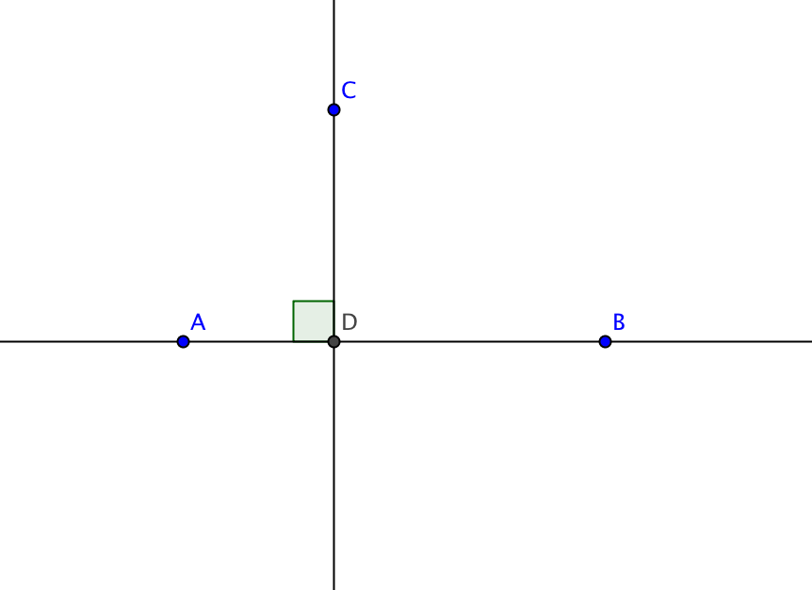
- We begin with another theorem: Shortest Distance Theorem: The shortest segment joining a point to a line is the perpendicular segment.
By our construction from Unit 2 Investigation 7 we know that we can construct a line perpendicular to $\overset{⃡}{AB}$ through the point C and call the point of intersection D.
a. Construct segment $\overline{CB}$. Sketch this segment on the diagram above.

b. Explain why $∠$ CDB is the largest angle in ∆ DCB.

c. Fill in the blank with > , < or =: m$∠$ CDB _______ m $∠$ CBD.

d. Now what can we conclude about sides?

Fill in the blank with > , < or =: CB _______ CD.

e. What theorem supports your conclusion in question 1d?
Since B was any point on the line other than D, we can conclude that the shortest segment joining a point to a line is the perpendicular segment.

- We are now ready to address our original question. What is the relationship between a radius of a circle and a tangent to the end of the radius on the circle? We will consider this in two parts. First we will establish a tangent at a point, then we will establish that any tangent is perpendicular to the radius.
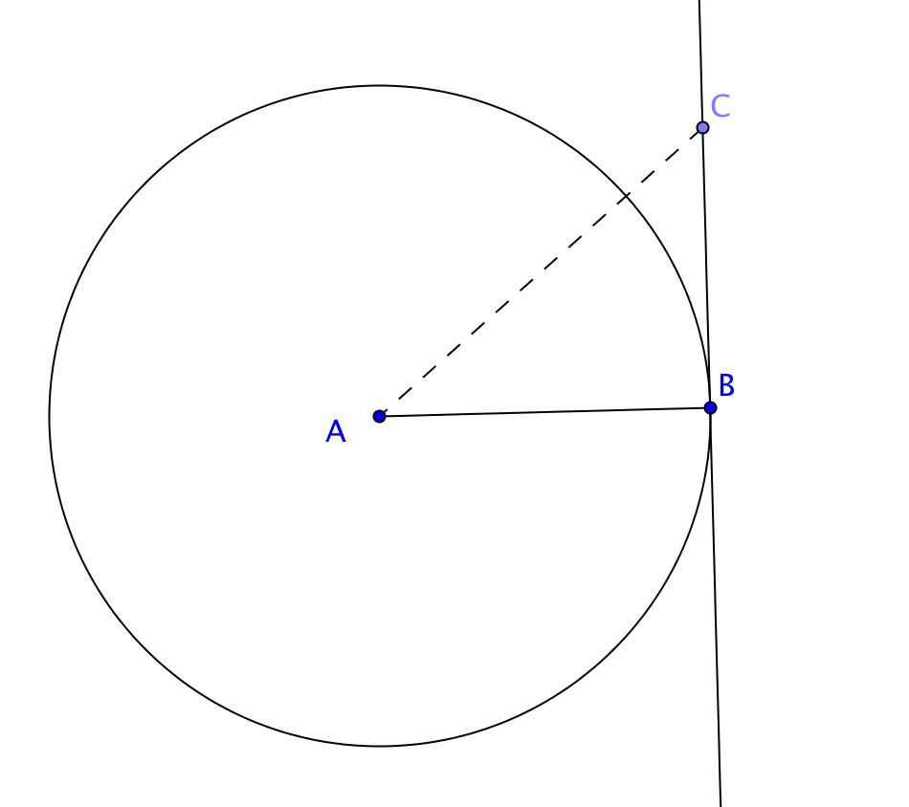
We begin with a radius ($\overline{AB}$) of a circle and construct a line perpendicular to $\overline{AB}$ at B. We choose a point C to be another point on the perpendicular line.

a. Draw segment $\overline{AC}$. We note that AC>AB.
Why?
This must mean that C lies outside the circle. Because C could be any point on the perpendicular line other than B, the only intersection of$\overset{⃡}{BC}$ with the circle is point B.
b. Because $\overset{⃡}{BC }$ intersects the circle in exactly _____point, it is a ___________ to the circle. This means that a line perpendicular to a radius at a point of a circle is a tangent.
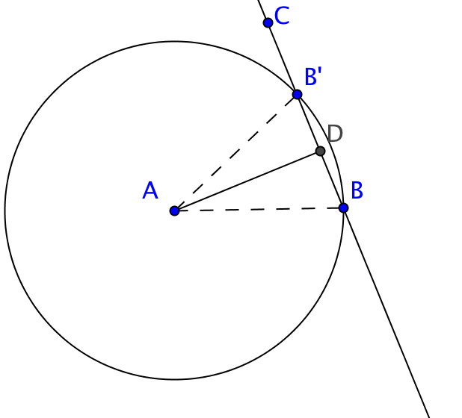
- Now we begin with a tangent line $\overset{⃡}{BC}$ a circle A at a point B and show that it is perpendicular to the radius $\overline{AB}$.
Suppose $\overline{AB}$ is not perpendicular to $\overset{⃡}{BC}$. Then draw $\overline{AD}$ so that $\overline{AD}$ $⊥\overset{⃡}{BC}$ at point D. Reflect B over $\overline{AD}$ and name its image B’.

- B’ lies on $\overset{⃡}{BC}$. Why?
- AB = AB’. Why?

- B’ lies on circle A. Why?

If our assumption that $\overline{AB}$ is not perpendicular to $\overset{⃡}{BC}$ is true, then line $\overset{⃡}{BC}$ would intersect circle A in two points, B and B’, and could not be a tangent to circle A. But we were given that $\overset{⃡}{BC}$ is tangent to the circle. Therefore our assumption that $\overline{AB }$is not perpendicular to $\overset{⃡}{BC}$ is false and we conclude that $\overline{AB}$ must be perpendicular to $\overset{⃡}{BC}$.

