Activity 5.3.4 Applications of Arc Length and Sector Area

- The Ferris wheel at the Navy Pier in Chicago is one of the country’s oldest and most famous Ferris wheels. It has a diameter of 140 feet and contains 40 gondolas for people to sit in. If you are almost done with the ride and are the next one to be let off, how far will you travel before the ride stops to let you off?

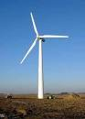
- The arc length between blades of a wind turbine was calculated to be 309.8 feet. To the nearest whole number, what is the length of each of the blades?

- A stage is in the shape of a semicircle with a radius of 18 feet and the curved edge facing the audience. If a banner is hung all around the front of the stage, how long will the banner need to be?

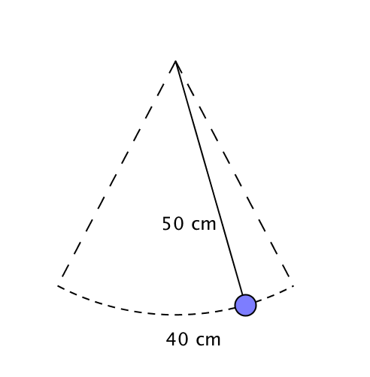
- A 50 cm pendulum covers a distance of 40 cm when it swings from one side to the other. Find the angle measure (in degrees) through which it swings.

- A spotlight is set up that will light up to 30 feet away and covers a circular sector with area 353 square feet. What is the angle measure (to the nearest whole number of degrees) of the central angle of this sector?

Image from imgarcade.com

- A circular pizza, with a radius of 8 inches, is cut through the center into 12 equal pieces. If the crust is ¾ - inch wide, what is the approximate area of the crust on each piece? Explain the method you used to arrive at your answer.

- Make up a real world problem that involves arc length or the area of a sector. Solve your problem and then give it to one of your classmates to solve.

