Activity 5.3.3 Arcs and Sectors

Circumference of a circle: $c=πd$ or $c=2πr$.
c is the circumference, d is the diameter, r= the radius, π ≈ 3.14
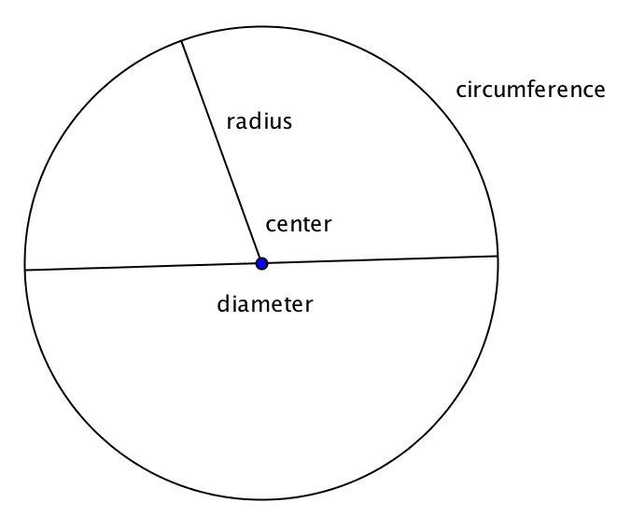
1. You probably have learned the two formulas for the circumference of a circle. Explain why both formulas say the same thing.

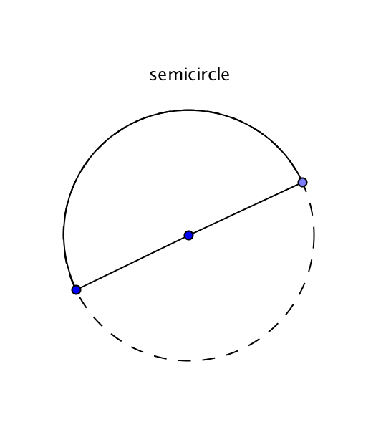
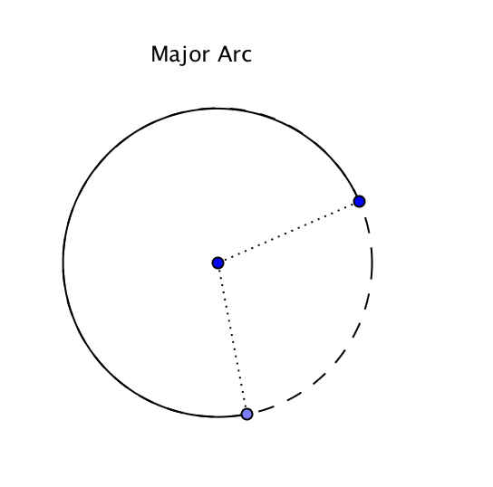
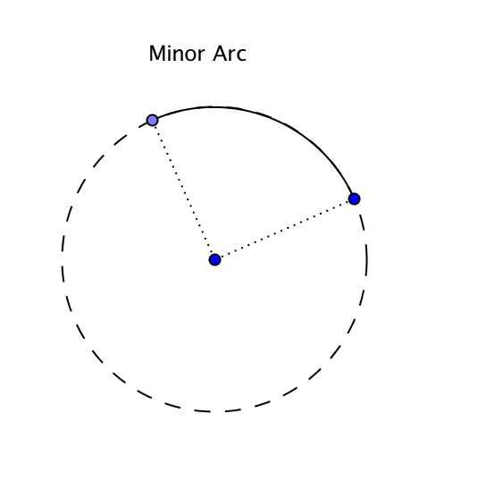
2. An arc of a circle is part of the circle that lies between two points. There are three types of arcs as shown below.
Explain in your own words the differences between a major arc, a minor arc, and a semicircle.

3. In each figure below the radius of the circle and the measure of a central angle in degrees is given. Find the circumference and the length of the indicated arc. (Answer in terms of π and also to the nearest 0.1 cm²)

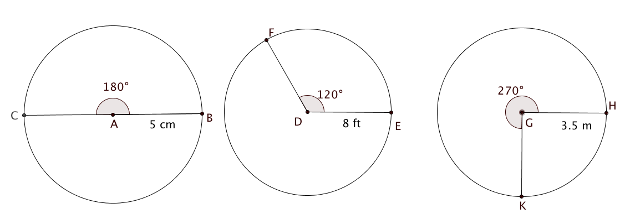
a. b. c.

Circumference = ______ Circumference = _______ Circumference = ________

Arc length = _________ Arc length = ___________ Arc length = ___________
4. If you know the radius of a circle and the degree measure of a central angle, how can you find the length of the intercepted arc?

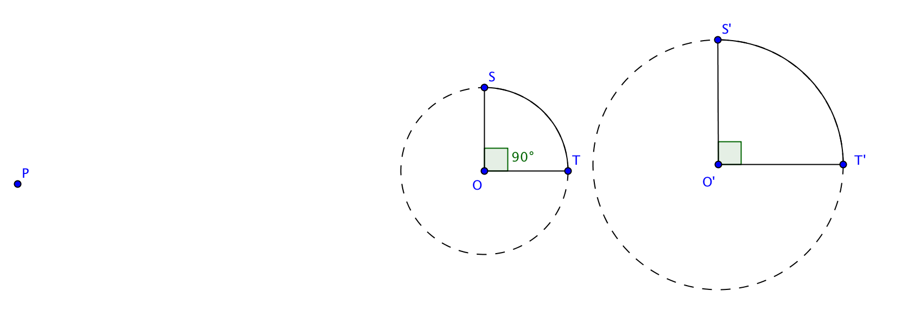
5. In Unit 4 Investigation 2 you proved that all circles are similar to each other. In the figure circle O’ is the image of circle O under a dilation with center P and scale factor 1.5.
m$∠$ SOT = 90° and OT = 6 inches.
a. O’T’ = _______
b. Find the length of arc ST.
c. Find the length of arc S’T’
d. In circle O find the ratio of the length of arc ST to radius OT.
e. In circle O’ find the ratio of the length of arc S’T’ to radius O’T’.
f. Find the measure of angle SOT and S’O’T ’in radians.
g. Compare your results in questions d, e, and f, and complete this sentence: The radian measure of a central angle is a circle is equal to the ratio of the length of its intercepted _________ to the _______ of the circle.
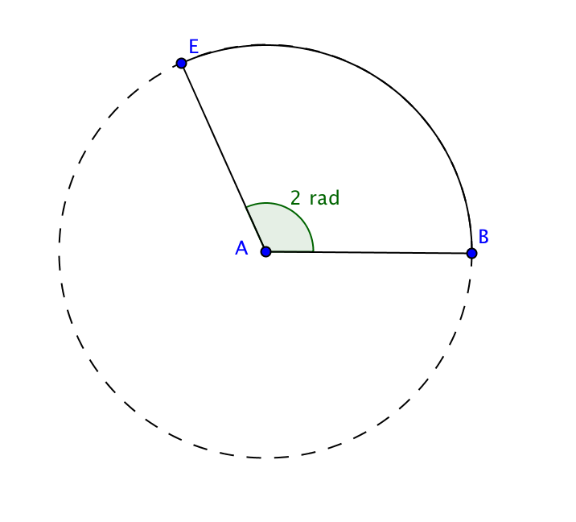
6. Central angle BAE measures two radians. The length of arc $BE$is 14 cm. Find the radius and circumference of the circle.

7. The length of an arc of a circle is half the length of the radius. Find the measure of the central angle that intercepts this arc

a. in radians b. in degrees

Area of a circle: A = πr²

You are probably familiar with the above formula for the area of a circle.

We can also find the area of a sector of a circle. A sector is the figure bounded by two radii and the arc intercepted by the central angle that they form.
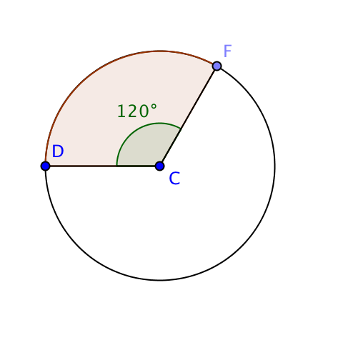
8. The radius of circle C is 15 cm.
a. Find the area of the circle. (Answer in terms of π and also to the nearest 0.1 cm²)

b. Find the area of sector FCD. (Answer in terms of π and also to the nearest 0.1 cm²)

9. If you know the radius of a circle and the degree measure of a central angle, how can you find the area of the sector bound by the sides of the angle and the intercepted arc?

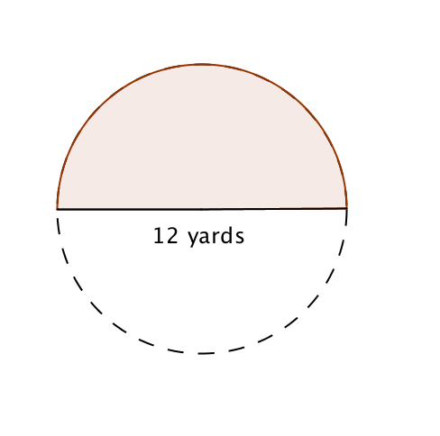

10. The diameter of a circle measures 12 yards. Find the area of a sector bounded by a diameter and a semicircle. . (Answer in terms of π and also to the nearest 0.1 cm²)

11. A central angle in a circle intercepts an arc and forms a sector with two radii. Complete this proportion

$$\frac{length of arc}{circumference of circle}=\frac{}{area of cirlce}=\frac{degree measure of central angle}{}$$

12. Find the area of the sector of a circle with central angle 1 radian if the radius is 4 feet.

