Activity 5.2.2b Proof of the Perpendicular Bisector Theorem

The Perpendicular Bisector Theorems says that the locus of points that are equidistant from the endpoints of a segment is the perpendicular bisector of the segment.

To prove this theorem we need to prove two things:

- If a point lies on the perpendicular bisector of a line segment, then it is equidistant from the endpoints of the segment, and
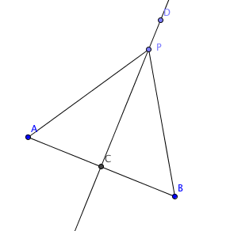
- If a point is equidistant from the endpoints of a segment, then it lies on the perpendicular bisector of the segment.
Prove part (1):
Given: $\overset{⃡}{DC }$is the perpendicular bisector of $\overline{AB}$
P lies on $\overset{⃡}{DC}$
Prove: PA = PB

Fill in the blanks to complete the proof below
Statements | Reasons
$\overset{⃡}{DC }$is the perpendicular bisector of $\overline{AB}$ and P lies on $\overset{⃡}{DC}$ | Given
AC = CB | (a) Definition of _________________________
$∠ACP$and $∠BCP$ are both right angles | (b) Definition of _________________________
(c) _______________________________ | All right angles are congruent
PC = PC | (d) ___________________________________
(e) _______________________________ | (f) ___________________________________
(g) _______________________________ | Corresponding parts of congruent triangles are congruent

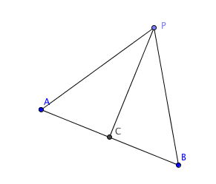
Prove part (2)
Given: PA = PB
C is the midpoint of $\overline{AB}$
Prove: $\overset{⃡}{PC }⊥$ $\overline{AB}$

Statements | Reasons
PA = PB | Given
C is the midpoint of $\overline{AB}$ | Given
AC = CB | (a) Definition of _________________________
(b) _______________________________ | Reflexive Property
(c) _______________________________ | (d) ___________________________________
$m∠ACP=$ $m∠BCP$ | (e) ___________________________________
(f) $m∠____________+$ $m∠__________$ = 180° | (g) ___________________________________
$m∠ACP+$ $m∠ACP$ = 180° | Substitution (substitute $m∠ACP for m∠BCP$)
$2m∠ACP$ = 180° | (h) __________________________________
(i) ______________________________ | Division property of equality
(j) ______________________________ | Definition of perpendicular lines

