Activity 5.2.2a Proof of the Perpendicular Bisector Theorem

The Perpendicular Bisector Theorems says that the locus of points that are equidistant from the endpoints of a segment is the perpendicular bisector of the segment.

To prove this theorem we need to prove two things:

- If a point lies on the perpendicular bisector of a line segment, then it is equidistant from the endpoints of the segment, and
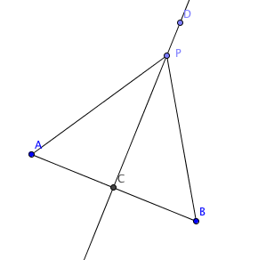
- If a point is equidistant from the endpoints of a segment, then it lies on the perpendicular bisector of the segment.
Prove part (1):
Given: $\overset{⃡}{DC }$is the perpendicular bisector of $\overline{AB}$
P lies on $\overset{⃡}{DC}$
Prove: PA = PB

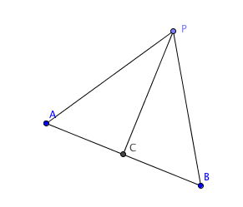
Prove part (2)
Given: PA = PB
C is the midpoint of $\overline{AB}$
Prove: $\overset{⃡}{PC }⊥$ $\overline{AB}$

