Activity 5.2.1b The Perpendicular Bisector as a Locus of Points
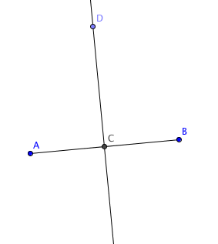
Open File ctcoregeomACT521.ggb.

- Measure the distances CA and CB. What do you notice?
- C is the ____________ of $\overline{AB}$.
- Measure $∠$DCB. What do you notice?
- $\overset{⃡}{DC}$ is __________________to $\overline{AB}$.
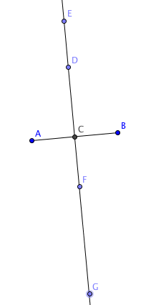
- $\overset{⃡}{DC}$ is the _______________ _______________ of $\overline{AB}$.
- Measure the distances DA and DB. What do you notice?
- Use the point on object tool to place points E, F, and G on $\overset{⃡}{DC}$.
- Measure these distances
EA = __________ EB = ____________
FA = __________ FB = _____________
GA = __________ GB = _____________
What do you notice?

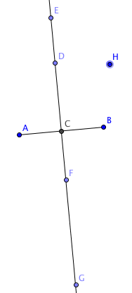
- Make a conjecture about all points that lie on $\overset{⃡}{DC}$

- Now place a point H in the plane that is not on $\overset{⃡}{DC}$. Measure HA and HB. What do you notice?
- Move point H so that HA = HB. What do you notice?
- Make a conjecture about all points that are equidistant from points A and B.

