Activity 5.1.1 Circles with Center at the Origin

- Plot these points on a coordinate grid: (10,0), (8,6), (6,8), (0, 10), (-6, 8), (-8, 6), (-10, 0),
(-8,-6), (-6,-8), (0,-10), (6, -8), (8, -6).
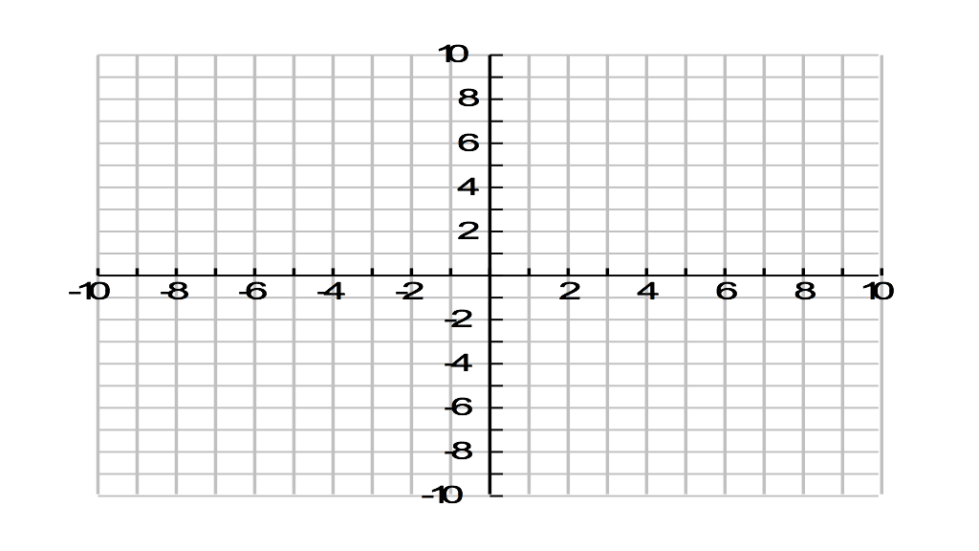

- Draw a smooth curve through the points. Describe the shape of the curve.

- Find the distance from each of these points to (0,0). (Since there are twelve points, you may want to divide up this task among members of your group.)

- What do you notice about the distances you found in question 3?

5. We define a circle as the locus of points that are the same distance from a given point (the center). In this case, our locus is the set of points that are all (how far?) _______________ from (which point?) ________________
6. Plot the circle centered at origin and radius 4, then find the equation of that circle. (Hint: start the plot by finding where the circle intersects the x- and y-axes.)

7. Find the equation of a circle whose center is at the origin and radius is 1 unit.

8. What is the radius of the circle with equation x² + y² = 49?

9. Find the equation of the circle with center at (0,0) and radius equal to r.

10. Is the graph shown in question 6 on this page the graph of a function? Explain.

11. Find the distance from the origin of each point. Then fill in the second column in the chart below.

Point | Distance from origin (to the nearest 0.01) | Is the distance greater than, less than, or equal to 5? | Does the point lie outside, inside, or on the circle with equation $x^{2}+y^{2}=25?$
A(2, 3)
B(–4, 4)
C(3, –4)
D(1,5)
E(4, –1)

12. Fill in the third column of the chart, showing whether for each point the distance from the origin is greater than, less than, or equal to 5.

13. Plot each point on the graph below and fill in the fourth column in the chart.

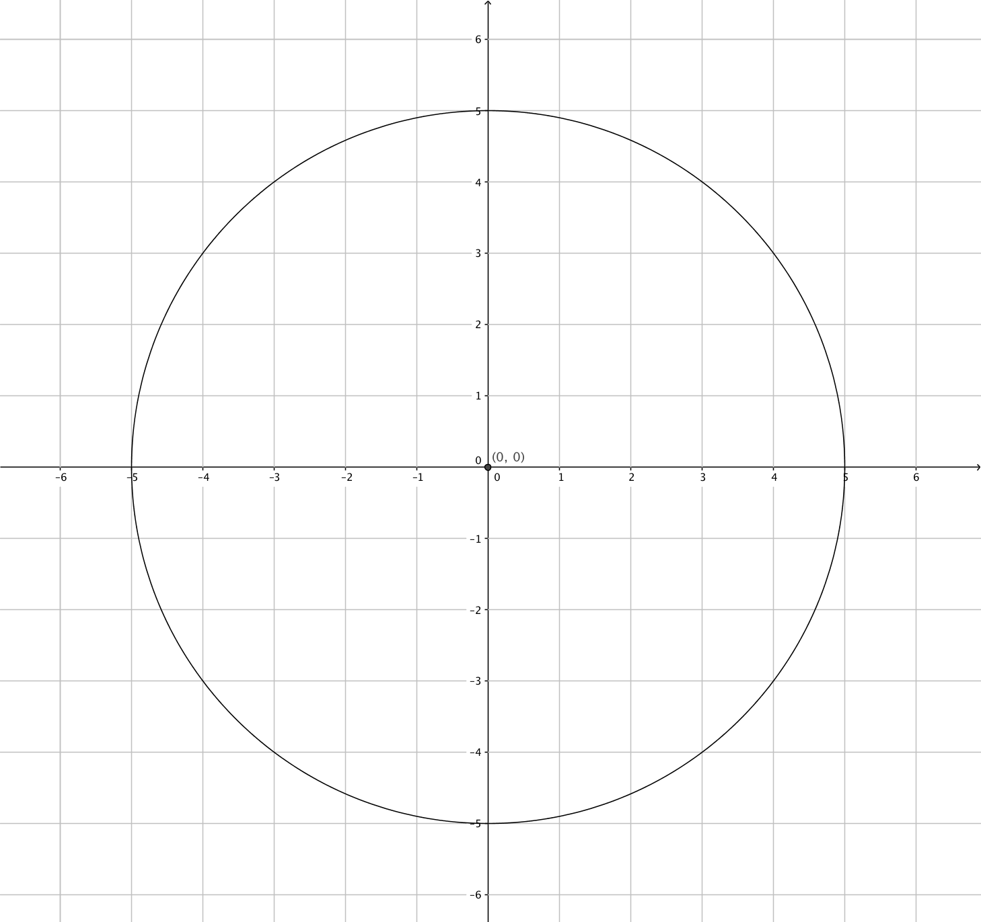

14. Make a conjecture about the location of a point relative to a circle based on what you have observed and recorded in the chart.

