Unit 4: Investigation 4 (2 Days)

Parallel Lines in Triangles

Common Core State Standards

- G-SRT.B.4 Prove theorems about triangles. Theorems include: a line parallel to one side of a triangle divides the other two proportionally, and conversely;
- G-SRT.B.5 Use congruence and similarity criteria for triangles to solve problems and to prove relationships in geometric figures.
- G-GPE.B.6 Find the point on a directed line segment between two given points that partitions the segment in a given ratio.
Overview
In this investigation students will use the AA Similarity Theorem and SAS Similarity Theorem to prove the Side Splitting Theorem and its converse. They will apply the theorem in a real life context and use the theorem to divide a line segment into n congruent parts using Euclidean construction tools. They will also divide a line segment in the coordinate plan into a given ratio.

Assessment Activities

Evidence of Success: What Will Students Be Able to Do?

- Students will be able to prove the Side Splitting Theorem and its converse.
- Students will use basic construction tools to divide a line segment into n congruent parts.

Assessment Strategies: How Will They Show What They Know?

- Exit Slip 4.4 has students apply the Side Splitting Theorem in two triangles.
- Journal Entry asks students to describe a real world context for the Side Splitting Theorem

Launch Notes

One way that you might introduce this investigation is by posing this problem. In Manhattan, New York, NY, Broadway and 7th Ave., come together to form an angle. There are multiple cross streets that are parallel to each other and intersect both Broadway and 7th Ave. This sets the stage for the theorem that students will discover in Activity 4.4.1. Introduce this problem to students by telling them that in Manhattan, the numbered avenues are perpendicular to numbered streets. For example, 7th avenue is perpendicular to 45th street. However, Broadway cuts across the grid so there are several intersections like the one at Times Square where Broadway and 7th avenue intersect but are not perpendicular to each other.
Tell the students that they are the owner of a construction company and have been asked to submit a quote to replace the sidewalks on Broadway. The city planners have given you an old drawing that once included all of the measurements. However, two of the measurements, DF and FG, are no longer legible. How can you determine the missing measurements from the drawing without having to go into the busy city with a measuring tape?
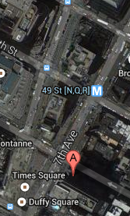
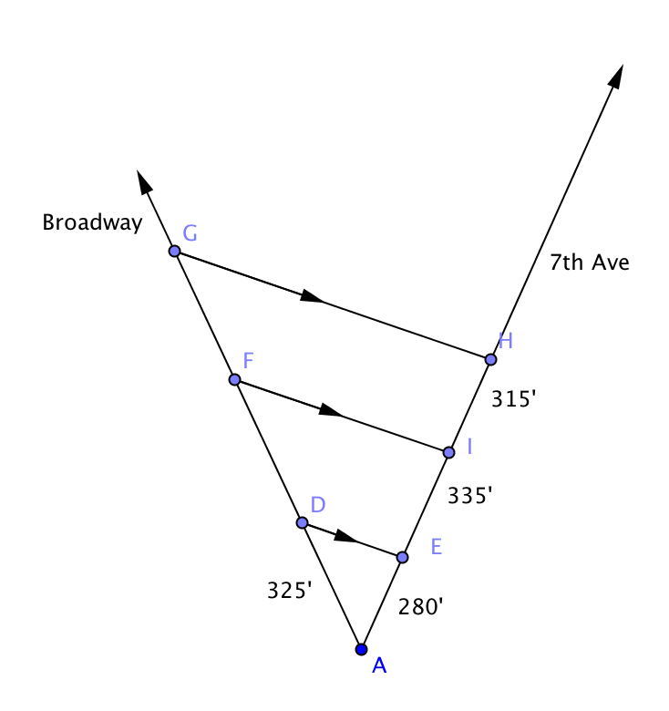

Students do not have to know the answer at this time but they should be given some time to brainstorm and share ideas as a class. Then inform them that they are going to investigate this scenario in the computer lab. In the lab they will discover something about triangles that will help them answer the question. In Activity 4.4.3 they will revisit this problem and solve it.

Teaching Strategies

In Activity 4.4.1 Parallel Lines in Triangles students use software to discover the theorem, if a line is parallel to one side of a triangle then it divides the other two sides proportionally. The converse of this “side splitting” theorem is a generalization of the Triangle Midsegment Theorem studied in Unit 3.

A discussion of precision in measurement is in order here. GeoGebra’s measurements of length are precise to the nearest 0.01 unit. When ratios are taken the results may not be exactly the same, but in most cases will agree to the nearest tenth if not the nearest hundredth. Based on this fact students should be able to conjecture that the segments formed by the parallel line are proportional.

In Activity 4.4.2 The Side-Splitting Theorem and Its Converse, students prove the theorem and its converse discovered in Activity 4.4.1. The proofs rely on the triangle similarity theorems proved in Investigation 3. However in both cases some algebraic manipulation is required to get the necessary result. Questions 1–3 lay the groundwork for students to be able to use the technique of adding or subtracting a fraction on both sides of a proportion in questions 5 and 6, in which the proofs are developed.

In Activity 4.4.3 Manhattan Sidewalk Construction Project, students revisit the problem posed in the launch. They will use what they learned in Activities 4.4.1 and 4.4.2 to determine lengths and answer practical questions that the contractor would need to address.

Exit Slip 4.4 may be given at any time after Activity 4.4.3.

Using only a compass and a straightedge, students will then divide a line segment into 3 congruent parts in Activity 4.4.4 Dividing Segments into Parts. They generalize the method to any number of parts and explain how this construction is based on the Side Splitting Theorem. In question 5 they see a sheet of paper with equally-spaced parallel line lines is another tool that may be used to divide a segment into n parts.

In Activity 4.4.5 Dividing a Line Segment in the Coordinate Plane students will extend their understanding of how to partition a line segment. They will find the point on a directed line segment between two given points that partitions the segment in a given ratio. This is the coordinate geometry equivalent of the construction. The activity starts with a specific example and then derives a general formula for dividing a segment in the ratio m to n.
Differentiated Instruction (For Learners Needing More Help)
Students for whom the algebra may be too difficult may be assigned to do only questions 1–8 in Activity 4.4.5

Group Activity: Give students a segment in the coordinate plane whose endpoints have coordinates divisible by 6. Each member of the group is assigned to divide the segment in a given ratio. Choose from this set of ratios: 1:1, 1:2, 2:1, 1:3, 3:1, 1:5, and 5:1. Have students use the formula developed in Activity 4.4.5 to find their points of division. Then have them plot all the points found on a graph to show (1) that they lie on the original segment and (2) that they appear in the order one would predict.

Differentiated Instruction (Enrichment): Ask students to explore what happens when either m or n is negative in the general formula for dividing a segment in the ratio m to n.

Journal Entry
Describe a real world scenario that uses the Side Splitting Theorem or its converse. Look for students to find a situation where a line intersects two sides of a triangle and is parallel to the other side.

Closure Notes

Ask students to explain how the Side Splitting Theorem and its converse are related to similar triangles.

Vocabulary

Division (of a segment)

Theorems

Side Splitting Theorem: If a line parallel to one side of a triangle, then it divides the other sides proportionally

Side Splitting Converse: If a line divides two sides of a triangle proportionally, then it is parallel to the third side.

Construction: To divide a given line segment into n congruent parts.

Construction: To find the point on a directed line segment between two given points that partitions the segment in a given ratio.

Resources and Materials

Activities:
Activity 4.4.1 Side Splitting Conjecture and Converse
Activity 4.4.2 Proving the Side Splitting Theorem and Its Converse
Activity 4.4.3 Manhattan Sidewalk Reconstruction Project
Activity 4.4.4 Dividing Segments into Parts
Activity 4.4.5 Partitioning a Line Segment in the Coordinate Plane

PowerPoint: Manhattan Construction Project

