Activity 4.8.2 Making a Clinometer

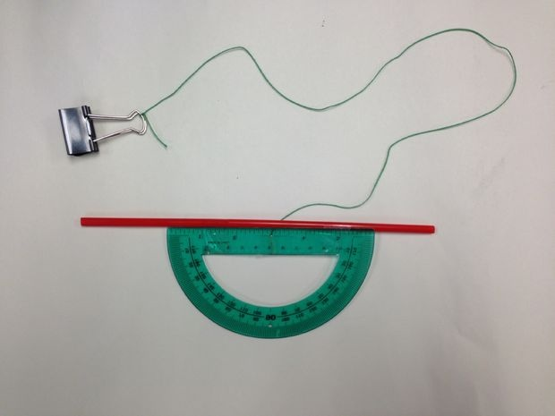
Materials needed:

Protractor
Straw
Tape
String
Weight to place at end of string

Source: http://www.instructables.com/id/how-to-make-a-clinometer-1/
1. After making your clinometer, use it to measure the angle of elevation of an object. Work with a partner.
- One person places one end of the straw at eye level and sites the object through the straw.
- The other person records the acute angle shown on the protractor. Record that angle measurement here:

- Subtract the result found from 90° to find the angle of elevation:

2. Explain why you now must subtract the angle found in step 1b from 90° to find the angle of elevation.

3. Rashid and Fernando are measuring the height of a tree. They stand at a distance of 70 ft from the tree. Rashid looks through the straw and Fernando looks at the measurement on the protractor. The string passes through the 55° mark on the protractor. How tall is the tree?

4. Brittany and Latisha are measuring the same tree. They decide to walk to a place where the angle on the protractor measures 45°. They say that the distance to the tree will then be equal to the height of the tree. Are they correct? Explain.

