Activity 4.8.1 Indirect Measurement Tools
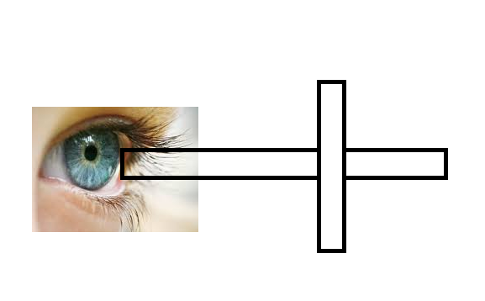
A cross staff is constructed out of popsicle sticks as shown. The cross pieces are constructed perpendicular to each other and so that the horizontal piece bisects the vertical piece.
The diagram below shows how this tool could be used to measure the height of a pyramid.

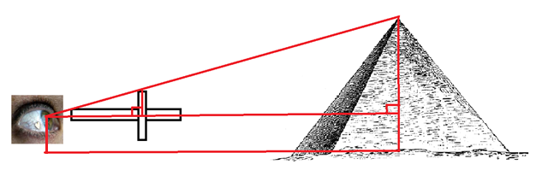
- What measurements would you need to know to find the pyramid’s height?
- Suppose the horizontal popsicle stick is 6 inches long and the vertical cross piece measures 4 inches. The great pyramid of Giza in Egypt is 481 ft high. How far away from the pyramid would you have to be to measure the height with this cross staff?

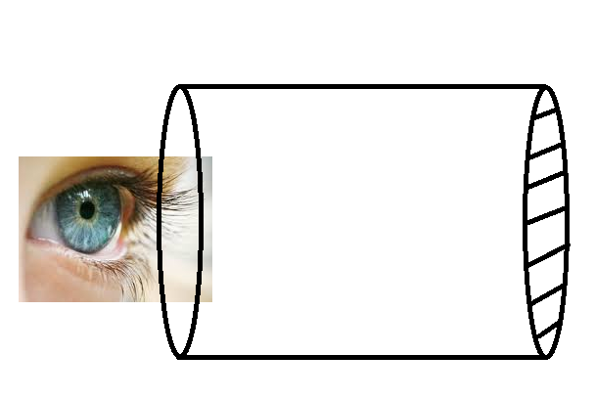
The scope shown in the picture at the right is constructed from a paper towel or toilet paper tube with parallel strings placed as equal distances covering one opening.

The diagram below shows how this scope could be used to measure the height of a tree.

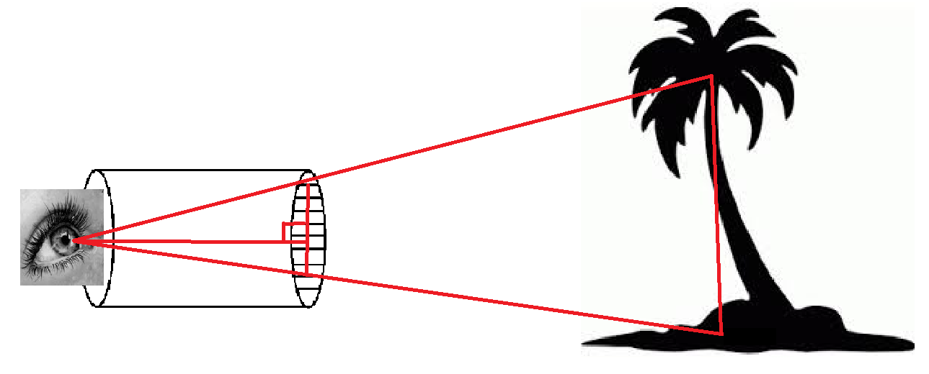
- Explain how this scope works.
- A scope is made from a paper towel tube that is 28 cm long with a diameter of 4 cm. The strings at one opening are 4 mm apart. Suppose that a tree is sited through the scope so that is spans 7 spaces between the strings, as shown above. The observer is 80 meters from the tree. How high is the tree?

