**Activity 4.7.4 Applications of Special Right Triangles**

1. **Warm up:** Find the value of variable indicated. Leave in simplified square root form.

a. b.





1. Bianca and Marcel are discussing special right triangles. Marcel says that **all** 30o - 60o - 90o triangles are similar. Bianca say’s that Marcel is not correct. Who is correct? Defend your answer.
2. A baseball diamond has four congruent sides and four right angles. Josh debates with Tamara that the way to find the distance from home plate to 2nd base on a baseball diamond is to use the Pythagorean Theorem. Tamara says there is a more efficient way to determine the length. What is the distance from home plate to 2nd base and who is correct?

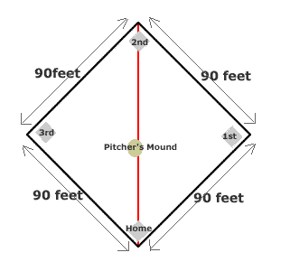

Graphic: <http://adudat.com/baseball-diamond-measurements.html>

1. Euclid Park is a square. George is walking his dog and decides to take a short cut and walk the diagonal path (connect opposite angles) that cuts through the park. If the side of the park is 50 feet, how long is the diagonal path?
2. 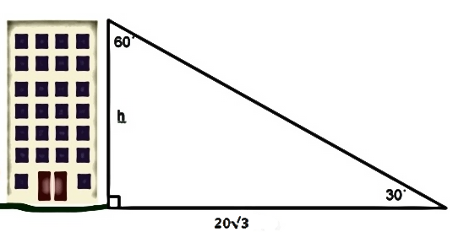 What is the height of the building? (Distances given in meters)
3. 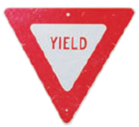A yield sign is an equilateral triangle with side lengths of 34 inches. Find the area of the triangle.
4. A girl in a castle tower sees two riders in the distance. From her eye level the riders are at a 45o angle of depression and a 30o angle of depression. Her eye level is 56 feet from the ground. How far apart are the two riders? (image: mathforum.org)

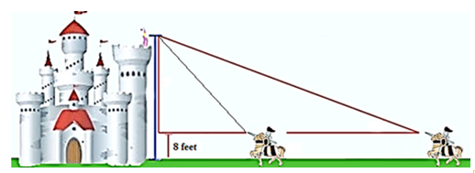

1. Use the diagram to tell whether the equation is true or false.
2. 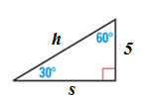 $s=5√3$ d. $s=h√3$

1. $h=2s$ e. $5=\frac{s}{√3}$
2. h = 10 f. $5= \frac{h}{2}$