**Activity 4.6.3 Applying Right Triangle Trigonometry**

1. Over the vacation your uncle wanted to cut down a tree that was on his property. He did not want the tree to hit his house when it came down. So he measured the distance from the base of the tree to the base of the house. While he did not know how tall the tree was, he did know that the angle of elevation from the ground at the base of the house to the top of the tree was . Is there enough room to cut the tree down without hitting the house. Why or why not?.







131 feet

2. Emily is a great swimmer and like any good swimmer she knows her limits. She wants to swim across the Connecticut River from Wethersfield to Glastonbury and then back to Wethersfield. Her friends tell her that it is too far. However, Emily is a great geometry student and is going to find out herself if the swim is within her limits.

Emily places a stake in the ground that is directly across from a rock on the other side of the river. Then she walks 175 feet down shore and places another stake. She then measures the angle formed by the line on the beach and the line of sight to the rock to be .



*Rock*

Wethersfield 175’ Glastonbury



1. To the nearest foot, determine how wide the river is at the point of the rock.
2. If Emily can swim up to a quarter mile without stopping, will she be able to make this swim if she doesn’t take a break? Show all work.
3. If Emily decides to swim straight across the river what might prevent her from arriving exactly at the rock?

3. A see-saw, 15 feet long, rests on a pivot at its midpoint 3 feet above the ground. Through what maximum angle can the see-saw rotate? Round your solution to the nearest tenth of a degree.

4. Captain Trig is flying his geometry class to a vacation resort where they will further develop their geometry skills. To begin Captain Trig gives the class a problem before they even land. He tells them that the plane is currently 22,000 feet in the air and the runway is 8 miles away from a point directly below the plane. If they begin descending now, at what angle of descent should they set the plane? Draw a diagram of this to help you and your crew and round your solution to the nearest tenth of a degree.

5. A water-lily was growing 10 cm above the surface of a pond when a strong wind came and blew it 50 cm sideways to the surface of the pond.

a. Use this information to determine the depth of the pond. Assume the stem is rigid and does not bend.

10cm 50 cm

b. To the nearest hundredth of a degree, through what angle measure

did the stem of the water-lily rotate from the wind?

1. Jamie is lying on the edge of the top of a building looking at a bird that is sitting on an edge of the roof of another building below him. The building Jamie is on is 128 feet tall and the building the bird is on is 72 feet tall. The buildings were built on the same elevation and are 307 feet apart. Through what angle of depression is Jamie is viewing the bird through his binoculars?

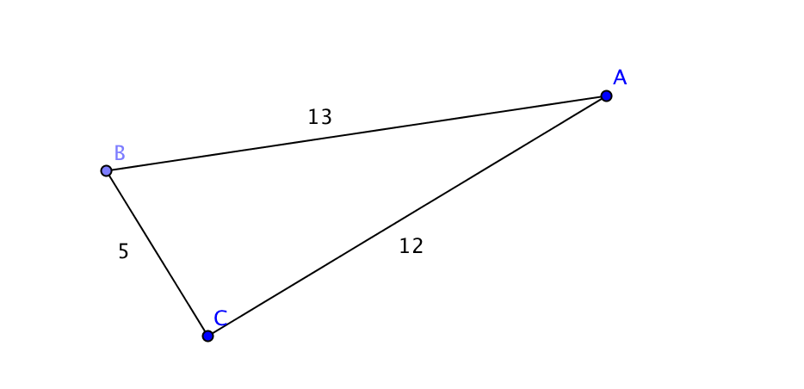

1. Use the diagram to answer these questions.

a. Can you use right triangle trigonometry to find the missing angle measures in the diagram? Why or why not?

b. If you answered “no” in part (a), then determine what type of triangle is shown below. If you answered yes, then find each missing angle measure.

1. Due to increased texting in New Britain, the local cell phone company has put up a new cell phone tower. You want to know the height of the tower. However, the area where it is located is off limits for security reasons so you can’t find out how far you are away from the tower. Instead, from a point outside the fenced area you get an angle of elevation from a point to the top of the tower. Call this point *A*. The angle of elevation is  from point *A* to the top of the tower. Then you walk 72 feet closer to the tower and measure the angle of elevation at point *B* to be . To the nearest foot what is the height of the tower? (Use the diagram below and solve for both *x* and *h*.)

