**Activity 4.6.2 Inverse Trigonometric Functions**

Recall that in a right triangle we have three trigonometric ratios:

$\sin\left(x\right)=\frac{length of leg opp. x}{length of hypot.}⁡$ $\cos\left(x\right)=\frac{length of leg adj. x}{length of hypot.}⁡$ $\tan\left(x\right)=\frac{length of leg opp. x}{length of leg adj. x}$.

Up until now you were always given the measure of the acute angle and the length of a leg or hypotenuse. This allowed you to solve for the missing side lengths. However, in many real world situations you know the lengths of the legs but not the measure of the acute angle. In these situations you need to use inverse trigonometric functions.

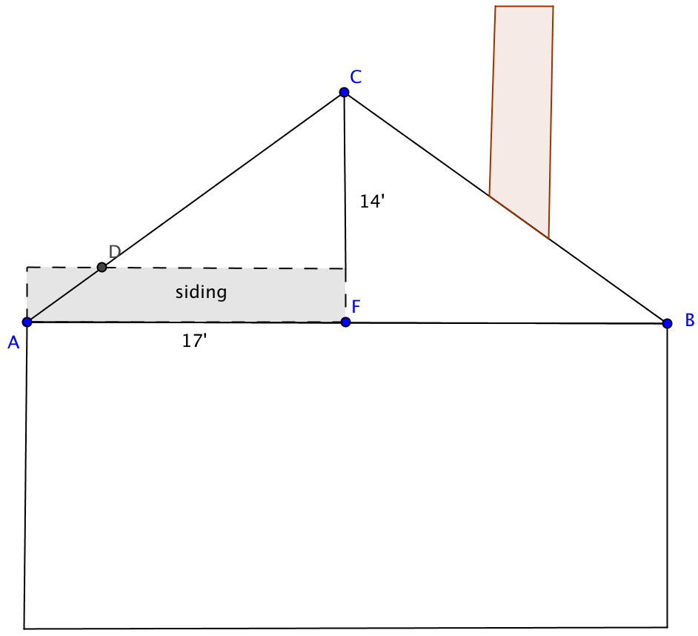Enrique is repairing some siding on his house. Siding comes in rectangular pieces but the side of his house is in the shape of a triangle, which means he will have to cut the siding at the correct angle measure.

Enrique understands that the measure of angle *A* is a little less than ${45}^{∘}$ because 17’ to 17’ would result in a ${45}^{∘}$ angle. Since 14’ is slightly less than 17’ the angle will be less than ${45}^{∘}$. To determine the measure of $∠A$ Enrique sets up the tangent ratio $tan⁡(A)=\frac{14}{17}$. Using a calculator Enrique can determine the measure of the angle using an inverse trigonometric function.

The inverse tangent of *A* is defined as the measure of the acute angle whose tangent is *A*. In this case, $tan⁡(A)=\frac{14}{17}$ gives us $\tan^{-1}\left(\frac{14}{17}\right)=m∠ A$. Using a TI-84, Enrique presses 2nd then TAN then he enters the ratio $14/17$ and presses **Enter** to get the angle measure. The result is $≈39.4725^{∘}$.

**Caution: *tan*–1 does not mean $\frac{1}{tan}$ Read *tan*–1 as “inverse tangent.”**

Let’s take a look at an example using the sine ratio.

If $sin⁡(B)=\frac{13}{20}$ then $\sin^{-1}\left(\frac{13}{20}\right)=m∠ B$ or $m∠ B≈40.5416^{∘}$

Part I: Now you try. Fill in the blanks using the given information,.

1. If $cos⁡(C)=\frac{1}{2}$ then $___________=m∠ C$ or m $∠$ $C≈____________$.
2. If $tan⁡(X)=\frac{45}{31}$ then $__________=m∠ X$ or m $∠$ $X≈____________$.
3. If $_______________$ then $\sin^{-1}\left(\frac{3}{4}\right)=m∠ Y$ or $m∠ Y≈___________$.

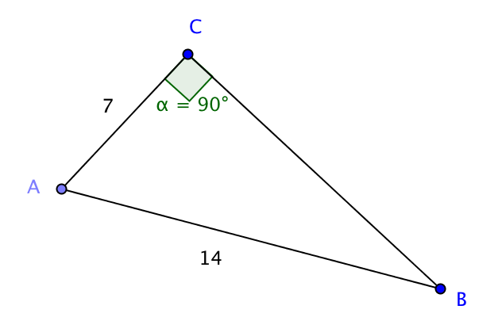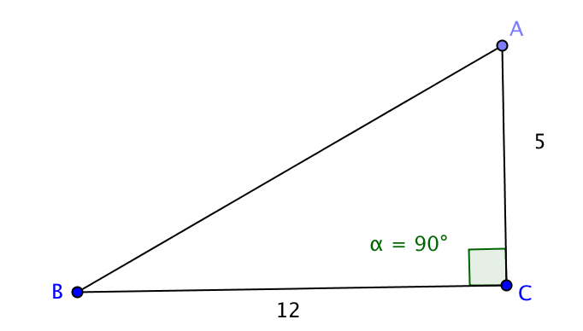Part II: Solve the triangle (find all missing angle measures and side lengths.) Round to the nearest hundredth when necessary.

4. 5.

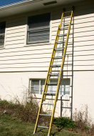Part III: Real World Problems

6. At what acute angle measure does a 16’ ladder meet a house if the base of the ladder is 5’ from the base of the house?

7. The Americans with Disability Act or ADA has specified that handicap ramps must meet any horizontal plane at an angle measure of $4.75^{∘}$ or less. If a handicap ramp has a rise of 4.5 feet and a run of 38 feet, does it meet ADA specifications?

8. You are flying at an elevation of 30,000 feet when the tower informs you that you are 25 miles from the runway and must begin descending at a constant rate. At what angle of descent should you set the airplane so that you land on the runway?

9. Write and solve your own real world problem that requires the user to set up the equation $\cos^{-1}\left(\frac{12}{21}\right)=m∠ X$ to determine the measure of $∠$*X*.