Activity 4.5.6 The Converse of the Pythagorean Theorem
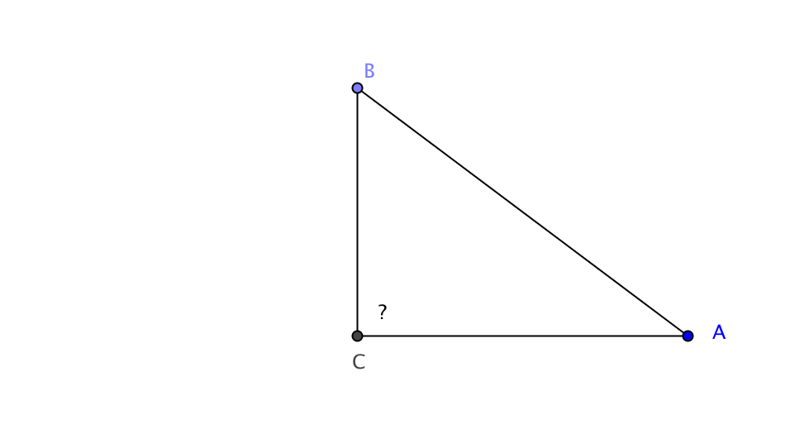
Given: $△ABC$ where ${AC}^{2}$ + ${BC}^{2}$ = ${AB}^{2}$

Prove: $△ABC$ is a right triangle. (We don’t yet know that $∠C$ is a right angle. See ? on figure at the right.)

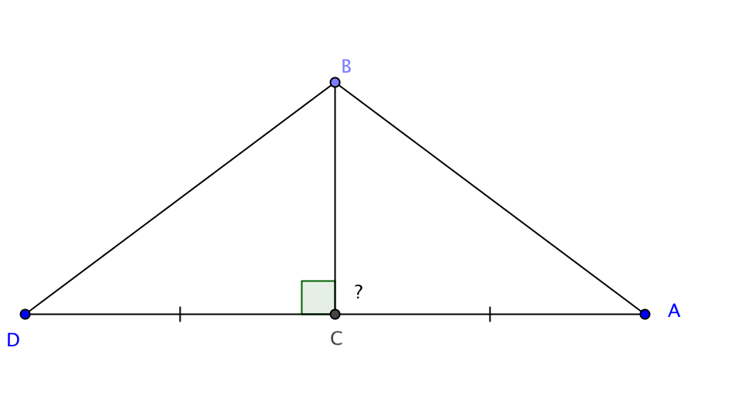
1. Construct a line perpendicular to $\overline{BC}$ and then find point D on that line so that DC = AC (Construction is shown by marks on diagram below.)

2. Construct $\overline{DB}$ to form $∆BCD$.

3. Since AC = DC by construction then ${AC}^{2}$ =_____.

4. Adding BC² to both sides of equation 3 gives ${AC}^{2}$ + ${BC}^{2}$ =_____+ ${BC}^{2}$.

5. By construction, $△BCD$ is a __________ triangle.

By the Pythagorean Theorem _____² + _____² = _____².

6. From equations 4 and 5 we conclude that ${AC}^{2}$ + ${BC}^{2}$ = ${DB}^{2}$by the _________ property.

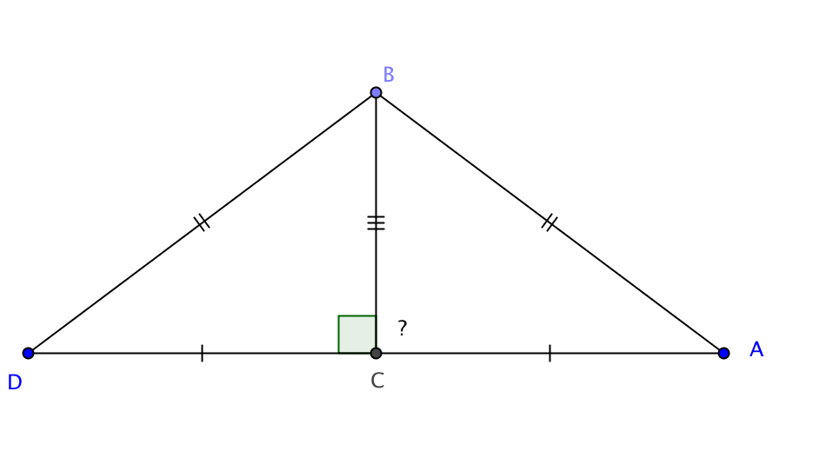
7. We were given that ${AC}^{2}$ + ${BC}^{2}$ = $____$². Therefore _____² = _____² by the ____________ property and thus DB = AB.

8. CB = CB by _________________.

9. Using information from steps 1, 7, and 8 we can prove that $△ABC≅△DBC$ by the _____ Congruence theorem.

10. m $∠$BCD = m $∠$BCA by ______________.

11. m $∠$BCD = ____ because perpendicular lines form right angles.

12. $∠$_______ is a right angle because___________________; therefore, $ΔABC$ is a right triangle.

Applications of the Converse of the Pythagorean Theorem

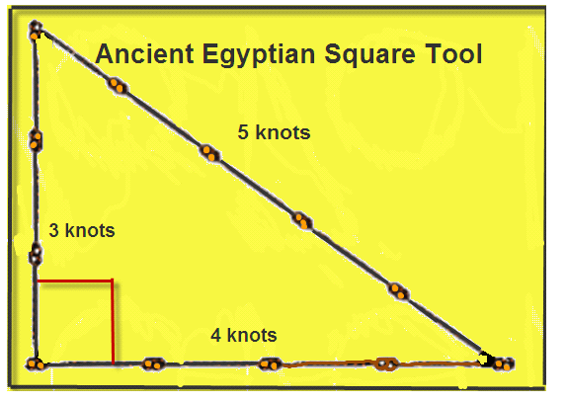
13. In Ancient Egypt stonemasons used a rope with 12 equally spaced knots to make a right angle. See figure at the right. Explain why this method worked.

http://www.eduswaplearning.com/Math/Pythagoras/Who-was-Pythagoras.html

14. A “Pythagorean Triple” is a set of three numbers that could be the lengths of the sides of a right triangle. Determine whether or not each set of numbers is a Pythagorean Triple:

- 7, 24, 25
- 8, 9, 12
- 8, 15, 17
- 11, 13, 17
- 11, 60, 61

15. a. Show that 5, 12, 13 is a Pythagorean triple.

b. Loretta says, “Since 5, 12, 13, is a Pythagorean triple, I know that 10, 24, 26 must also be a Pythagorean triple. I don’t even need to check to see whether 10² + 24² = 26².”

Is Loretta correct? Explain why or why not.

