Activity 4.5.5 Right, Acute, Obtuse?

- a, b, and c represent the lengths of the sides of a triangle. Compare a² + b² with c². Then complete only the outlined columns of the table. The last column will be filled in later.

 | a (shortest length) | b (medium length) | c (longest length) | a² + b² | =,>,< | c² | Right, Acute, or Obtuse
1 | 8 | 10 | 12
2 | 13 | 16 | 18
3 | 11 | 15 | 18
4 | 3 | 4 | 5
5 | 5 | 12 | 13
6 | 8 | 15 | 17
7 | 3 | 4 | 6
8 | 5 | 8 | 10
9 | 9 | 13 | 20

2. Using the given string, mark off the three provided lengths on the string. For example,

8cm 10cm 12cm

3.. Place the string through two paper clips as shown below

4.. Two members of your group should hold the paper clips at the middle marks on the string while holding the string tight. The third member of the group needs to take the two ends of the string and bring them together so that a triangle is formed with the measured lengths.

8 12

10

5. Examine your triangle. Does it appear to be a right, acute, or obtuse triangle? Record your results in the table above.

6. Repeat steps 2-5 for each row of the table.

7. Suppose the three sides of a triangle have lengths a, b, and c and c is the longest side. Make a conjecture about the relationship between a² + b² and c² for acute triangles.

8. Suppose the three sides of a triangle have lengths a, b, and c and c is the longest side. Make a conjecture about the relationship between a² + b² and c² for obtuse triangles.

9. Previously you learned that in a right triangle the sum of the square of the length of the legs is equal to the square of the length of the hypotenuse. Is the converse true? That is if we don’t know the given triangle is a right triangle but we have a² + b² = c², where a, b, and c are the lengths of the sides of a triangle would that mean we have a right triangle?

10. Complete the following

Converse of the Pythagorean Theorem
If a² + b² = c², where a, b, and c are the lengths of the sides of a triangle, then
________________________________________________________

11. Compare your results on questions 1–10 with the results of another group.

Answer each of the following questions while showing your work or explaining your reasoning.

12. A contractor is building a rectangular shed (16’ by 30’) and begins by setting up four boards that form the outer part of the floor. To see if the floor is “square” (meaning that there is a right angle formed by the sides) the contractor measures the diagonal and finds it is 35’. What should he do?

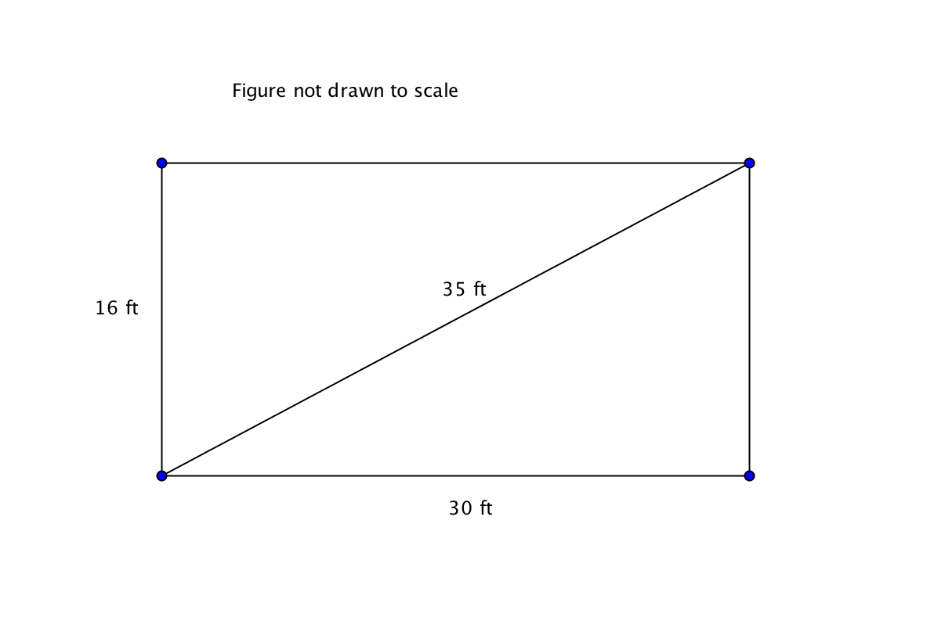

13. Jane was asked to check if the three side lengths 7, 21, and 29 form a right, acute, or obtuse triangle. Her response was, “It is obtuse because 7² + 21² is 490 and that is less than 29² or 841.”

What should you say to Jane about her work?

14. Quan was asked to check if the three side lengths 18, 7, and 15 form a right, acute, or obtuse triangle. His response was, “It is acute because 18² + 7² is 373 and that is greater than 15² or 225.

What should you say to Quan about his work?

15. Determine if the measures form a triangle and if so, whether it is right, acute, or obtuse.
a. 12, $\sqrt{23}$, 11 b. 10, 20, 24 c. 9, 14, 5

