Activity 4.5.3 Geometric Means
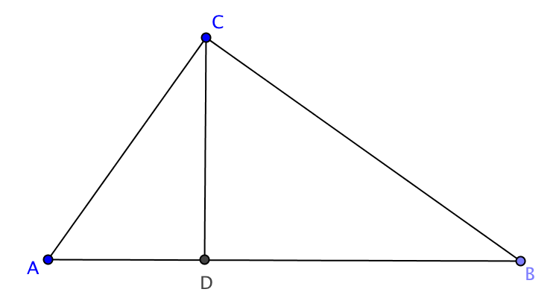
In Activity 4.5.2, you proved that an altitude to the hypotenuse of a right triangle from the opposite vertex creates two new triangles that are similar to each other and the original triangle.

$ΔABC$ is a right triangle with altitude $\overline{DC}$.
$∠C$ is a right angle.

Part I:

1. By the Right Triangle Similarity Theorem we know that $⊿_______≅⊿_______≅⊿_______$.

2. Using the two smaller triangles we can set up the following proportion
$\frac{__}{AD}=\frac{BD}{__}$ which results in $AD⋅BD=_________$

When a the same number appears twice in a proportion, in the numerator of one ratio and the denominator of the other ration, it is called the geometric mean of the other two numbers.

3. In the example above, ______ is the geometric mean of AD and BD.

If an altitude is drawn to the hypotenuse of a right triangle from the opposite vertex, then the altitude to the hypotenuse is the geometric mean between the segments on the hypotenuse.

4. In the figure at the right, $h^{2}=___⋅$

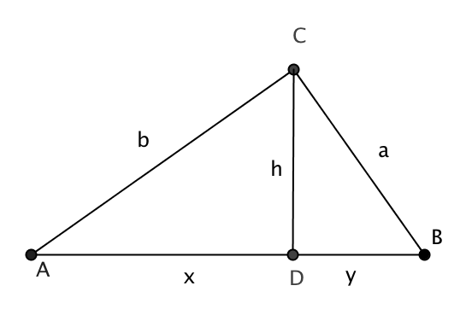
$h$ is the geometric mean between ___ and _____.

5. Find the geometric mean between

- 20 and 5
- 10 and 90
- 28 and 15
Part II:
6. Using $ΔACB$ and $ΔCDB$, set up the following proportion

$\frac{BC}{AB}=\frac{BD}{__}$ which results in $AB⋅BD=_________$

7. Using $ΔACB$ and $ΔADC$, set up the following proportion
$\frac{AC}{AB}=\frac{__}{AC}$ which results in $AC⋅AC=_________$

If an altitude is drawn to the hypotenuse of a right triangle from the opposite vertex, then a leg of the given right triangle is the geometric mean between the hypotenuse of the triangle and the segment on the hypotenuse that is adjacent to the chosen leg.
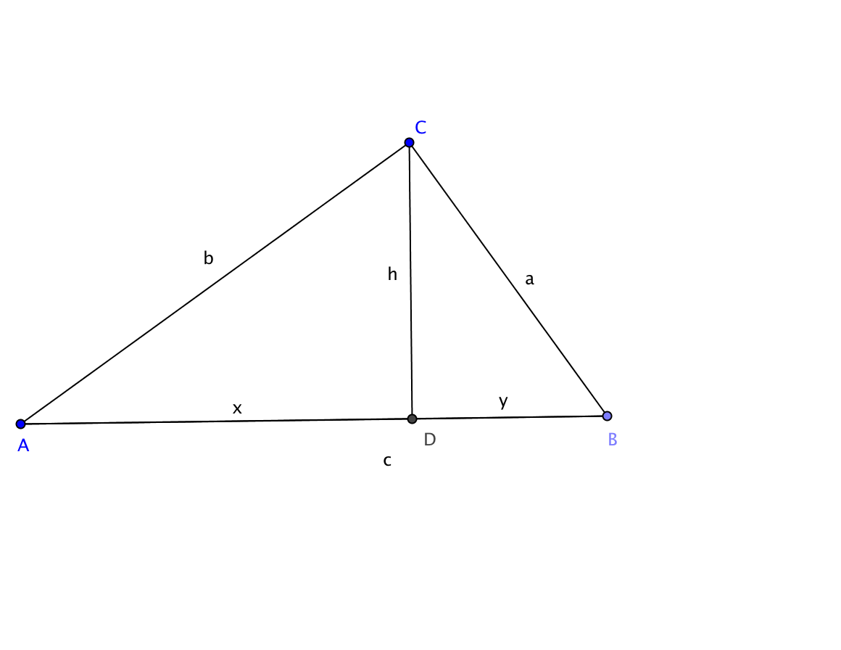
8. In the figure c = x + y. Find
$b^{2}=_____⋅______$ and $a^{2}=_____⋅______$

9. Find the geometric mean between c and x: ____________

Part III: Exercises
Given $ΔNOM$ is a right triangle with right angle $∠MON$ and altitude $\overline{PO}$, determine the missing measurement in each problem.

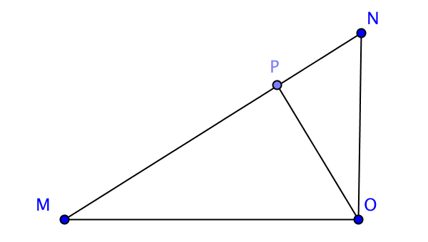
- If MP = 7 and PN = 28, find OP.

- If OP = 8 and NP = 6, find MP.

- If MN = 12 and MP = 4, find MO.

- If NO = 7 and MN = 12, find NP.

