Activity 4.4.5 Dividing a Line Segment in the Coordinate Plane
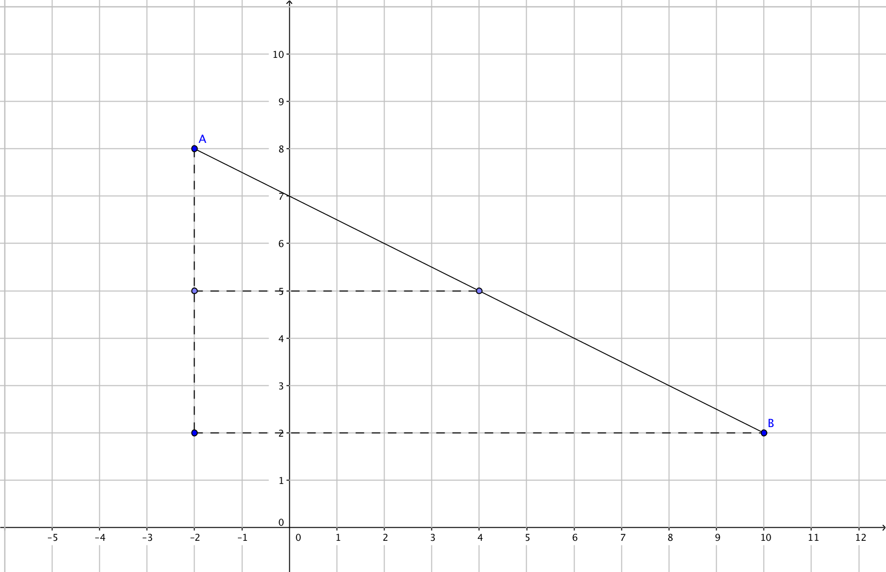
In Unit 1 you learned the Midpoint Formula to find the midpoint of any line segment in the coordinate plane.

- Segment $\overline{AB}$ has endpoints A (–2, 8) and B (10, 2).

a. Write the Midpoint Formula. The midpoint of the segment from (x₁, y₁) to (x₂, y₂) has coordinates (_______, ______)

b. Let M be the midpoint of $\overline{AB}$. Find the coordinates of M (______, ______)

2. Another way to determine the location of M is to think of traveling along the segment halfway from A to B.
- Find the vector from A to B = [___, ___]. This indicates that we are moving ___ units in the horizontal direction and ____ units in the vertical direction.

- Take half of each component of the vector in (a): [ ___, ___ ].
Now move ____ units in the horizontal direction and ____ units in the vertical direction. Starting at point A(–2, 8) we will end up with the point (____, ____)

- Compare your answers in questions 1b and 2b. What do you notice?

- Here is another way to look at what we just did. We found a point M on $\overline{AB}$ such that the ratio of its distance from A to its distance to B is 1 to 1. Check to see that this is true.

a. Find the distance MA = _____
b. Find the distance MB = _____
c. Find the ratio $\frac{MA}{MB}= ______$

4. Now let’s find a point N that is $\frac{1}{3}$ the distance from point A (–2, 8) to point B (10, 2).
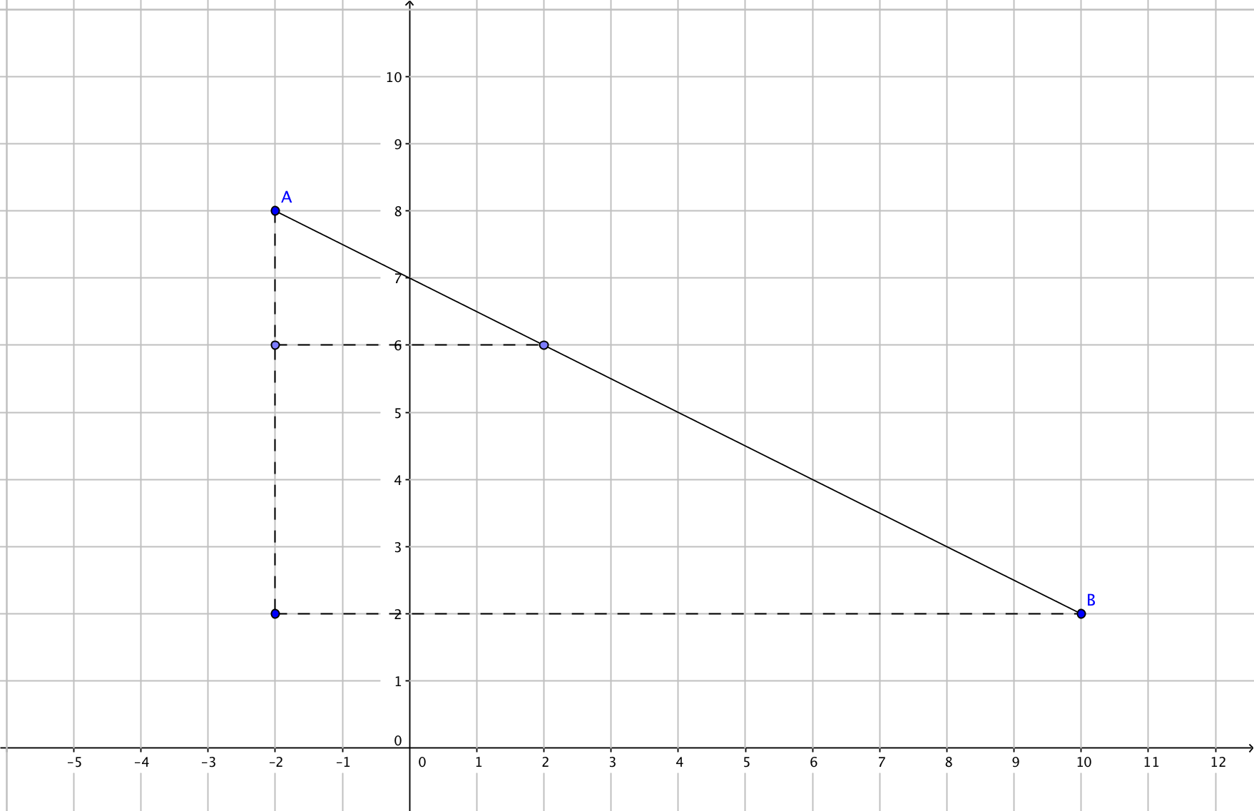
a. The vector from A to B = [___, __]. Take $\frac{1}{3}$ of each component: [___, ___].
b. Now move ____ units in the horizontal direction and ____ units in the vertical direction.
Starting at point A(–2, 8) we will end up with the point N (____, ____)
c. Find the distance NA = _____
d. Find the distance NB = _____
e. Find the ratio $\frac{NA}{NB}= _____$
f. We can say that the ratio of the distance from N to A and the distance from N to B is in the ratio of ____ to ____.

Consider this problem:

Find Point M on the line segment below such that point M divides $\overline{AB}$ into the ratio 2 to 3. That is, Point M is $\frac{2}{5}$ the way from Point A (3, 1) to Point B (13, 6) or Point M is $\frac{3}{5}$ the way from Point B to point A along $\overline{AB}$.

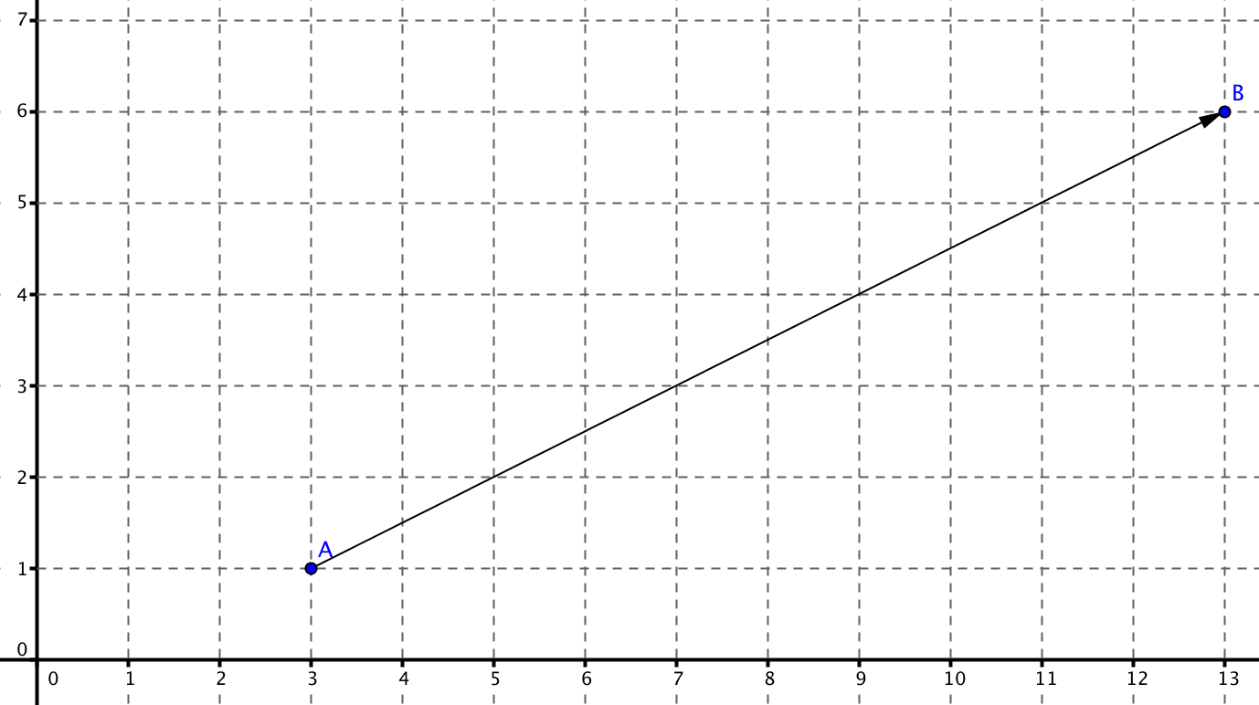

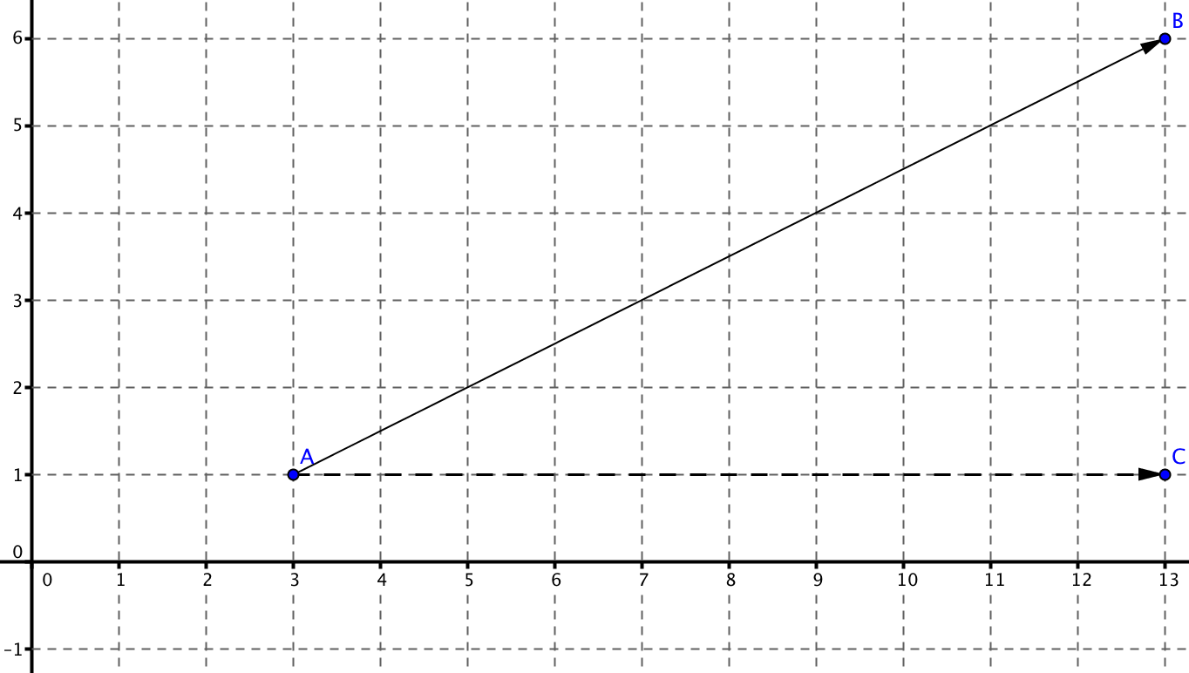
5. We want to partition $\overline{AB}$ into two parts; one worth 2 units and the other worth 3 units. These five units will make up the whole. You might begin by dividing the horizontal distance (the “run”) into 5 congruent units.

A(3, 1) B(13, 6)
Horizontal distance = ____-____= 10

$\frac{Horizontal distance }{___ pieces}=$ ___ units per 1/5

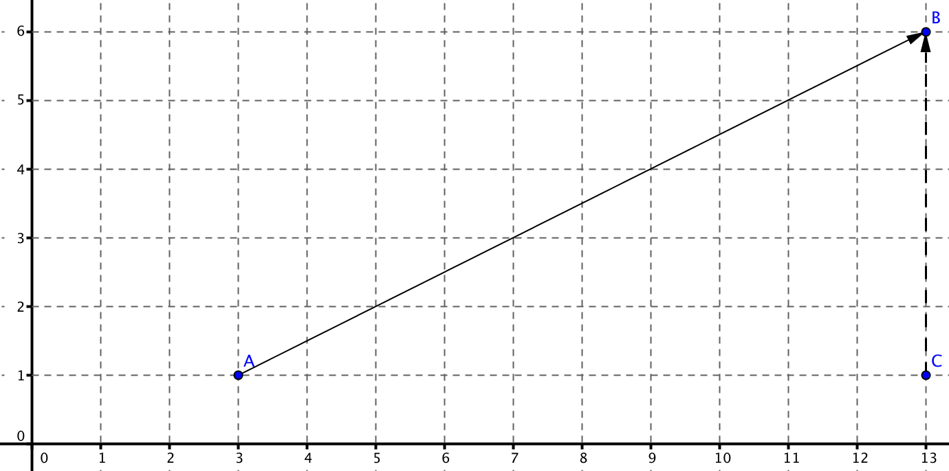
6. Now divide the vertical distance (the “rise”) into 5 congruent units.
A(3, 1) B(13, 6)
Vertical distance = ___-___= 5

$\frac{Vertical distance }{___ pieces}=$ ___ unit per 1/5

7. Now that we know the number of spaces for 1/5 of the segment in both vertical and horizontal directions from point A, determine 2/5 or 2 of the $\frac{1}{5}$ units in BOTH the vertical and horizontal directions.
a. 2/5 in the horizontal direction:
2$×$___ units per 1/5 = ___ spaces in the horizontal direction from A

b. 2/5 in the vertical direction:
2$×$___units per 1/5 = ___ spaces in the vertical direction from A
8. Now move from point A, in both the horizontal and vertical directions, the number of spaces you determined in question 7.

- This can also be thought of as adding the horizontal distance to which coordinate?

- This can also be thought of as adding the vertical distance to which coordinate?

- The coordinates of point P: (____, _____)

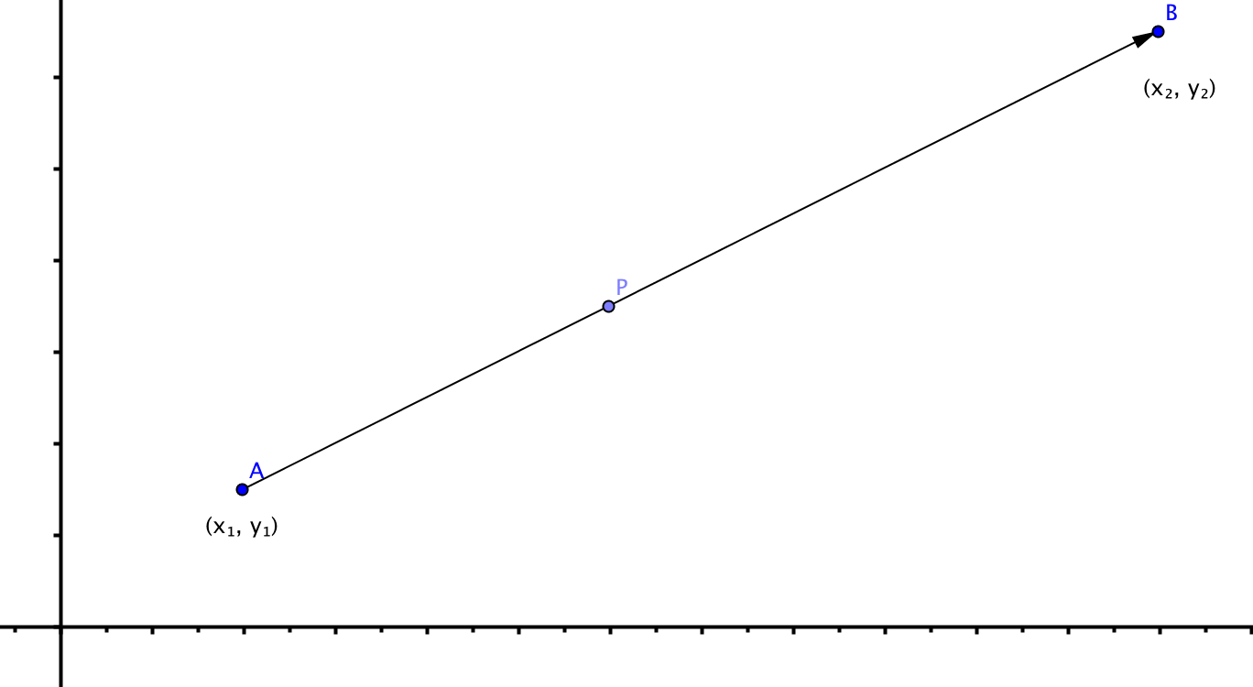

Now let’s generalize. Given segment $\overline{AB}$, A(x₁, y₁) and B(x₂, y₂), determine the coordinates of point P such that point P divides $\overline{AB}$ into the ratio m/n.
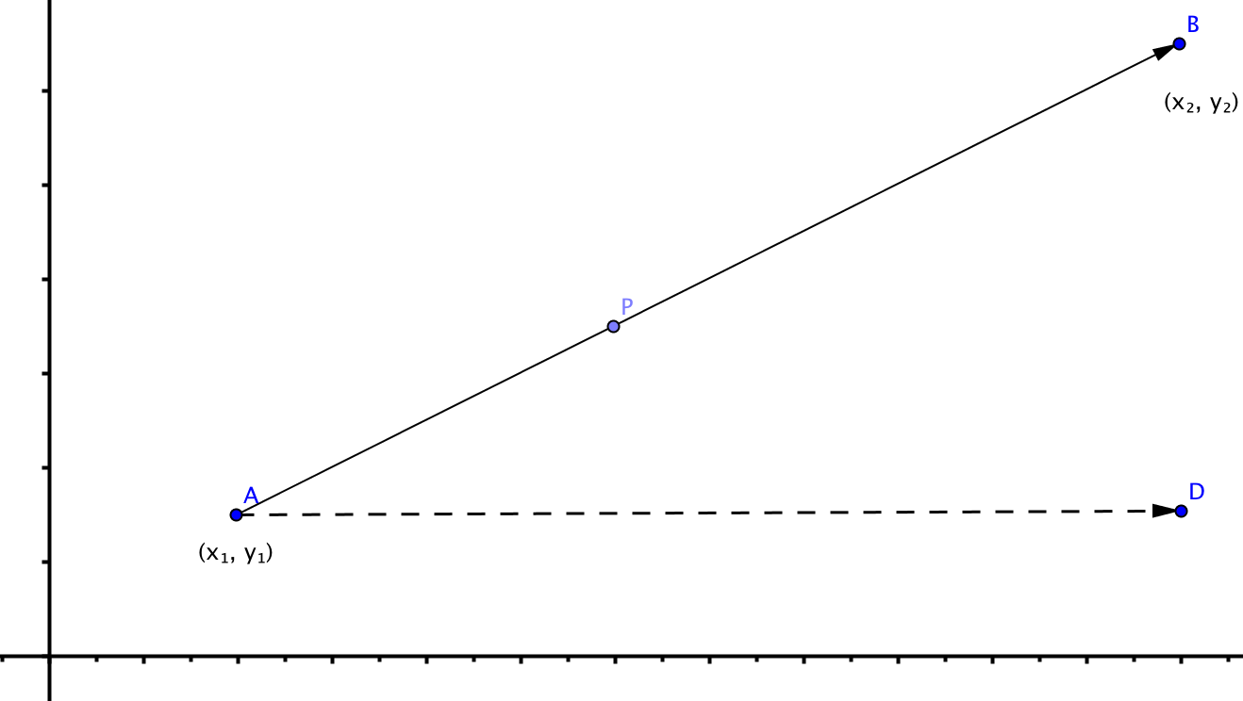
9. Since we want point P to partition $\overline{AB}$ into the ratio $\frac{m}{n}$ , then we need to determine how much is $\frac{1}{m+n}$. You might begin by dividing the horizontal distance of the segment into m+n congruent units.
A$(x_{1}, y_{1})$ B$(x_{2}, y_{2})$

Horizontal distance = _____–_____

$\frac{Horizontal distance }{____ pieces}=$ $\frac{___}{___}$ units per 1/(m+n)

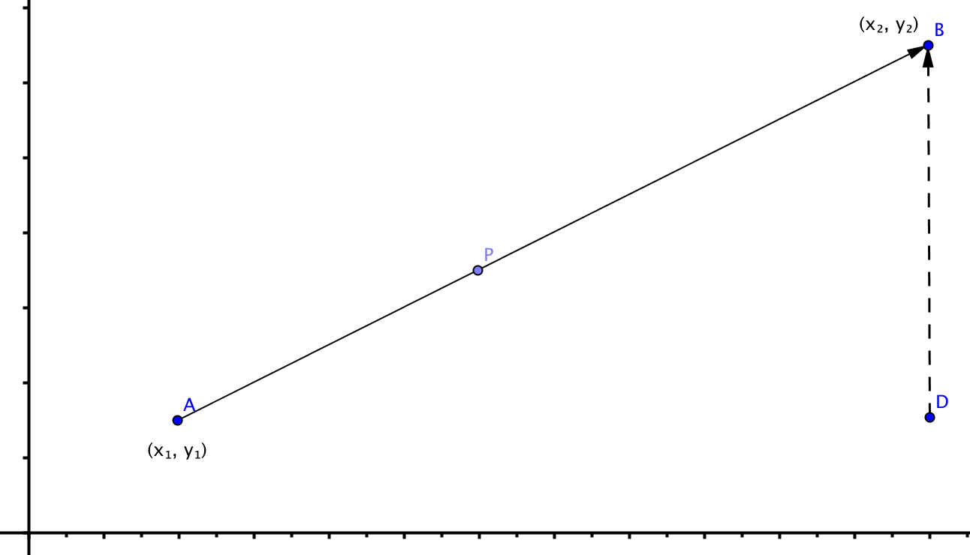
10. Now divide the vertical distance of the segment into n congruent units.
$A(x_{1}, y_{1})$ B$(x_{2}, y_{2})$

Vertical distance = _____-_____

$\frac{Vertical distance }{_______ pieces}=$ ___units per 1/(m+n)

11. Now that we know the number of spaces for 1/(m+n) units we can determine how many spaces for m/(m+n) in both the vertical and horizontal directions

a. m$×$___units per 1/(m+n) = ___spaces in the horizontal direction from A.

b. m$×$___units per 1/(m+n) = ___spaces in the vertical direction from A.

12. Now move from point A, in both the horizontal and vertical directions, the number of spaces you determined in question #7.

- For the horizontal distance this can found by
___+ $x_{1}$ = ___

- For the vertical distance this can found by
___ + $y_{1}$ = ___

13. Given segment $\overline{AB}$, A(x₁, y₁) and B(x₂, y₂), the coordinates of point P such that point P divides $\overline{AB}$ into the ratio m to n are ($______,______$ ).

14. Suppose the coordinates are A(–2, 8) and B(10, 2) and that m = 1 and n = 1. Use the formula your found in question 14 to find the coordinates of P, the point that divides$\overline{ AB}$ into the ratio 1 to 1. Compare your result with what you found in questions 1 and 2.

15. Suppose the coordinates are A(–2, 8) and B(10, 2) and that m = 1 and n = 2. Use the formula your found in question 14 to find the coordinates of P, the point that divides$\overline{ AB}$ into the ratio 1 to 2. Compare your result with what you found in question 4.

16. Suppose the coordinates are A(3, 1) and B(13, 6) and that m = 2 and n = 3. Use the formula your found in question 14 to find the coordinates of P, the point that divides$\overline{ AB}$ into the ratio 2 to 3. Compare your result with what you found in question 8.

17. Suppose the coordinates are A(3, 1) and B(13, 6) and that m = 3 and n = 2. Use the formula your found in question 14 to find the coordinates of P, the point that divides$\overline{ AB}$ into the ratio 3 to 2. How does this point compare with the one you found in questions 8 and 13?
a. Which one is closer to A?
b. Which one is closer to B?
c. Do these results make sense? Explain.

