Activity 4.4.2 The Side Splitting Theorem and Its Converse

- In Activity 4.4.1 you discovered the Side-Splitting Conjecture: If a line is parallel to one side of a triangle, then it divides the other two sides proportionally.
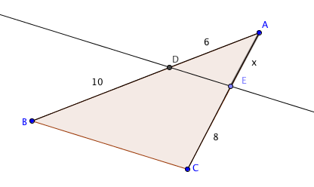
In this figure, line $\overset{⃡}{DE}$ is parallel to side $\overline{BC}$ of ∆ABC.

- Write a proportion based on the Side Splitting Conjecture.
$\frac{}{}=\frac{}{}$.
- Use your proportion to solve for x.

- Since $\overset{⃡}{DE}$ || $\overline{BC}$ we know that m$∠$ ABC = m $∠$ADE. State the theorem that allows us to draw that conclusion.
- We also know that $∠$ A is an interior angle of both ∆ ______ and ∆ _________.
- Therefore these two triangles are similar. State the theorem that allows us to draw that conclusion.
- Because the two triangles are similar, corresponding sides are proportional, that is
$\frac{AD}{AB}=\frac{}{AC}$.
- Now substitute the known values and x to get this proportion: $\frac{6}{}=\frac{}{x+8}$.

- Solve this proportion for x and compare your result with the value you found in part (b).

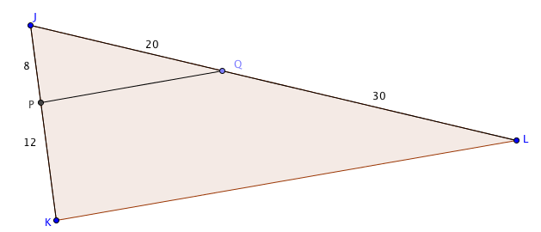
- Finding proportions:

In the figure at the right, $\overline{PQ}$ || $\overline{KL}$.

a. According to the Side Splitting Conjecture, which of these proportions must be true? (There may be more than one correct answer.)

(1) $\frac{JP}{PK}=\frac{JQ}{QL}$ (2) $\frac{JP}{PK}=\frac{JL}{QL}$ (3) $\frac{JP}{QL}=\frac{JQ}{PK}$ (4) $\frac{PK}{JP}=\frac{QL}{JQ}$ (5) $\frac{PK}{JP}=\frac{JQ}{QL}$

b. The lengths of segments $\overline{JP}$, $\overline{PK}$, $\overline{JQ}$, and $\overline{QL}$ are given on the figure. Show that these numbers satisfy the proportion or proportions you found in question (a).

c. As we did in question 1, we can prove that ∆PJQ ~ ∆KJL. Write a proportion showing that all three pairs of corresponding sides of the two triangles are proportional.

d. Using the numbers given on the diagram, substitute values for JK, JP, JQ, and JL in the proportion in part (c).

e. Fill in the blanks:
Start with the proportion $\frac{20}{8}=\frac{50}{20}$
Subtract 1 on both sides of the equation $\frac{20}{8}-1=\frac{50}{20}-1$
Find common denominators $\frac{20}{8}-\frac{}{8}=\frac{50}{20}-\frac{}{20}$
Write each side of the equation as a single fraction $\frac{}{8}=\frac{}{20}$

f. What do you notice about the last proportion in question (e)?

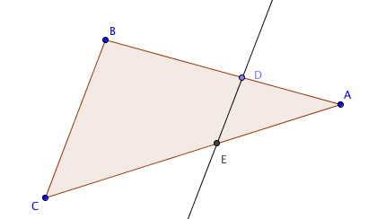
- Adding and subtracting lengths of segments:
Sides $\overline{AB}$ and $\overline{AC}$ are each split into two segments.
Fill in the blanks to make each statement true:

BD + DA = ______ AB – ____ = BD

CE + ___ = AC ___ – AE = CE

4. Complete this proof of the Side Splitting Theorem: If a line is parallel to one side of a triangle, then it divides the other two sides proportionally.

Given: ∆ABC with $\overset{⃡}{DE}$ || $\overline{BC}$.

Prove: $\frac{BD}{AD}=\frac{CE}{AE}$

Step 1. Prove that $∠ADE$ $≅$ $∠ABC.$

Step 2. Prove that ∆ABC ~ ∆ ADE

Step 3. Because corresponding sides of similar triangles are proportional, $\frac{AB}{AD}=\frac{AC}{AE}$.
Now subtract 1 from both sides of the proportion to show that $\frac{BD}{AD}=\frac{CE}{AE}$.

5. Complete this proof of the Side Splitting Converse: If a line divides two sides of a triangle proportionally, then it is parallel to the third side.

Given ∆ABC with $\frac{BD}{AD}=\frac{CE}{AE}$

Prove: $\overset{⃡}{DE}$ || $\overline{BC}$.

Step 1. Given that $\frac{BD}{AD}=\frac{CE}{AE}$, add 1 to both sides of the proportion to show that $\frac{AB}{AD}=\frac{AC}{AE}$.

Step 2. Prove that ∆ABC ~ ∆ ADE

Step 3. Prove that $∠ADE$ $≅$ $∠ABC$

Step 4. Use the result in step 3 to prove that $\overset{⃡}{DE}$ || $\overline{BC}$.

