Activity 4.4.1 Parallel Lines in Triangles

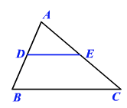
Warm Up:

1. In ∆ABC segment $\overline{DE}$ is the midsegment joining sides $\overline{AB}$ and $\overline{AC}$.

a. What do you know about segments $\overline{DE}$ and $\overline{BC}$?

b. What is the ratio of $\frac{AD}{DB}$ and $\frac{AE}{EC}$?

=====================================================================
In this investigation you will discover a relationship associated with splitting the sides of a triangle. It is a generalization of the theorem you used in the warm up

Part I - Open up GeoGebra and draw a triangle. Label its vertices A, B, and C.
- Follow these steps to draw a line that is parallel to side $\overline{BC}$ of your triangle.
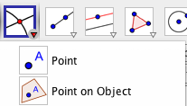
- Use the “Point on Object “ tool to place a point D anywhere on side $\overline{AB}$.
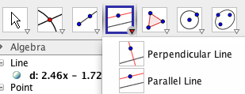
- Use the “Parallel Line” tool to construct a line through D parallel to $\overline{BC}$.

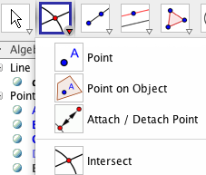
- Use the “Intersect” tool to locate E, the point where the parallel line intersects side $\overline{AC}$.

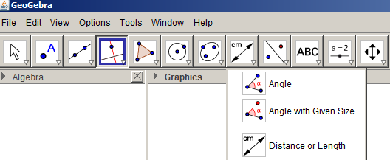
- Line $\overset{⃡}{DE}$ now “splits” two sides of the triangle, $\overline{AC }$and $\overline{AC}$. Measure each segment of the sides that have been split. Use the “Distance or Length” tool

- Your sketch should look something like the one below. Record your side lengths below:
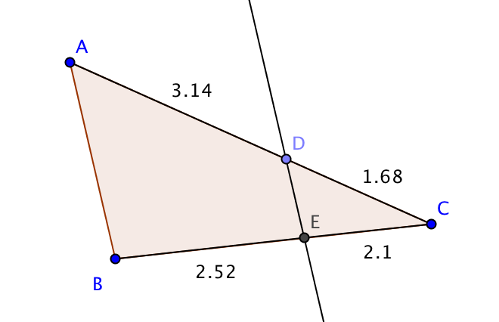
BE = __________
EC = __________
AD = __________
DC = __________

- Find the ratio of segments on each side of the triangle (to the nearest 0.1):
$\frac{BE}{EC}$ = _________ and $\frac{AD}{DC}$= _________

What do you notice?

- Move the line you constructed parallel to $\overline{AB}$ so that your side lengths change. Record your new side lengths below:
BE = __________
EC = __________
AD = __________
DC = __________

- Find the new ratios:
$\frac{BE}{EC}$ = _________ and $\frac{AD}{DC}$= _________
- Compare your results with other students in the class. How are the results similar? How are they different?

- You have just discovered the “side splitting” relationship. In your own words write a conjectiure that describes your discovery.

Part II – Using the side splitting conjecture

- In the triangle below $\overset{⃡}{EF }$is parallel to $\overline{AB}$. Find EC

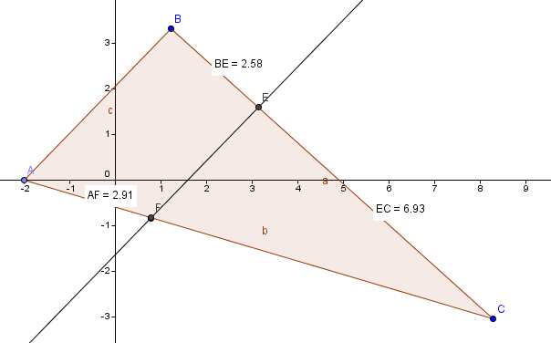

- In the triangle below could $\overset{⃡}{ED}$ be parallel to $\overline{AB}$? Explain your reasoning.
(Assume the given lengths are accurate to the nearest 0.01.)

