Activity 4.3.4 Using Similarity Theorems

1. Given $\overline{NO}||\overline{PQ}$, prove $∆MNO\sim ∆MPR.$ You may use a two column proof format if you choose.

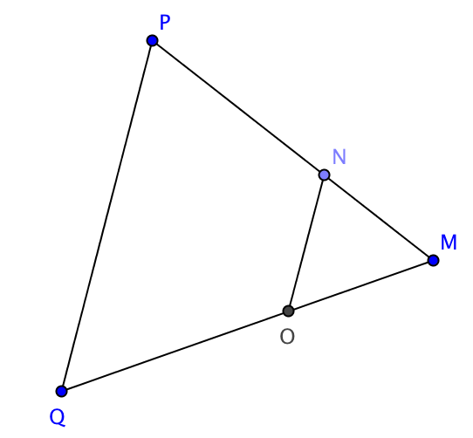
Statements Reasons

2. Given the following lengths, prove $∆HIJ\sim ∆KLJ.$ You may use a two column proof format if you choose. Note: The figure is not drawn to scale.

Statements Reasons

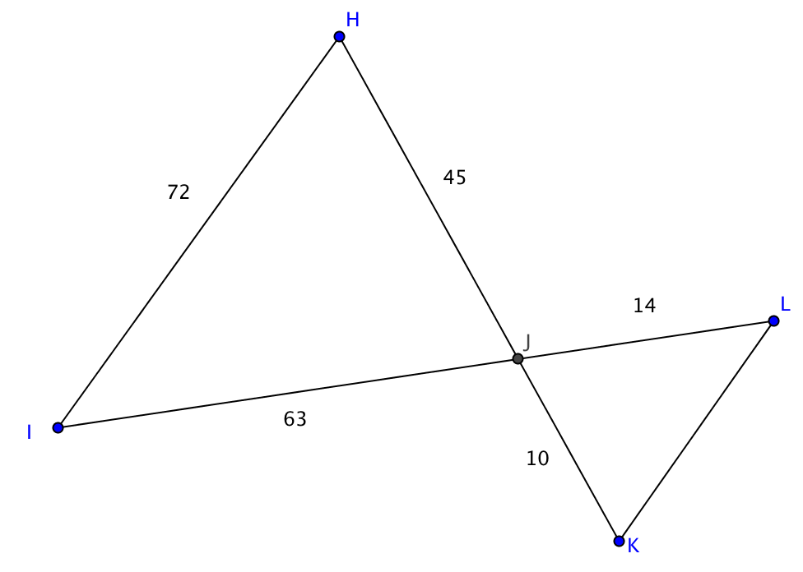

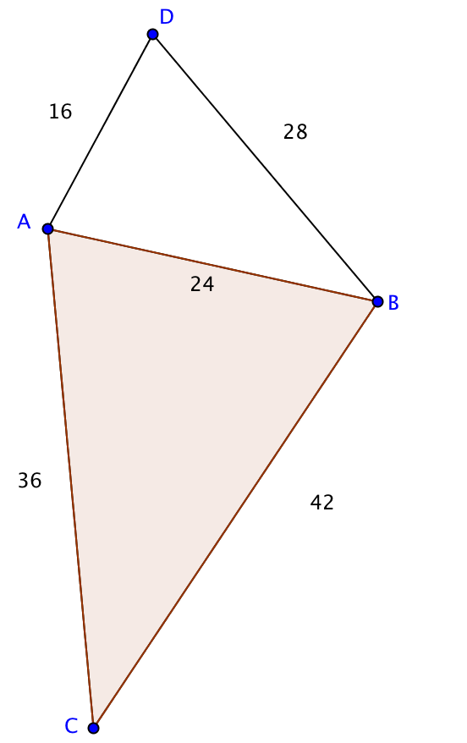
3. Determine if the triangles are similar. Justify your answer. If the triangles are similar, write a similarity statement and indicate the theorem used to prove their similarity.

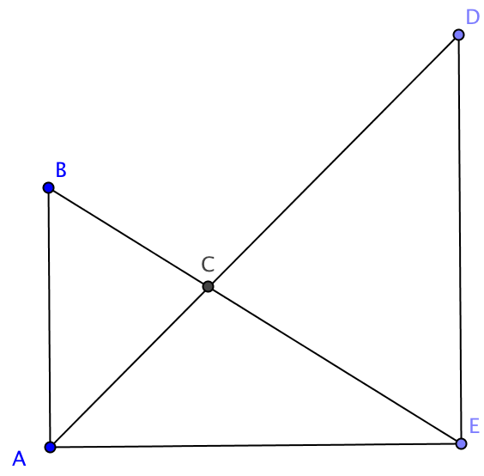
4. Given $\overline{AB}⊥\overline{AE}$, $\overline{AE}⊥\overline{ED,}$ prove $∆ABC\sim ∆DEC.$ You may use a two column proof format if you choose.

Statements Reasons

5. If we know that two triangles are congruent, we can conclude that any pair of corresponding parts (sides or angles) are congruent, often abbreviated CPCTC. With similar triangles we need to make a distinction. We can say that

- Corresponding ________________of similar triangles are congruent.
- Corresponding ________________of similar triangles are proportional.
- Make up abbreviations for the two properties of similar triangles stated in parts (a) and (b).

6. Answer each of these questions based on the similar triangles you found in questions 1 to 4. Justify each conclusion using corresponding parts of similar triangles.

a. In question 1 find another pair of sides that have the same ratio as $\frac{PQ}{NO}$.

Justification:

b. In question 2 find the length of the unmarked side, KL.

Justification:

c. In question 2 which angle in ∆KJL is congruent to $∠$ IHJ?

Justification:

d. In question 3 which angle in ∆ABC is congruent to $∠$ ADB?

Justification:

- In question 4 complete this proportion with the remaining sides of ∆ABC and ∆DEC.
$$\frac{AC}{DC}= \frac{}{}=\frac{}{}$$
Justification:

