Activity 4.3.2 AA & SAS Similarity Theorems
AA Similarity Theorem

Prove the AA Similarity Theorem: If two angles of one triangle are congruent to two angles of another triangle, then the triangles are similar.

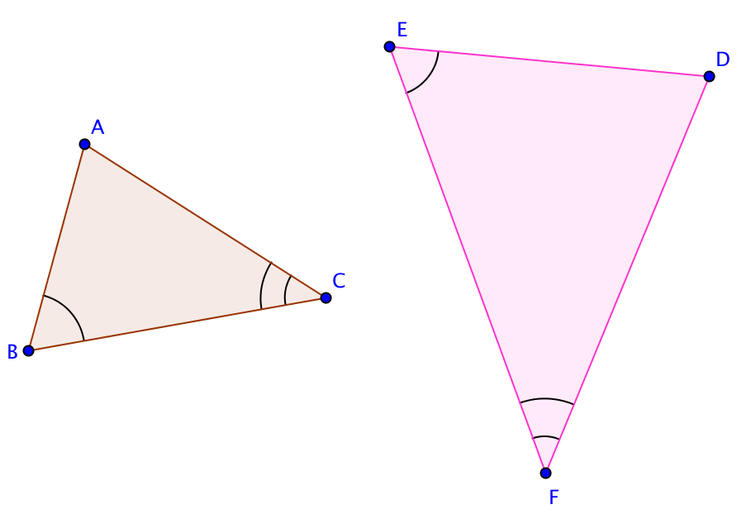
Given: ∆ABC and ∆DEF with m$∠$ACB = m$∠$DFE and m$∠$ABC = m$∠$DEF

Prove ∆ABC$\sim$∆DEF.

1. If C and F do not coincide then translate ∆ABC by the vector from ____ to ____ and name the image ∆A’B’C’. Sketch the translated image.

2. If B’ does not lie on $\overset{⃡}{EF}$, then rotate ∆A’B’C’ about point F or C’
through $∠$______. Name the image ∆A’’B’’C’’. Sketch the rotated image.

3. $\overline{C''B''}$will lie on ____ and $\overline{C^{''}A^{''}}$ will lie on ____ since m$∠$ACB = m$∠$DFE.
4. Since m$∠$A’’B’’C’’ = m$∠$_______ then $_______ ||______$ because when _____________ angles formed by two lines are a transversal are congruent, the two lines are parallel.

5. Dilate ∆A’’B’’C’’ using center point ______ by factor $\frac{}{B"C"}$. Point B’’’ will then coincide with point ____.
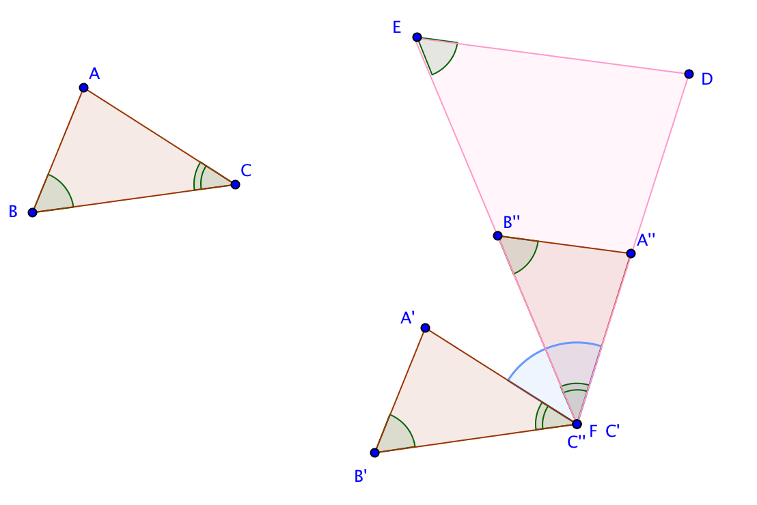

6. By our dilation postulate:

- $\overset{⃡}{B’’’A’’’}$ || $\overset{⃡}{B’'A'’}$(Dilations map a line not through the center onto a parallel line.) Therefore, through point B’’’ (that is, point E) both $\overset{⃡}{ED}$ and $\overset{⃡}{B’’’A’’’}$ are parallel to $\overset{⃡}{B’’A’}$’. Since there is only one line through a given point parallel to a given line, this means that lines _____ and _____ coincide.
- $\overset{⃡}{C’’A’’}$will map onto $\overset{⃡}{C’’'A’’}'$ (Dilations map a line through the center onto itself). Since two lines ($\overset{⃡}{B’’’A’’’}$) and $\overset{⃡}{FA’’’}$ intersect in at most one point. points _____ and ____ coincide.
7. Since ∆A’’’B’’’C’’’ coincides with ∆DEF, ∆DEF is the image of ∆ABC under a _______________ transformation. This means that ∆ABC and ∆DEF are _________________.
This completes the proof.

SAS Similarity Theorem

Prove the SAS Similarity Theorem: If two sides of one triangle are proportional to two sides of another triangle and the angles included by these sides are congruent, then the triangles are similar.
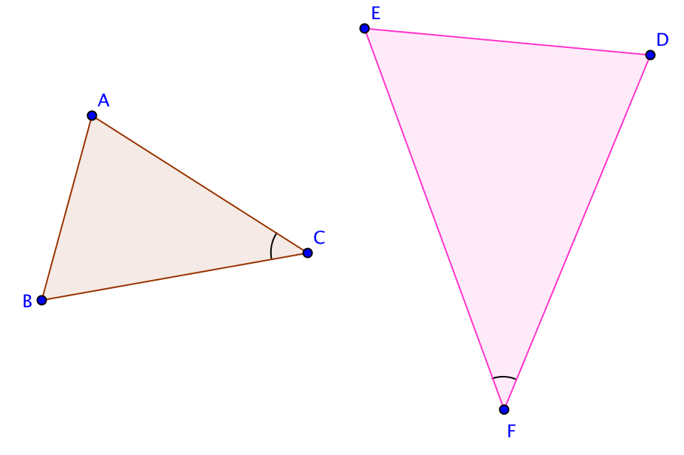

Given ∆ABC and ∆DEF
with m$∠$ACB = m$∠$DFE and $\frac{DF}{AC}=\frac{EF}{BC}$.

Prove ∆ABC$\sim$∆DEF.

1. If Points C and F do not coincide then translate ∆ABC by
the vector from ____ to ____.
Draw the translated image and call it ∆A’B’C’.

2. If ____does not lie on $\overset{⃡}{EF},$then rotate ∆A’B’C’ about point _____ through $∠$______. Draw the image of this rotation and call it ∆A’’B’’C’’.

3. Segment ______ will lie on $\overline{FE}$ and segment _____ will lie on $\overline{FD}$ since m$∠________$ = m$∠$DFE.
4. Dilate ∆_________ using center point F(C’’) by factor $\frac{DF}{A"C"}$. Point A’’’ will then coincide with Point D and since $\frac{}{AC}=\frac{EF}{}$ then Point B’’’ will coincide with Point ______.

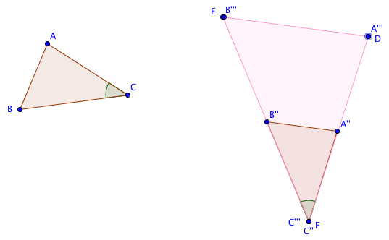

5. Side $\overline{A’’’B’’}$’ must coincide with side $\overline{DE}$ because only _____ ________ may pass through two points.
6. Since ∆DEF is the image of ∆ABC under a _____________ transformation then ∆ABC$\sim$∆DEF. This completes the proof.
7. Suppose after step 2 in either of the above proofs, we had a situation like this:
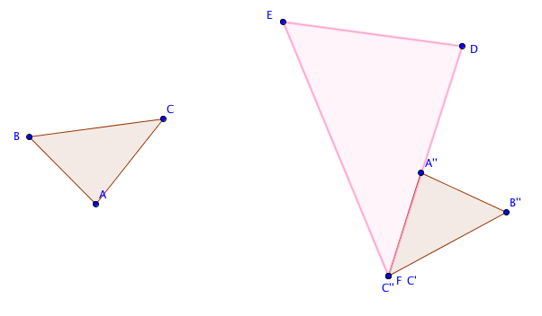

What additional transformation would be needed to complete the proof?

