Activity 4.2.4a Similarity and Circles

- Open the file ctcoregeomACT424.
a. Translate the circle with center A so that the center of its image is at point C.
b. Dilate the translated circle so that the new image has a radius equal to CD.
c. Describe the relationship between the two original circles.

d. In Unit 2 you proved that if two circles have the same radius, then they are congruent. If two circles do not have the same radius, they cannot be congruent, but they are ___________.

- Prove that Circle A with radius r₁ is similar to Circle C with radius r₂. Hint: Use transformations.
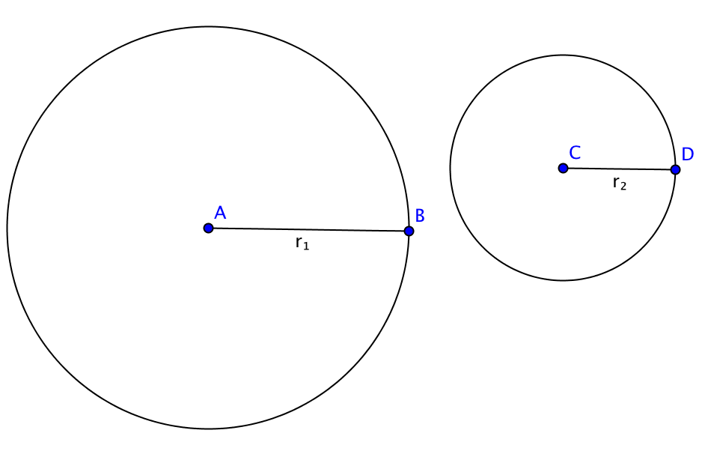

- Would you say that any two circles are similar? Explain.

- Would you say that any two triangles are similar? Explain.

- Are congruent circles also similar circles? Why or why not?

- Recall that $π=\frac{C}{d}$ , where C is the circumference and d is the diameter of a circle. Explain why $π$ is the same for all circles.

