Activity 4.2.3 Corresponding Parts of Similar Polygons

- Find the center of dilation in the figure below.
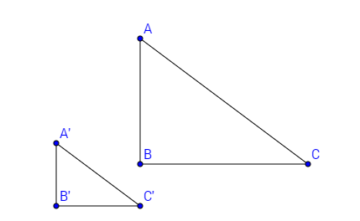

2. In order for the two figures to be similar, corresponding angles must be congruent.
Measure the angles and show that the corresponding angles are congruent.

$$m∠A=$$ | $$m∠A'=$$
$$m∠B=$$ | $$m∠B'=$$
$$m∠C=$$ | $$m∠C'=$$

3. In order for two figures to be similar, their corresponding sides must be in proportion.
Find the lengths of the sides and show that corresponding sides in proportion.

Pre-image | Image | Image  Pre-image
$$AB=$$ | $$A'B'=$$
$$BC=$$ | $$B'C'=$$
$$CA=$$ | $$C'A'=$$

4. The value of the$\frac{image}{pre-image}$ found above is called the _______________ __________________ of a dilation.
5. Summarize what you know about similarity. Similar figures have:

- ________________________________________________________ AND
- _________________________________________________________
6. Explain how you can tell that the figures below are similar.

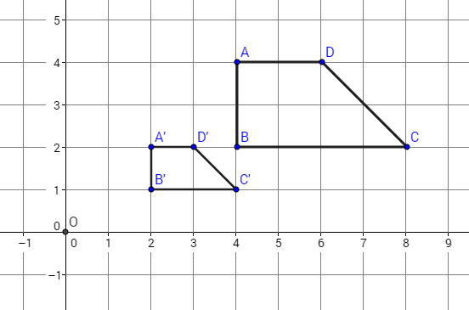

7. If P is the center of the dilation below, AB = 12 and DE = 20, find the scale factor.
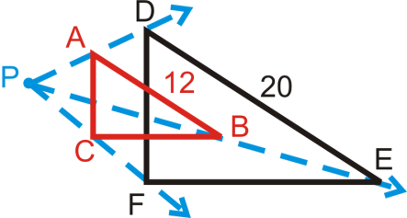

- If the scale factor of the figure below is, k=¹/₃, and the three side lengths of the pre-image are given, find the missing side lengths of the second triangle.

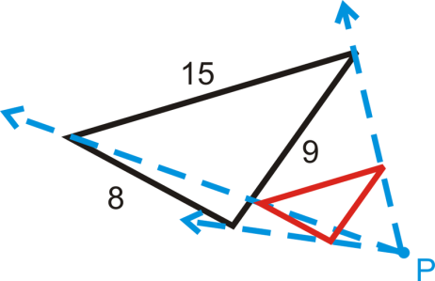

9. Are the triangles below similar? Explain.

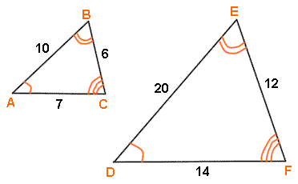

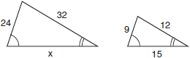
10. The accompanying diagram shows two similar triangles.

Which proportion could be used to solve for x?

1) | $\frac{x}{9}=\frac{24}{15}$
2) | $$\frac{24}{15}=\frac{9}{x}$$
3) | $$\frac{32}{12}=\frac{x}{15}$$
4) | $$\frac{32}{15}=\frac{12}{x}$$

Explain your choice.

11. Rebecca says that if two triangles are congruent, then they must be similar. Lemar disagrees. He says that pairs of triangles can be congruent or similar but not both. What do you think? Explain your reasoning.

