Activity 3.7.3 Tessellating Triangles

Show that any triangle may tile the plane.

- Pick three points and create ∆ABC.
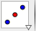
- Find the midpoint of side $\overline{BC}$.
(You may use Geogebra’s shortcut with the midpoint or center tool.)
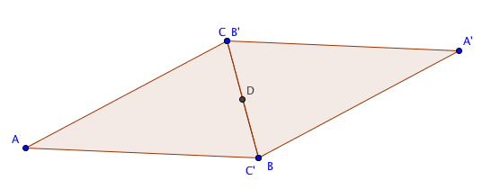
- Rotate ∆ABC by 180° around the midpoint.
- The two triangles now form what special quadrilateral? _______________________

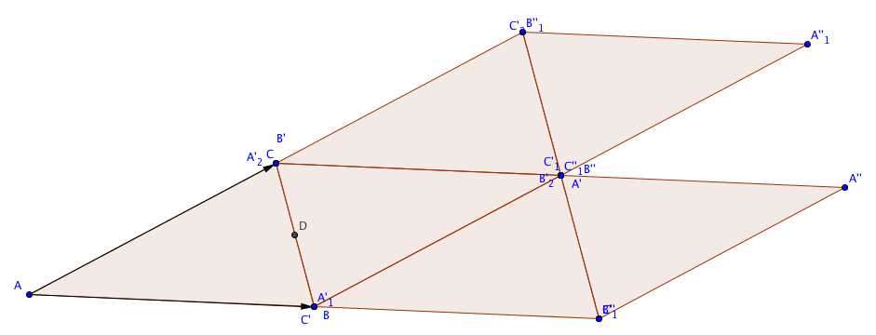
- Translate the two triangles with the vector from A to B.
- Translate the same two triangles with the vector from A to C.
- Keep translating until you have at least 12 copies of the original triangle.
- Will you be able to continue filling the plane with copies of the triangle? Explain your reasoning.
- How many triangles are there at each vertex?
- What is the sum of the angles at each vertex?
- Now change the shape of ∆ABC and observe what happens.
- Which types of triangles will tile the plane?
a. acute triangles
b. right triangles
c. obtuse triangles
d. all of the above
Chose a, b, c, or d and explain your choice.

