Activity 3.6.4 Converses of Quadrilateral Theorems

In Activity 3.6.3 it was shown that quadrilaterals may be represented by variable coordinates. This allows us to prove theorems in general using coordinate methods.

Recall the coordinate representations for Quadrilateral, Trapezoid, Parallelogram, and Rectangle.
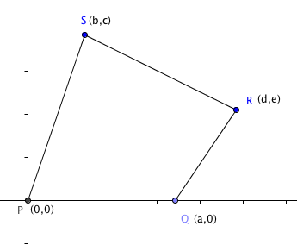
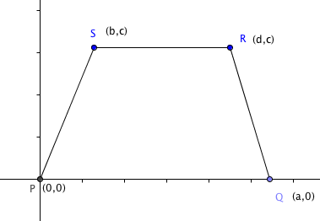

Quadrilateral with vertices Trapezoid with vertices
P(0,0), Q(a,0), R(d,e) and S(b,c) P(0,0), Q(a,0), R(d,c) and S(b,c)
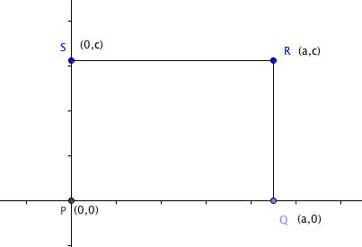
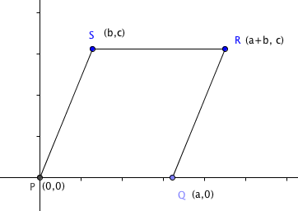
Parallelogram with vertices Rectangle with vertices
P(0,0), Q(a,0), R(a + b, c) and S(b,c) P(0,0), Q(a,0), R(a,c) and S(0,c)

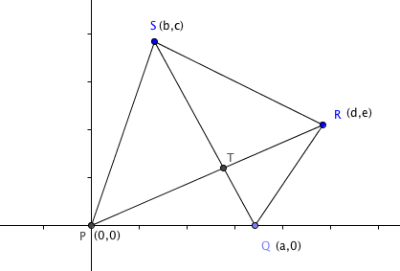
1. Prove the Parallelogram Diagonals Converse: If the diagonals of a quadrilateral bisect each other, then the quadrilateral is a parallelogram.

Given: Quadrilateral PQRS with T the midpoint of both diagonals $\overline{PR}$ and $\overline{QS}$.
Prove: PQRS is a parallelogram.

Proof: Because T is the midpoint of $\overline{PR}$ its coordinates are ( ____, _____)
Because T is the midpoint of $\overline{QS}$its coordinates are ( ____, _____)
Because the y-coordinates are equal, we have e = _______
Because the x-coordinates are equal we have d = _______
The coordinates of PQRS are P(0, 0) Q(a,0), R(___, ___), and S(b, c)
Therefore, PQRS is a ___________________________.
2. Prove the One Pair Congruent and Parallel Theorem: If one pair of sides of a quadrilateral are congruent and parallel, then the quadrilateral is a parallelogram.

Given: Quadrilateral PQRS with $\overline{PQ}$ || $\overline{RS }$and PQ = RS
Prove: PQRS is a parallelogram.

Proof: The slope of $\overline{PQ}$ = _____________
The slope of $\overline{RS }$ =
Because the slopes of parallel lines are the same this means that e – c = _______
Therefore e = _______

Use the distance formula to find PQ = _______ and RS = ___________.
Because PQ = RS we can solve for d in terms of a and b. Show how in the space below:
(Hint: Assume a > 0 and d > b.)

The coordinates of PQRS are P(0, 0) Q(a,0), R(___, ___), and S(b, c)
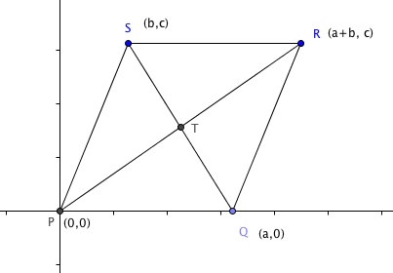
Therefore, PQRS is a ___________________________.

3. Prove the Rectangle Diagonals Converse: If the diagonals of a parallelogram are congruent, then the parallelogram is a rectangle.

Given: Parallelogram PQRS with PR = QS.
Prove: PQRS is a rectangle.

Proof: Using the distance formula we find PR = _______________and QS = _______________.

Now show that b = 0.

The coordinates of PQRS are P(0, 0) Q(a,0), R(___, ___), and S(___, ___)
Therefore, PQRS is a ___________________________.
4. Prove the Rhombus Diagonals Converse: If the diagonals of a parallelogram are perpendicular, then the parallelogram is a rhombus.
Given: Parallelogram PQRS with $\overline{PR}$ $⊥$ $\overline{QS}$.
Prove: PQRS is a rhombus.

Hint 1: In order show that PQRS is a rhombus we need to show that PQ = QR = RS = SP. This means that we will need to show that ${____}^{2}=b^{2}+c^{2}$.

Hint 2: Find the slopes of $\overline{PR}$ and $\overline{QS}$. Since the slopes of perpendicular lines are opposite reciprocals, their product = ______. Use this fact to get the result you need from Hint 1.

Now write a proof in the space below:

