Activity 3.6.3 Quadrilaterals in Standard Position
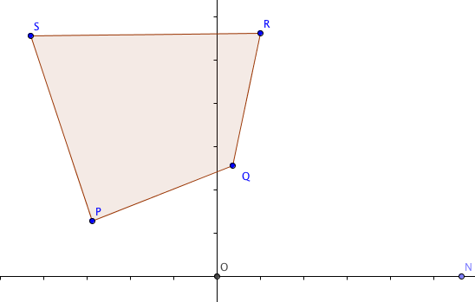
Do this part of the activity with Geogebra.

1. Pick any four points P, Q, R, and S that are the vertices of a convex quadrilateral. Try to make it so that no pairs of sides are parallel or congruent.

- Use the Polygon tool to form quadrilateral PQRS.

- Label the origin, (0,0), as point O.

- Label a point on the positive x-axis as point N.
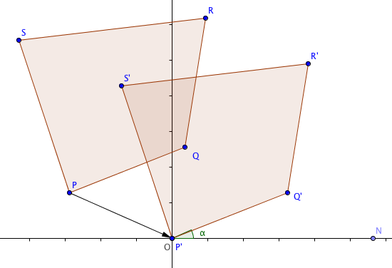

- Translate PQRS by the vector from P to O.

- Measure the angle $∠$QON.

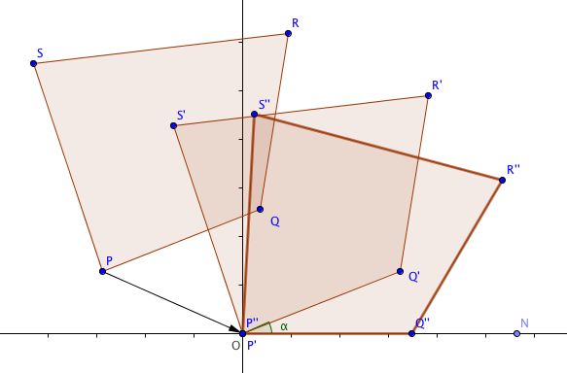
- Rotate P’Q’R’S’ by m $∠$ QON so that Q” lies on the positive x-axis. (Your rotation may be either clockwise or counter-clockwise, so think carefully which one you want.)

- Write the coordinates of P’’Q’’R’’S’’ in the space below.
P’’(___,___), Q’’(___,___), R’’(___,___),and S’’(___,___).
Through translation and rotation, any quadrilateral may be represented with these coordinates: P(0,0), Q(a, 0), R(d,e), and S(b,c).
- For your quadrilateral P’’Q’’R’’S’’ find the values of these five variables:
a = _________ b = __________ c = _________ d = ___________ e = __________
- Hide quadrilaterals PQRS and P’Q’R’S’ so that only P’’Q’’R’’S’’ is visible.

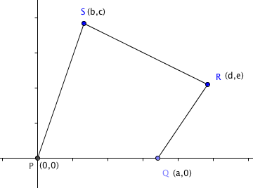
Special Quadrilaterals

As we have seen, every quadrilateral may be represented with five variables: a, b, c, d, and e. These variables appear in the coordinates of the vertices: P(0,0), Q(a, 0), R(d,e), and S(b,c).

Special quadrilaterals require fewer variables as the following exercises demonstrate:
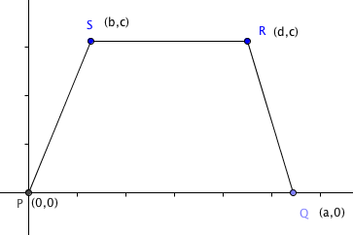
2. Suppose e = c.
Then the quadrilateral is P(0,0), Q(a, 0), R(d,c), and S(b,c).
Show that this quadrilateral must be a trapezoid.

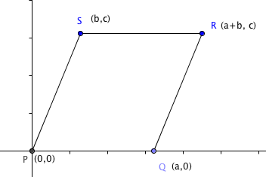

3. Suppose e = c and d = a + b.
Then the trapezoid is P(0,0), Q(a, 0), R(a + b, c), and S(b,c).
Show that this trapezoid must be a parallelogram.

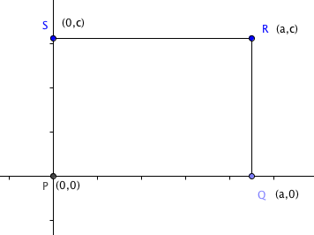
4. Suppose e = c, d = a + b, and b = 0.
Then the parallelogram is P(0,0), Q(a, 0), R(a, c), and S(0,c).
Show that this parallelogram must be a rectangle.

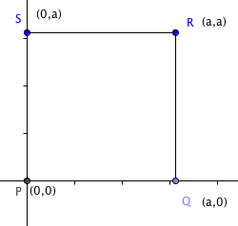
5. Suppose e = c, d = a + b, b = 0, and c = a.
Then the rectangle is P(0,0), Q(a, 0), R(a, a), and S(0,a).
Show that this rectangle must be a square.

