Activity 3.5.2b Diagonals of Quadrilaterals with Geogebra

Your teacher will assign you to a group with one or two of the following quadrilaterals: Quadrilateral, Trapezoid, Isosceles Trapezoid, Parallelogram, Kite, Rhombus, Rectangle, and Square. My group is assigned to study _____________________.

1. If the diagonals of a quadrilateral bisect each other, then the two diagonals intersect at their ___________________.

2. If the diagonals of a quadrilateral are perpendicular, then they intersect at a _______ degree angle.

3. Open the Geogebra file(s) for your quadrilateral(s). Use Geogebra to make necessary measurements to investigate whether each of the following properties are always true: diagonals are congruent, diagonals are perpendicular, diagonals bisect each other. Justify with measurements from Geogebra. Drag the vertices to make new quadrilaterals and observe what properties stay the same. Sketch at least three different versions of your quadrilateral(s) with measurements.

4. Assign one person from your group to be the rotator. When your teacher says to rotate, the rotator from each group will move to another group. During this time, explain what you learned with the new group member(s). Place a check mark in the appropriate box if the quadrilateral has the property. You will keep rotating until your chart is completed. Then return to your original group.
 | Congruent Diagonals | Perpendicular Diagonals | Diagonals Bisect Each Other
Quadrilateral
Trapezoid
Isosceles Trapezoid
Kite
Parallelogram
Rhombus
Rectangle
Square

5. Which quadrilaterals have congruent diagonals?

6. Which quadrilaterals have perpendicular diagonals?

7. Which quadrilaterals have diagonals that bisect each other?

8. Which quadrilaterals have diagonals that are perpendicular bisectors of each other?

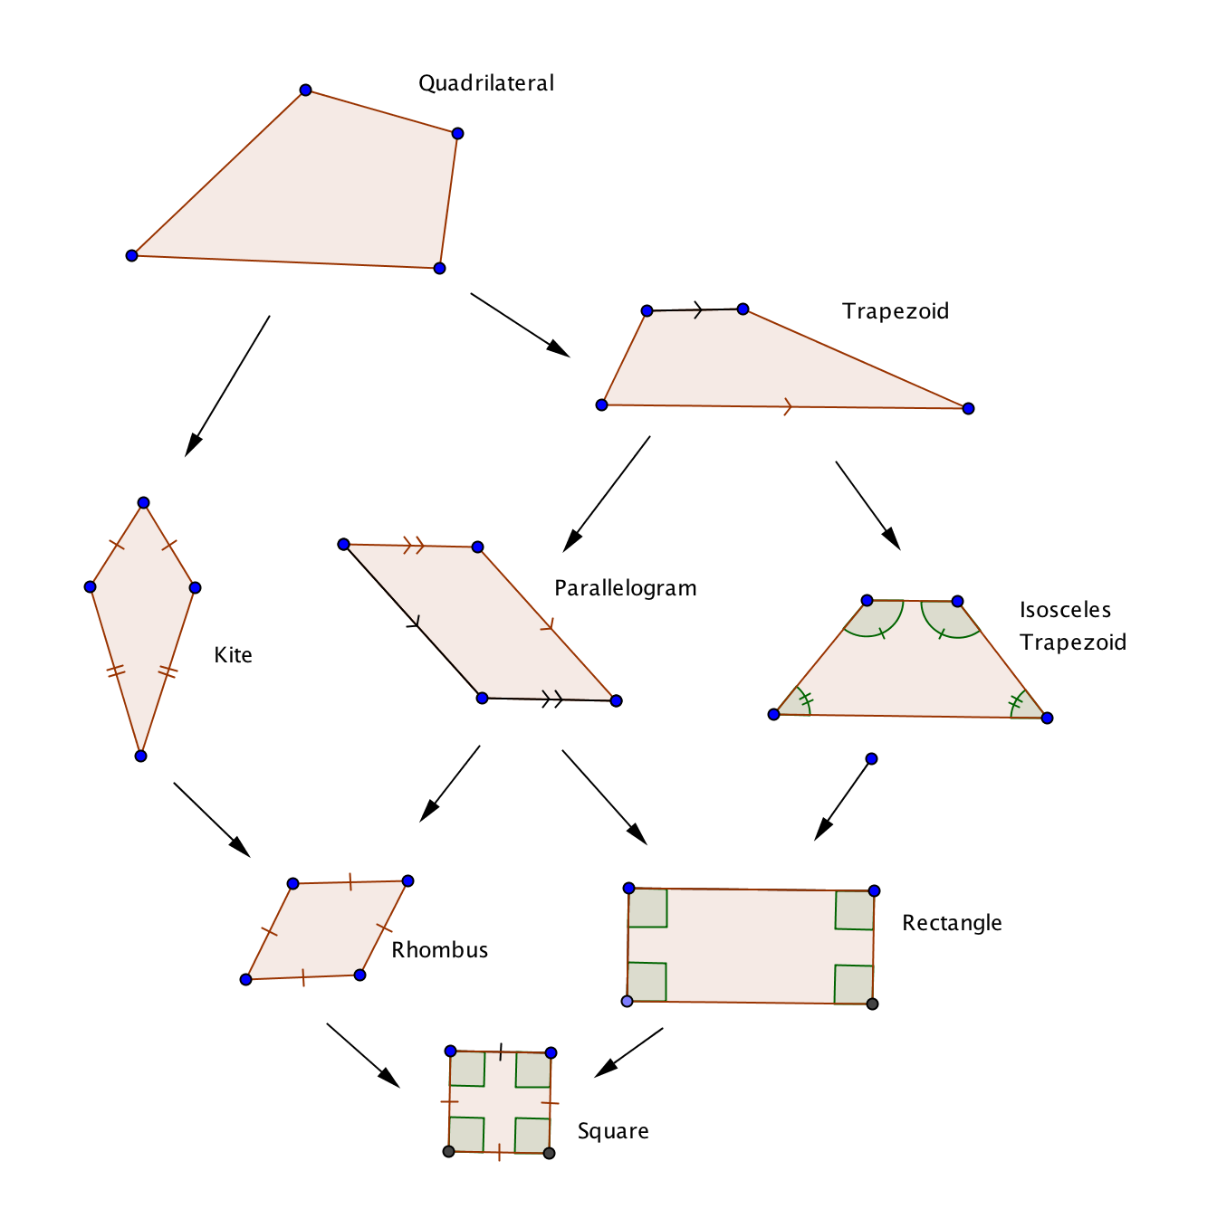
9. For each quadrilateral in the hierarchy, draw the diagonals and include any and all congruent or perpendicular markings and write the properties below. Remember that the quadrilaterals at the bottom of the hierarchy should have more properties than the quadrilaterals above them.

10. Answer the following with “Always,” “Sometimes,” or “Never.”
a. If a quadrilateral is a rhombus, then the diagonals are ____________ perpendicular.
b. If a quadrilateral is a parallelogram, then the diagonals are ____________ congruent.
c. If a quadrilateral is a kite, then the diagonals _______________ bisect each other.
d. If a quadrilateral is an isosceles trapezoid, then the diagonals are _____________ congruent.
e. If a quadrilateral is rhombus, then the diagonals are ___________ perpendicular bisectors of each other.

