Activity 3.5.2a Diagonals of Quadrilaterals

Use these 12 quadrilaterals for this activity (same as Activity 3.5.1). Write the most specific name of each inside the quadrilateral. Your teacher will assign you to a group with one or two of the following quadrilaterals: Quadrilateral, Trapezoid, Isosceles Trapezoid, Parallelogram, Kite, Rhombus, Rectangle, and Square. My group’s assigned quadrilateral is ___________________. Cut out the quadrilateral(s) that are labeled with your group name. Draw both diagonals with a ruler.

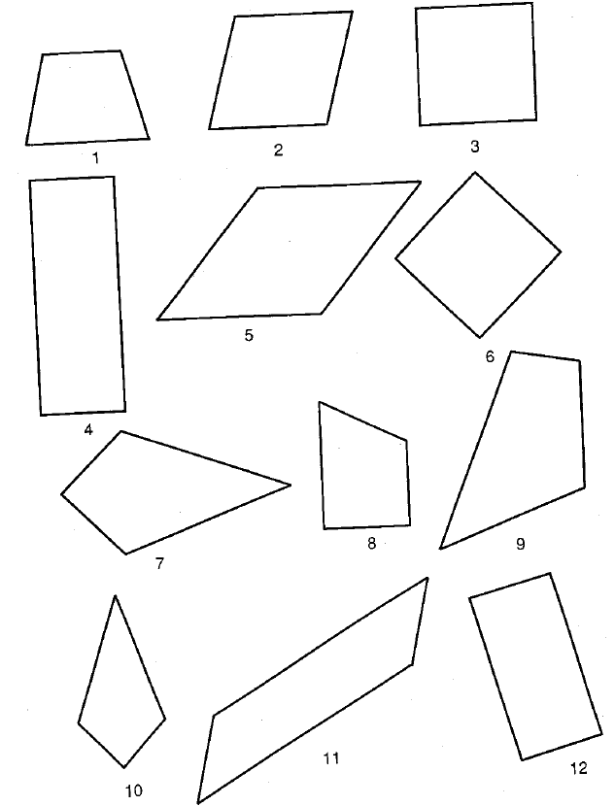

This page left intentionally blank.
You may tear off the first page to use when answering questions on page 3.

1. Investigate which of the following properties are always true about your quadrilateral(s). Place a check mark in the appropriate box if the quadrilateral has the property.
 | Congruent Diagonals | Perpendicular Diagonals | Diagonals Bisect Each Other
Quadrilateral
Trapezoid
Isosceles Trapezoid
Kite
Parallelogram
Rhombus
Rectangle
Square

2. Assign one person from your group to be the rotator. When your teacher says to rotate, the rotator from each group will move to another group. During this time, explain what you learned with the new group member(s). Fill in the chart with the information that you learned. You will keep rotating until your chart is completed. Then return to your original group.

3. Which quadrilaterals have congruent diagonals?

4. Which quadrilaterals have perpendicular diagonals?

5. Which quadrilaterals have diagonals that bisect each other?

6. For each quadrilateral in the hierarchy, draw the diagonals and include any and all congruent or perpendicular markings and write the properties below. Remember that the quadrilaterals at the bottom of the hierarchy should have more properties than the quadrilaterals above them.
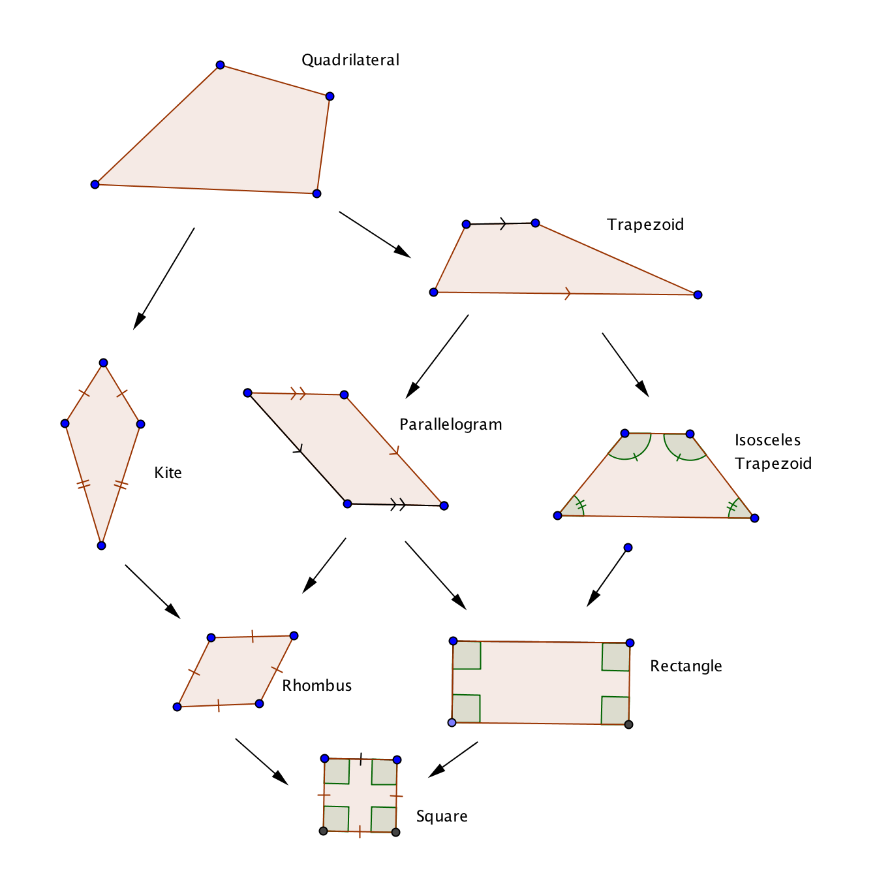

7. Answer the following with “Always,” “Sometimes,” or “Never.”
a. If a quadrilateral is a rhombus, then the diagonals are ____________________ perpendicular.
b. If a quadrilateral is a parallelogram, then the diagonals are ________________ congruent.
c. If a quadrilateral is a kite, then the diagonals __________________ bisect each other.
d. If a quadrilateral is an isosceles trapezoid, then the diagonals are ______________ congruent.
e. If a quadrilateral is rhombus, then the diagonals are _____________ perpendicular bisectors of each other.

