Activity 3.4.2 Angles in Regular Polygons

Angles in a Regular Polygon Conjecture: In a regular polygon the measure of each interior angle is _________

Below are an equilateral triangle and a square. Find the measure of each angle in these regular polygons.

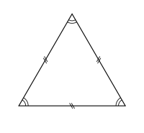 | 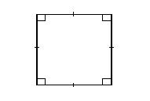
Sum of interior angles:  Measure of each interior angle: | Sum of interior angles:  Measure of each interior angle:

What do you notice?

Recall that the sum of all interior angle measures in a regular polygon with n sides is (n – 2)180°. Also, notice that all of the interior angles in a regular polygon have the same measure. Then we could find the measure of each interior angle by taking the interior angle sum and dividing by the number angles: $\frac{\left(n-2\right)180°}{n}$.

Similarly, recall that the sum of all exterior angle measures of a regular polygon with n sides is 360°. Then we could find the measure of each exterior angle by taking the exterior angle sum and dividing by the number angles: $\frac{360°}{n}$.

Complete the table below:
Polygon | Number of sides  n | Interior angle sum | Measure of each interior angle | Measure of each exterior angle
Triangle
Quadrilateral
Pentagon
Hexagon
n-gon

Angles in a Regular Polygon Theorem: In a regular polygon the measure of each interior angle is $\frac{\left(n-2\right)180°}{n}$ and the measure of each exterior angle is $\frac{360°}{n}$.

Practice Problem:
The Cherokee People originally inhabited the southern Appalachian mountain region of North Carolina, Tennessee, and Georgia. Their society was organized into 7 clans. Their council houses had seven sections, one for each clan to sit in. The council house was built in the shape of a regular heptagon. Find the measure of each interior angle and the measure of each exterior angle.
