Activity 3.3.5 Proofs with Parallel Lines

In each example, a figure is drawn with some information on the figure. Following will be some statements that can be either proved valid or disproved.

For this activity, the class should be divided into groups of 3 students. For each example, Student A will select a statement, Student B will try to prove or disprove the statement. Student C will offer suggestions to assist Student B. Once all of the statements in the example are completed, the students should switch roles. Each student will have an opportunity to be Student A, B and C.

- Use the figure below to prove or disprove the following statements
  - $\overline{AB} ǁ \overline{DC}$
  - ABDC is a trapezoid
  - Given that $m∠C=124°,$ABDC is an isosceles trapezoid

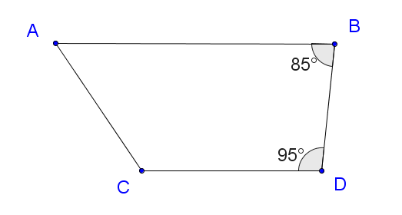

- Use the figure below to prove or disprove the following statements
  - Is there a value for x such that $\overline{FG} ǁ \overline{EH}$? What is that value?
  - Is there a value for y such that $\overline{EF} ǁ \overline{GH}$? What is that value?
  - Can $\overline{FG} ǁ \overline{EH}$ and $\overline{EF} ǁ \overline{GH}$ at the same time?

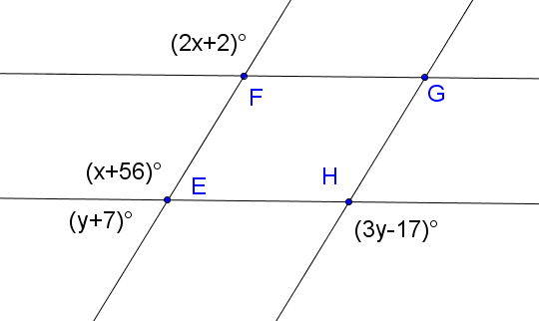

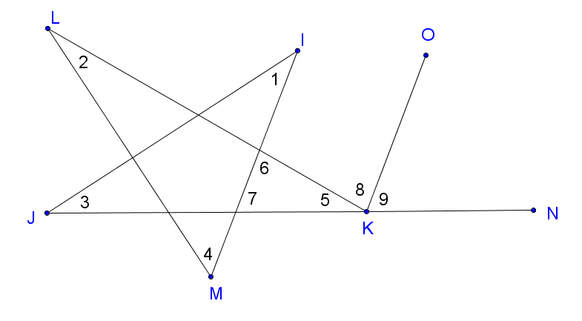
- Use the figure below to answer the questions. It is given that $\overline{IM} ǁ \overline{OK}$
  - How can $m∠6$ be re-written as in terms of other angles in the diagram?
  - How can $m∠7$ be re-written as in terms of other angles in the diagram?
  - How can $m∠8$ be re-written as in terms of other angles in the diagram?
  - How can $m∠9$ be re-written as in terms of other angles in the diagram?
  - What can this diagram be used to prove? (HINT: We have already proved this to be true in this course!!)

