Activity 3.3.4b Constructing Parallel Lines

Our goal is to create parallel lines using a straight edge and a compass. We are given only a line m and a point P. We will create a line parallel to line m through point P. Try this construction on another sheet of paper or on the computer.

Note: If you use GeoGebra, it is easier to draw complete circles rather than arcs. If you use a compass and straightedge, you may prefer to draw only an arc that passes through or locates the named points.
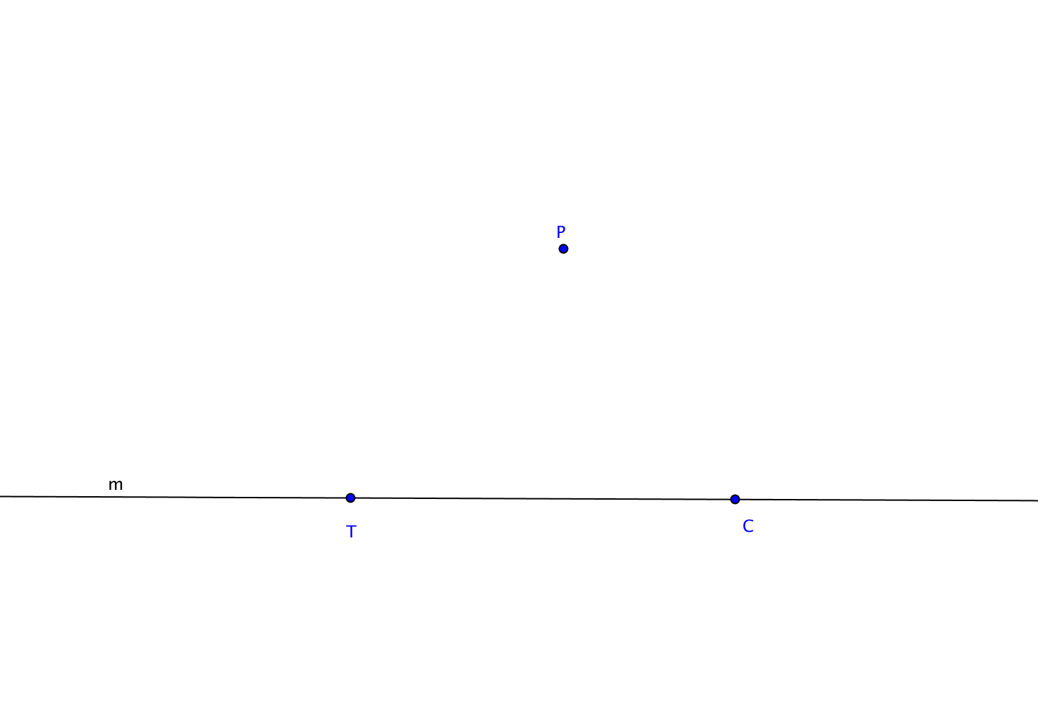
- Given line m and point P.

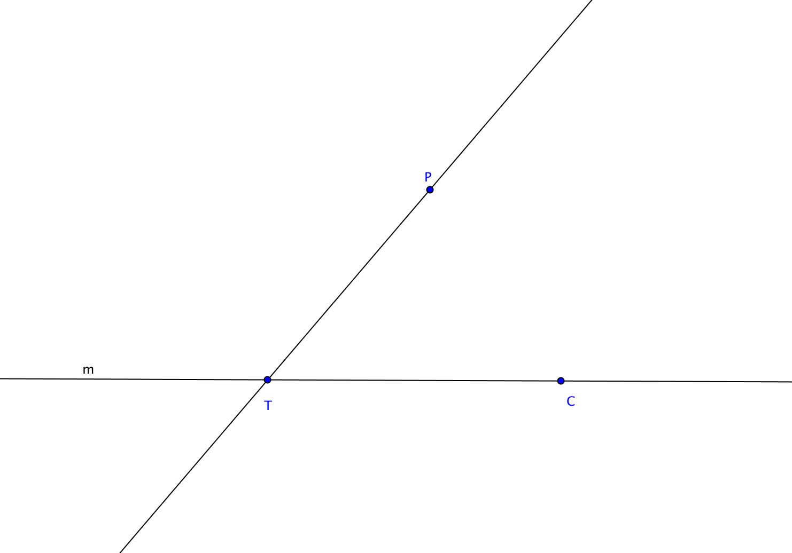
- Choose any point T on line m. Draw line $\overset{⃡}{TP}$. Let C be another point on m.

- Now construct an angle congruent to $∠PTC$ with P as its vertex and one side along $\vec{TP}$. (Review Activity 2.7.8 for the specific steps.)
- Prove that your construction produces a line parallel to line m through point P.

