Activity 3.3.3. Proving Lines are Parallel

We have already proved (in activity 3.3.2) that if two lines cut by a transversal form congruent corresponding angles, then the two lines are parallel. We will now use this fact to prove the converses of two other theorems about parallel lines.

- Parallel Lines Alternate Interior Angles Converse
Given: $m∠2=m∠3$

Prove: $AB ǁ DC$

.

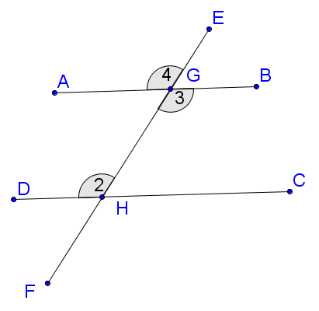

- Parallel Lines Same Side Interior Angles Converse
Given: $∠2 and ∠5$ are supplementary

Prove: $AB ǁ DC$

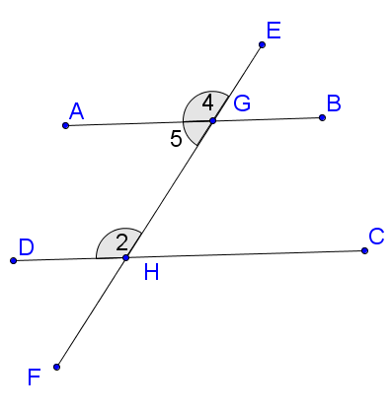

- Given: $RU= RQ$ and $∠RUQ≅∠TSQ$

Prove: $RQ ǁ ST$

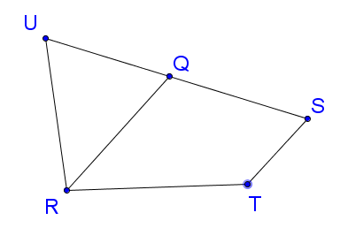

- Given: $VY= WX$ and $VW= YX$

Prove: $VY ǁ WX$

