Activity 3.2.2 Parallel Lines Corresponding Angles Converse

1. Prove the Parallel Lines Corresponding Angles Converse: If two lines are cut by a transversal and a pair of corresponding angles are congruent, then the lines are parallel. Fill in the blanks.

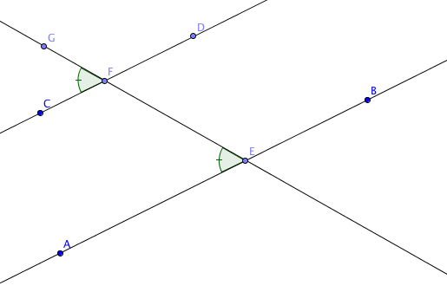
Given: Transversal $\overset{⃡}{EF}$ intersects lines $\overset{⃡}{AB}$ and $\overset{⃡}{CD}$ at points E and F.

m $∠$ CFG = m $∠$ AEF.

Prove: $\overset{⃡}{AB}$ || $\overset{⃡}{CD}$

Proof:

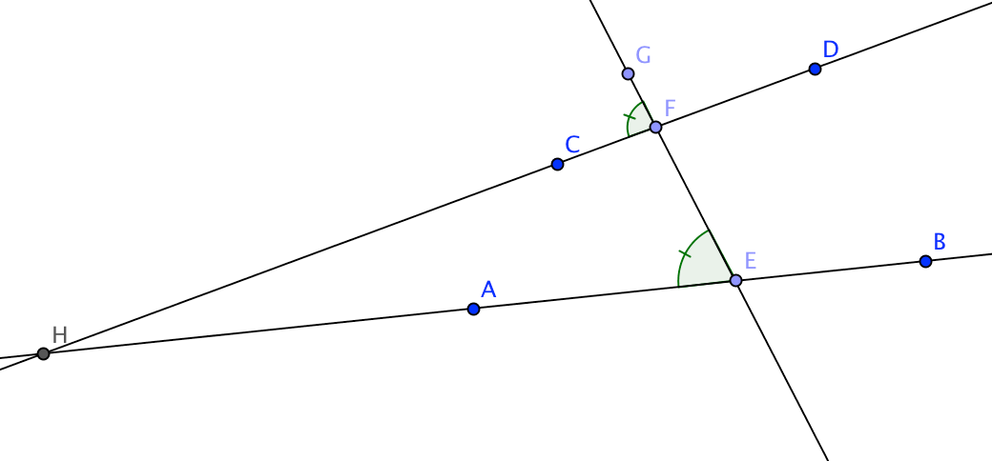
$\overset{⃡}{AB}$ and $\overset{⃡}{CD}$ either intersect or they are parallel.

Why? __________________________

Suppose $\overset{⃡}{AB}$ and $\overset{⃡}{CD}$ intersect at a point we will call “H.”

Then E, F, and H are the vertices of a triangle.

In ∆EFH, $∠$ HEF is an_____________ angle. (Note: $∠$ HEF is another name for $∠$ AEF)
and $∠$ HFG is an _________ angle. (Note: $∠$ HFG is another name for $∠$ CFG)

We were given that m $∠$ HEF = m _________________________.

Why is this a problem? ________________________________________

What conclusion can you draw? _____________________________________

2. Prove: If two lines are perpendicular to the same line, then they are parallel.

Complete this two-column proof.
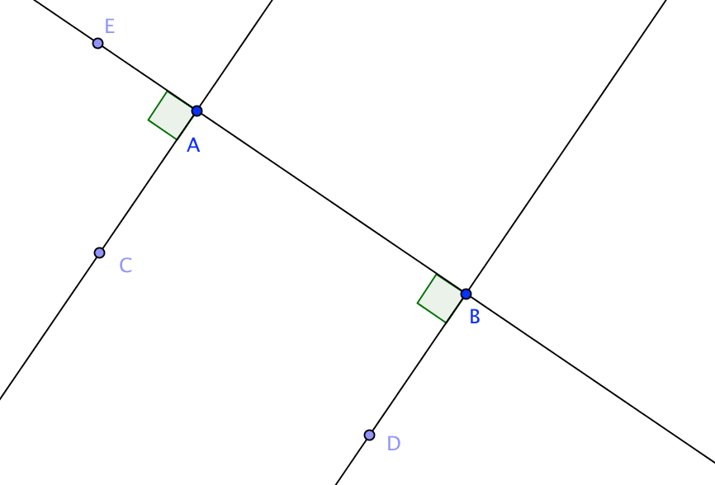

Given:

$\overset{⃡}{CA}$ is perpendicular to $\overset{⃡}{AB}$

$\overset{⃡}{DB}$ is perpendicular to $\overset{⃡}{AB}$

Prove:

$\overset{⃡}{CA}$ is parallel to $\overset{⃡}{DB}$

Proof:

Statement Reason

1. $\overset{⃡}{CA}$ is perpendicular to $\overset{⃡}{AB}$ 1. ___________________

2. m $∠$ CAE = 90° 2. ___________________

3. $\overset{⃡}{DB}$ is perpendicular to $\overset{⃡}{AB}$ 3. ___________________

4. m $∠$ DBA = 90° 4. ___________________

5. m $∠$ CAE = m $∠$ _________ 5. ___________________

6. _______________________________ 6. ___________________

