Activity 3.2.5 Possible or Impossible?

Determine whether each triangle is possible or impossible to occur. Circle the appropriate word. Then, state your reasons using vocabulary and/or theorems from the unit to support your answer.

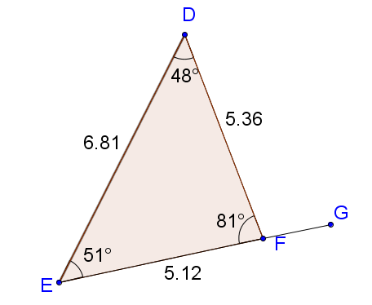
- Possible / Impossible
Reason: ___________________________
___________________________________
___________________________________
___________________________________
___________________________________
___________________________________

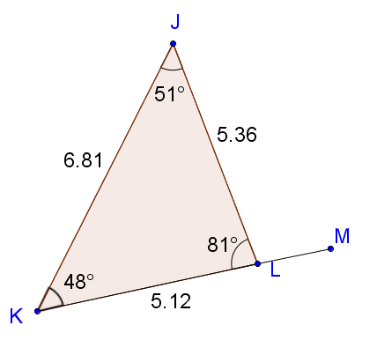
- Possible / Impossible
Reason: ___________________________
___________________________________
___________________________________
___________________________________
___________________________________
___________________________________

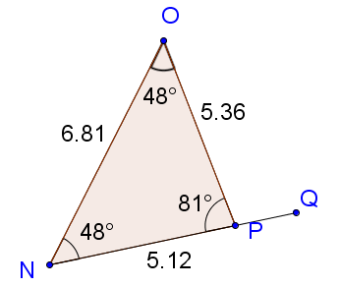
- Possible / Impossible
Reason: ___________________________
___________________________________
___________________________________
___________________________________
___________________________________
___________________________________

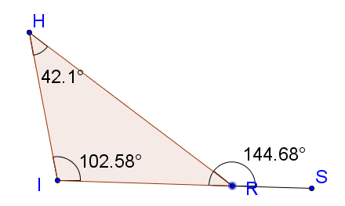
- Possible / Impossible
Reason: ____________________________
___________________________________
___________________________________
___________________________________
___________________________________
___________________________________

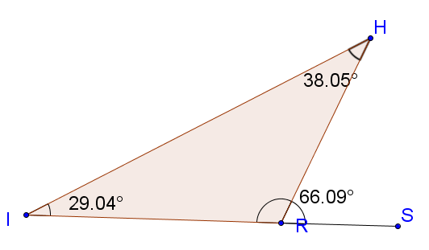
- Possible / Impossible
Reason: ____________________
____________________________
____________________________
____________________________
____________________________
____________________________

- Possible / Impossible
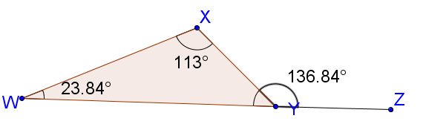
Reason: _____________________
____________________________
____________________________
____________________________
____________________________
____________________________

