Activity 3.2.4 The Triangle Inequality Theorem

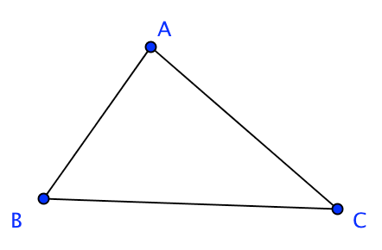
Study the proof and answer all questions in bold.

Prove the Triangle Inequality Theorem: The sum of the lengths of any two sides of a triangle is greater than the third side.

Given ∆ABC.

Prove: (1) BA + AC > BC
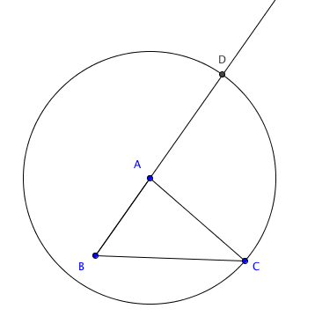
(2) AB + BC > AC
(3) BC + CA > BA

We will prove (1) since the proofs of (2) and (3) would be similar.

Step 1. Construct a circle with center A passing though point C.

The circle will intersect line $\overset{⃡}{BA}$ in how many points?

______________________________________________

Let D be the point where this circle intersects ray $\overset{⃑}{BA}$ with point A between B and D.
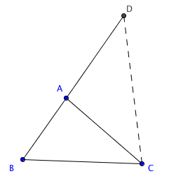

Step 2. Join points C and D.

Explain why AD = AC _________________________

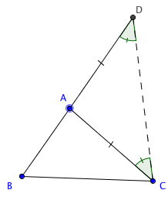
Step 3. In ∆ADC m$∠$ADC = m $∠$DCA.

What theorem is used here? ____________________________

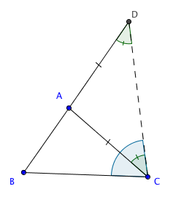
Step 4. m $∠$DCB > m $∠$DCA. Why?_________________

Therefore, m $∠$DCB > m $∠$ ADC. Why? ________________

(Notice that $∠$BDC is another name for $∠$ADC.)

Step 5. In ∆BCD we have m$∠$DCB > m $∠$ BDC.

Therefore BD > BC .

What theorem is used here? ____________________________

Step 6. BD = BA + AD = BA + AC.

Explain _________________________________________________________________

Step 7. From Steps 5 and 6 we conclude that BA + AD > BC.

Explain ___________________________________________________________________

