Activity 3.2.3 Sides and Angles in a Triangle

Study the two proofs and answer all questions in bold.
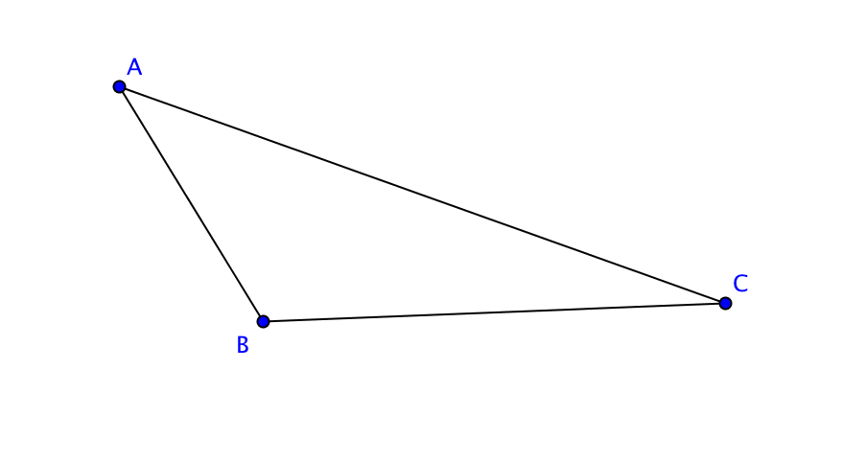
I. Prove the Angle Opposite Longer Side Theorem: If two sides of a triangle are not equal, the angle opposite the longer side is greater than the angle opposite the shorter side.

Given: ∆ABC with AC > AB.
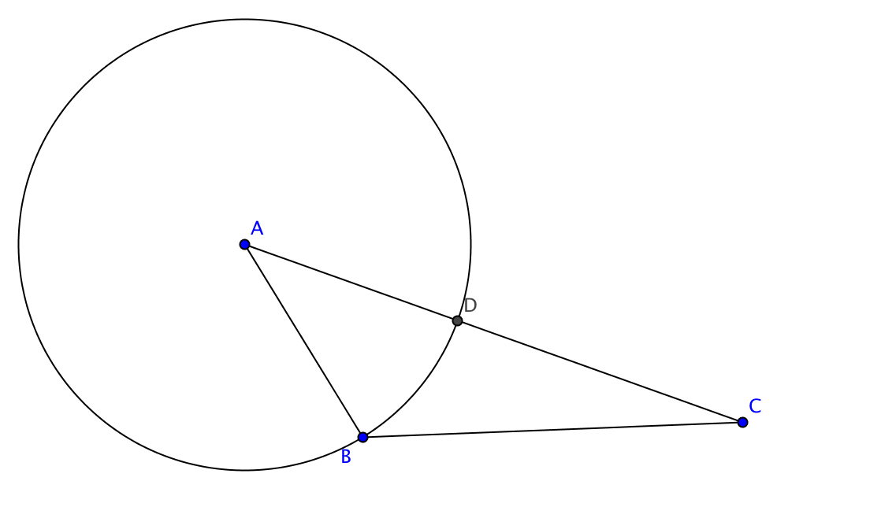
Prove: m $∠$ABC > m $∠$ BCA

Step 1. Construct a circle with center A passing through point B. Let D be the point where the circle intersects side AC.

How can we be sure that point D lies between points A and C?

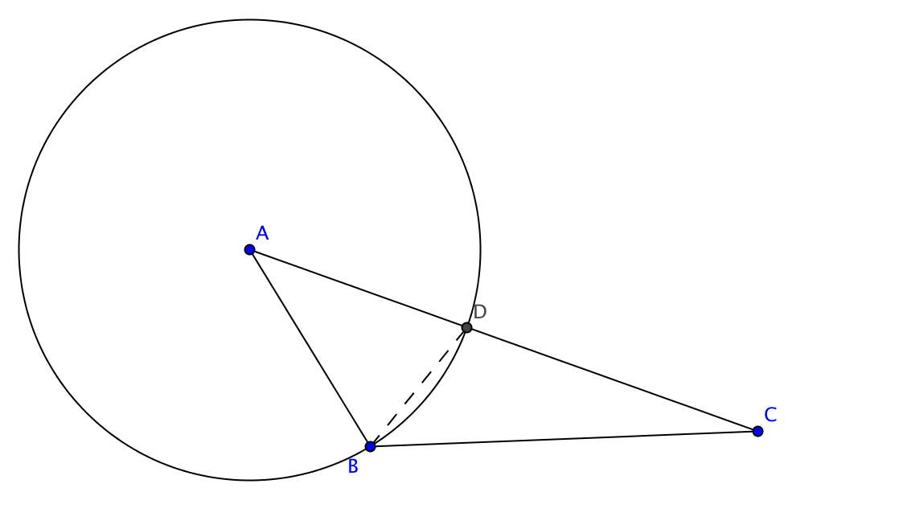

Step 2. Join points B and D.

Step 3. In ∆BDC exterior angle ADB is greater than interior angle BCA.

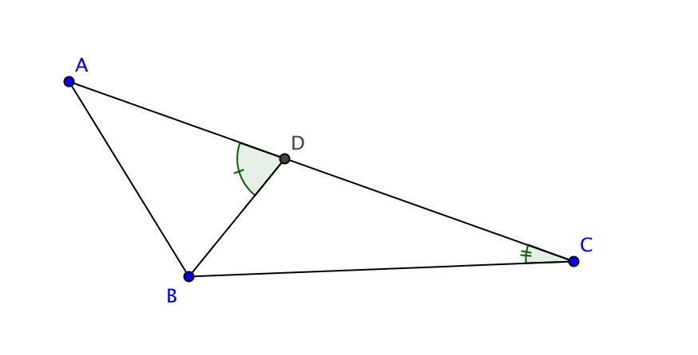
What theorem are we using here?

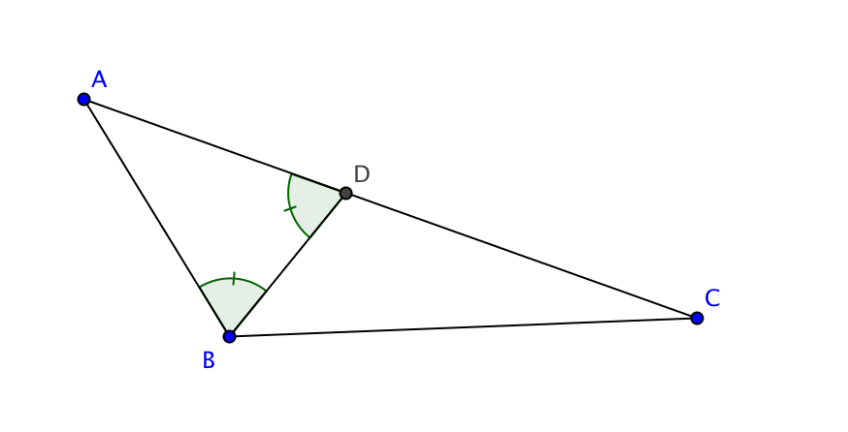
Step 4. AB = AD

Why?

Therefore m $∠$ADB $=$ m $∠$ ABD

What theorem are we using here?

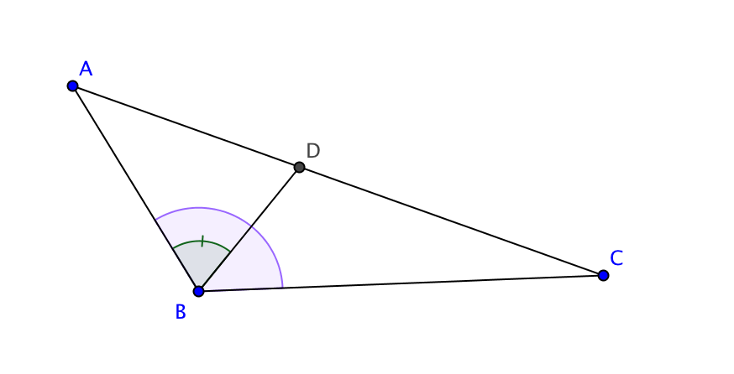
Step 5. m $∠$ ABC > m $∠$ ABD.

Explain.

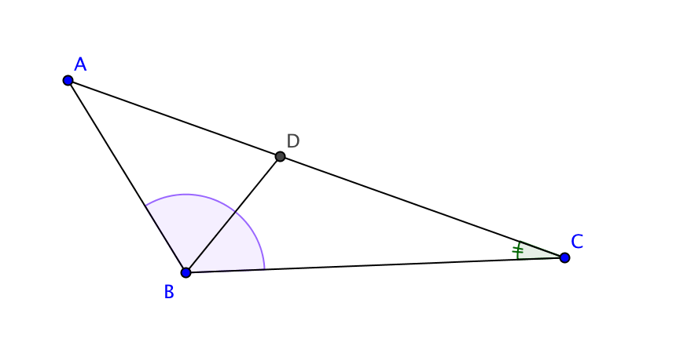
Step 6. Putting it all together we have
m $∠$ ABC > m $∠$ ABD = m $∠$ ADB > m $∠$ BCA

So that leads to what conclusion?

2. Prove the Side Opposite Greater Angle Theorem: If two angles of a triangle are not equal, the side opposite the larger angle is longer than the side opposite the smaller angle.
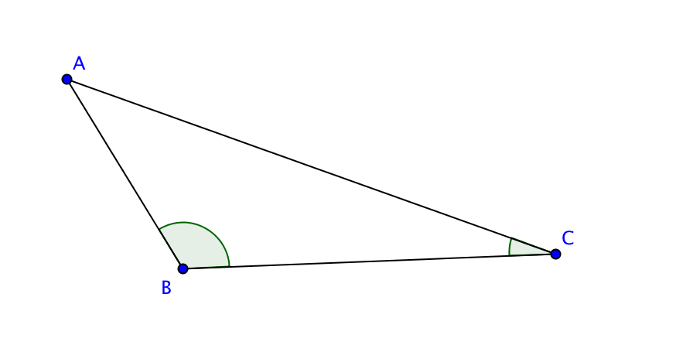

Given: ∆ABC with m $∠$ABC > m $∠$ BCA

Prove: AC > AB.

Step 1. Suppose AC = AB.

Then what could you conclude about m $∠$ABC and m $∠$BCA?

What theorem would lead to this conclusion?

Why is this impossible?

Step 2. Suppose AC < AB.

Then what could you conclude about m $∠$ABC and m $∠$BCA?

What theorem would lead to this conclusion?

Why is this impossible?

Step 3. If we know that AC cannot be equal to AB and that AC cannot be less than AB, what alternative is left?

Explain.

