Activity 3.2.1b Discovering Inequalities in Triangles

Use your protractor and ruler to measure the angles and side lengths of the following triangles. Fill in the table above each triangle. Once you are finished measuring all four triangles, review your data. What relationships do you notice about the lengths of the sides in comparison to the angles in the triangles? Is there any relationship you notice regarding the three side lengths?

SIDES (in mm) |  | ANGLES
a |  | A
b |  | B
c |  | C
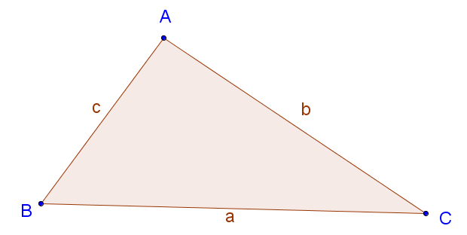

SIDES (in mm) |  | ANGLES
a |  | A
b |  | B
c |  | C

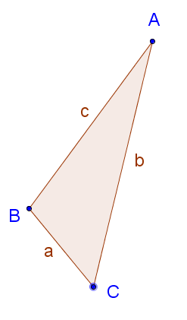

SIDES (in mm) |  | ANGLES
a |  | A
b |  | B
c |  | C

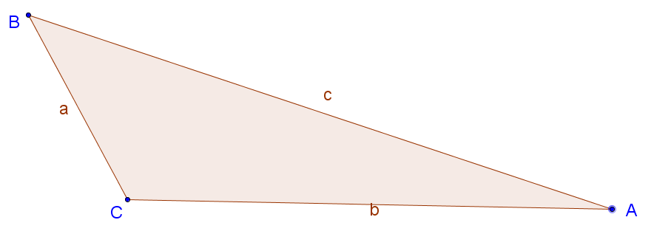

SIDES (in mm) |  | ANGLES
a |  | A
b |  | B
c |  | C
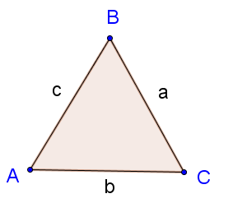

CONJECTURE TIME

- What do you notice about relationships between the side lengths and the angles?

- Ask a friend: Turn to your neighbor and write down their answer to question 5.

- Are you and your neighbor in agreement? If not, try to resolve any differences.

- What do you notice about the lengths of the three sides? Do you see any relationships or patterns?

- Ask a friend: Turn to your neighbor and write down their answer to question 8.

- Are you and your neighbor in agreement? If not, try to resolve any differences.

- Combine your thoughts from your answers to questions 5 and 6 to make a final conjecture.

- Combine your thoughts from your answers to questions 8 and 9 to make a final conjecture.

Room for Notes from class discussion on conjectures (answers to questions 11 and 12).

