Activity 3.2.1a Discovering Inequalities in Triangles

Use your protractor and ruler to measure the angles and side lengths of the following triangles. Fill in the table above each triangle. Once you are finished measuring all four triangles, review your data. What relationships do you notice about the lengths of the sides in comparison to the angles in the triangles? Is there any relationship you notice regarding the three side lengths?

SIDES (in mm) |  | ANGLES
a |  | A
b |  | B
c |  | C
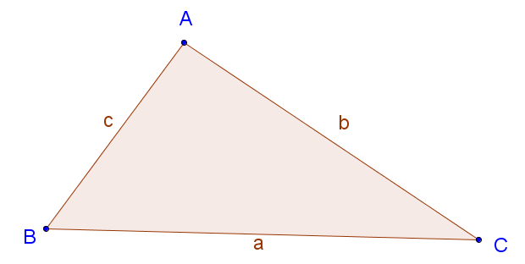

SIDES (in mm) |  | ANGLES
a |  | A
b |  | B
c |  | C

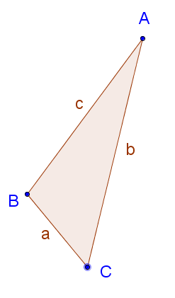

SIDES (in mm) |  | ANGLES
a |  | A
b |  | B
c |  | C

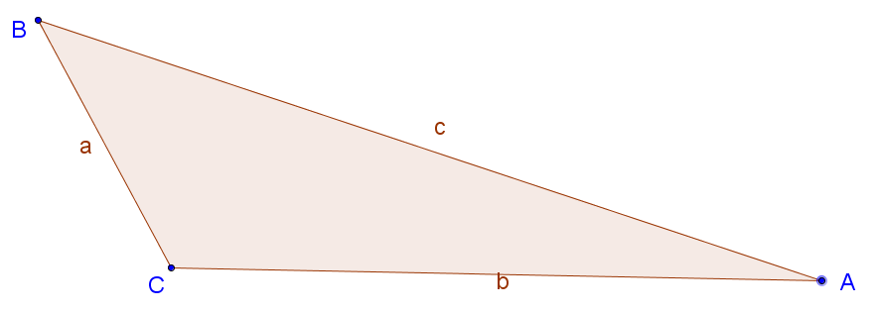

SIDES (in mm) |  | ANGLES
a |  | A
b |  | B
c |  | C
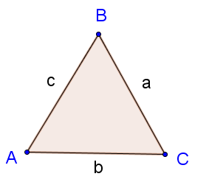

CONJECTURE TIME

- a. In each triangle, find the longest side and the largest angle. What do you notice?
b. Now find the shortest side and the smallest angle in each triangle. What do you notice?

- Ask a friend: Turn to your neighbor and write down their answers to question 5.

- Are you and your neighbor in agreement? If not, try to resolve any differences.

- In each triangle, find the sum of the lengths of the two shorter sides. Compare this sum to the length of the larger side. What do you notice?

- Ask a friend: Turn to your neighbor and write down their answer to question 8.

- Are you and your neighbor in agreement? If not, try to resolve any differences.

- Combine your thoughts from your answers to questions 5 and 6 to make a final conjecture.

- Combine your thoughts from your answers to questions 8 and 9 to make a final conjecture.

Room for Notes from class discussion on conjectures (answers to questions 11 and 12).

