Activity 3.1.3b Proving the Quadrilateral Sum Theorem
Quadrilateral Sum Theorem: The sum of the interior angle measures in any quadrilateral is 360°.

Given: ABCD is a quadrilateral

Prove: $m∠A+m∠B+m∠C+m∠D=360°$

Draw diagonal $\overline{AC}$. We can do this because _____________________________.
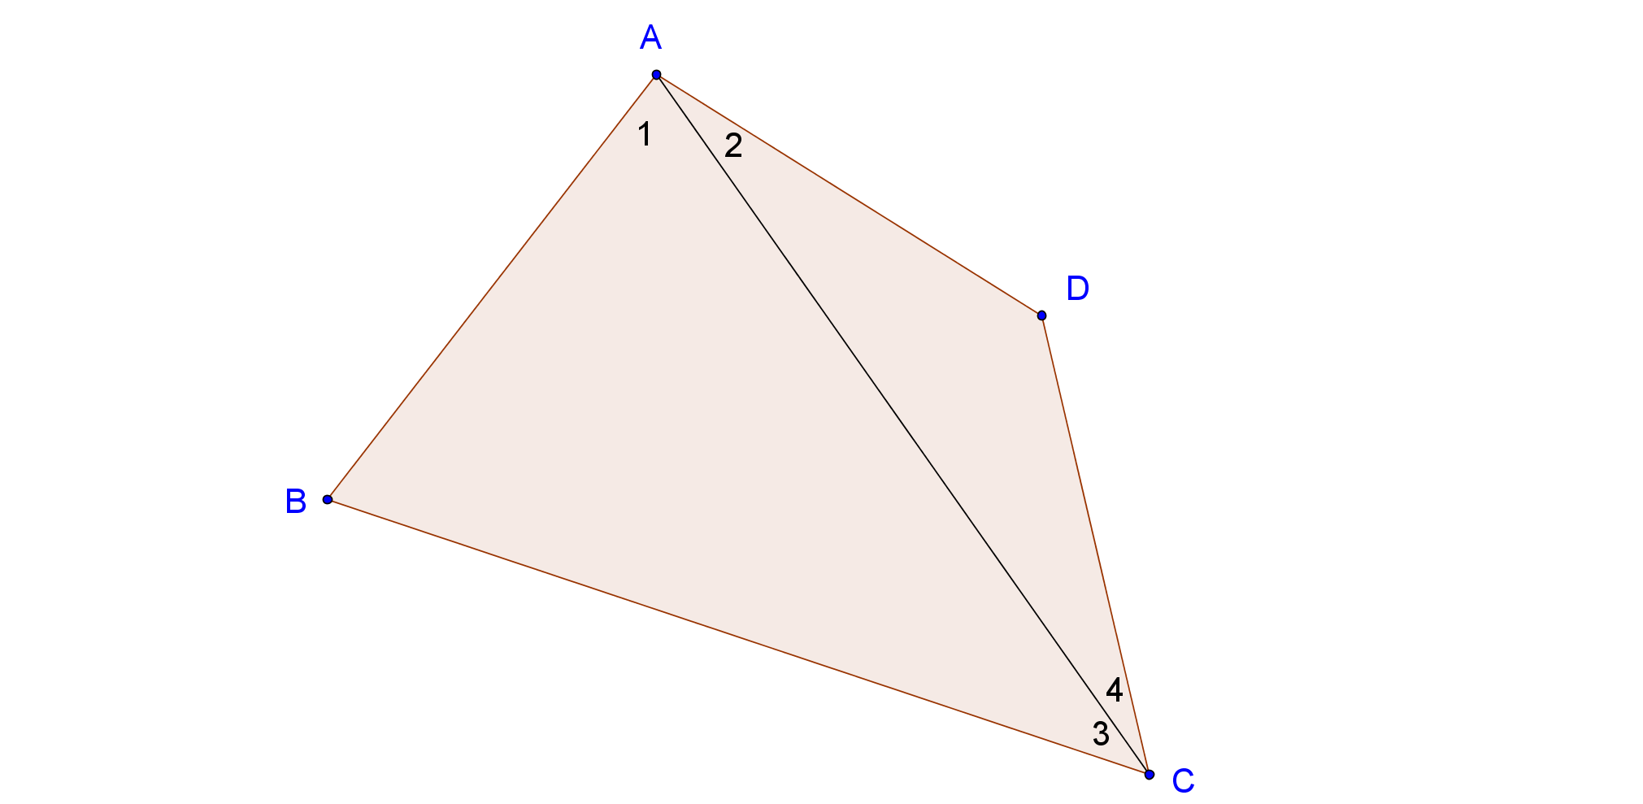

Now complete the proof using your knowledge of the triangle angle sum theorem and the above diagram to assist you.

