Activity 3.1.3a Proving the Quadrilateral Sum Theorem

Fill in the blanks for the proof of the Quadrilateral Sum Theorem.
Quadrilateral Sum Theorem: The sum of the interior angle measures in any quadrilateral is 360°.
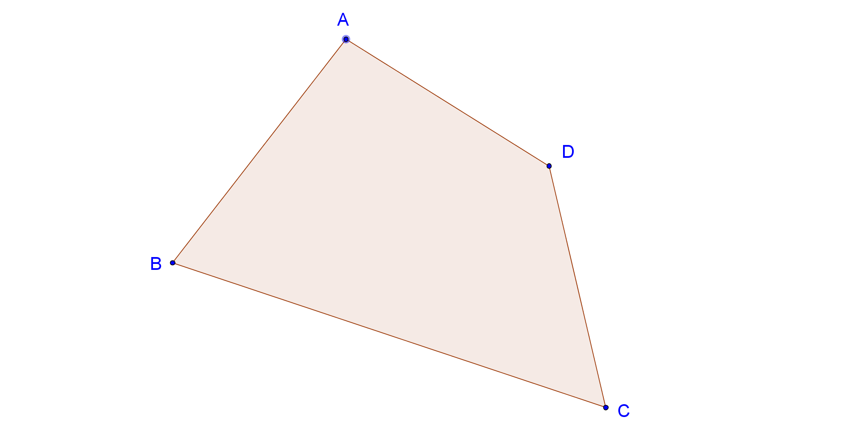
Given: ABCD is a quadrilateral

Prove: $m∠A+m∠B+m∠C+m∠D=360°$

Draw diagonal $\overline{AC}$. We can do this because _______________________________________

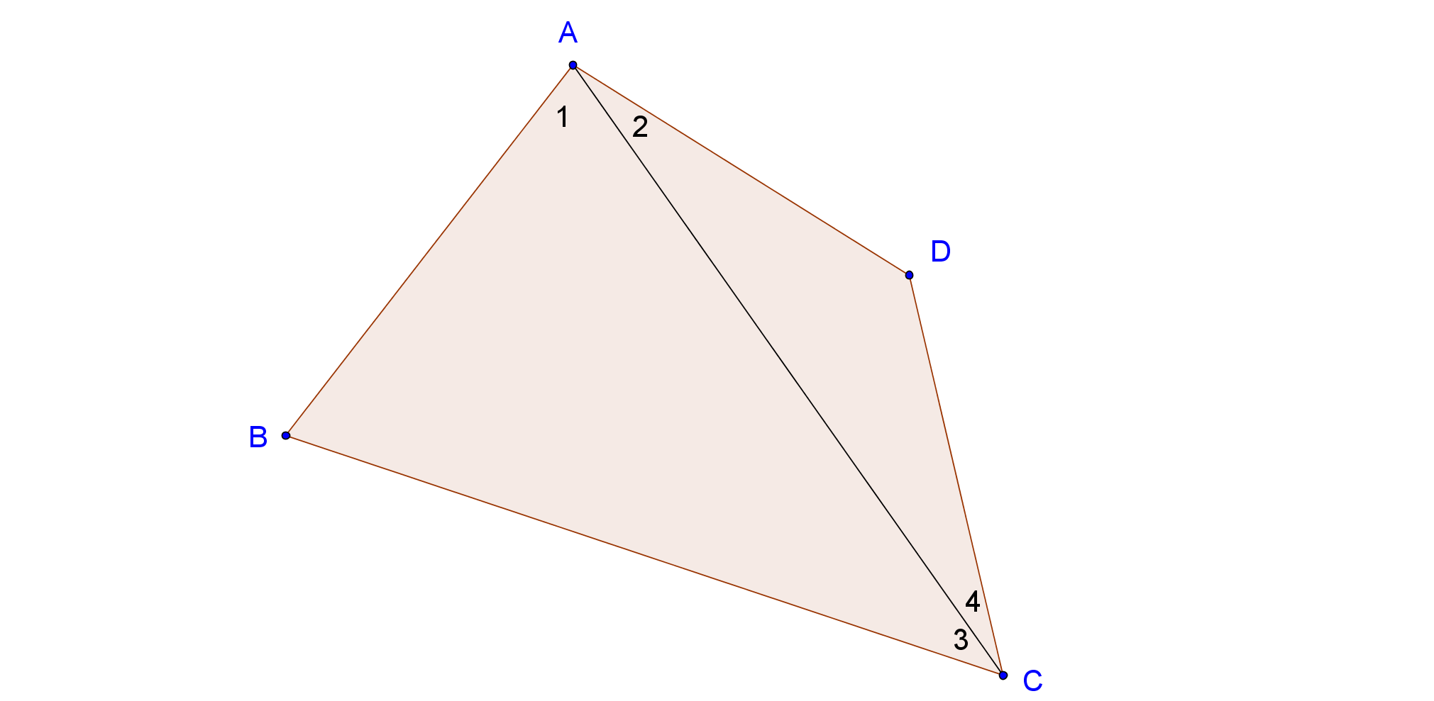

$m∠B+m∠1+m∠3= ______°$. We know this because __________________________.
$m∠D+m∠2+m∠4= ______°$. We know this because __________________________.
$m∠B+m∠1+m∠3+m∠D+m∠2+m∠4= ______°$. We know this because _________________________.
$m∠1+m∠2=m∠______$, because ____________________
$m∠3+m∠4=m∠______$, because ____________________
$m∠B+m∠D+m∠BAD+m∠BCD=______°$, because __________________

