Activity 3.1.1 Sums of Interior Angles of Triangles and Quadrilaterals

Triangle Angle Sum Conjecture: The sum of the interior angle measures in every triangle is ____?

On a sheet of blank paper, draw any triangle you like using your ruler. Label the vertices A, B, and C. Measure the three angles of your triangle. Then measure the three angles of your partner’s triangle. Record your answers in the appropriate space below.

Your triangle: Your partner’s triangle:
Angle measure at vertex A: ______ Angle measure at vertex A: ______

Angle measure at vertex B: ______ Angle measure at vertex B: ______

Angle measure at vertex C: ______ Angle measure at vertex C: ______

Sum of the three angle measures: ________ Sum of the three angle measures: ________

What conclusions can you make? Do you think this works for all triangles? Discuss this with your partner and write your combined thoughts in the space provided.

Now take the triangle that you drew and cut it out. Tear off the three corners. Rearrange the pieces to form a line. Does this confirm your conjecture or conclusions from the previous exercise? Are you sure? How can you be sure you have created a line?
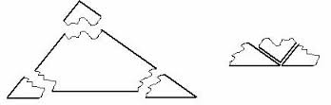

Review your thoughts on the triangle angle sum conjecture:

Triangle Angle Sum Conjecture: The sum of the interior angle measures in every triangle is ____?

Quadrilateral Angle Sum Conjecture: The sum of the interior angle measures in every quadrilateral is ____?

On a sheet of blank paper, draw any quadrilateral you like and label the vertices of the quadrilateral A, B, C, D. Measure the four angles of your quadrilateral. Then measure the four angles of your partner’s quadrilateral

Your quadrilateral: Your partner’s quadrilateral:

Angle measure at vertex A: ______ Angle measure at vertex A: ______
Angle measure at vertex B: ______ Angle measure at vertex B: ______
Angle measure at vertex C: ______ Angle measure at vertex C: ______
Angle measure at vertex D: ______ Angle measure at vertex D: ______
Sum of the four angle measures: ________ Sum of the four angle measures: ________

What conclusions can you make? Do you think this works for all quadrilaterals? Write down some of your thoughts. Discuss this with your partner and write your combined thoughts in the space provided.

Now take the quadrilateral and cut it out. Tear off the four corners. Rearrange the pieces to form a circle. Does this confirm your conjecture or conclusions from the previous exercise? Are you sure?
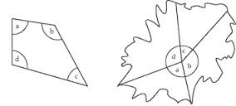
Review your thoughts on the quadrilateral angle sum conjecture:

Quadrilateral Angle Sum Conjecture: The sum of the interior angle measures in every quadrilateral is ____?

