**Activity 1.6.3 Using Functions and their Inverses**

Questions #1-4 refer to the following: The equation converts temperature in degrees Celsius to temperature in degrees Fahrenheit.

1. Use this formula to find the temperature in degrees Fahrenheit if the temperature in degrees Celsius is 40.
2. Find the inverse function of .
3. What does the inverse function tell you?
4. Use the inverse function to find degree Celsius if the degree Fahrenheit is 40.

Questions #5-9 refer to the following: To convert currency, Freedom Bank charges the current rate of conversions and a $12 fee. Based on the currency-conversion rate from the US dollar to the Euro, the function models the resulting currency *C* (in Euros) when a person converts *a* dollars.

1. If a person converts $100 US dollars, how many Euros will they get?
2. Find the inverse (function) of .
3. What does the inverse function mean?
4. If you received 50€ Euros, how much did you start with in US dollars?
5. Suppose you wanted to convert US dollars into pounds or another currency at Freedom Bank. Research the conversion rate and create your own function. Explain what your function tells you, in words.

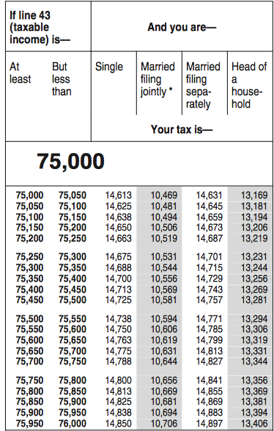

Questions #10-16 refer to the tax table on the right.

1. Using the tax table, what is a person’s income tax if their income is $75,750 and they are single?
2. Using the tax table, what is a person’s income tax if their income if $75,250 and they are married filing jointly?
3. Suppose that we think of the entries in this table as giving the tax as a function of taxable income. What would the inverse relation tell you?
4. Is the inverse relation a function? Explain why or why not.
5. What is a person’s income if they are married filing jointly and their income tax is $10556?
6. What is a person’s income if they are single and their income tax is $14,813?
7. Suppose a person is single. Could you find a function defined by a formula instead a table that would tell exactly how much their income tax is based on their income for the year? Explain why or why not. (You do not have to actually find this function.)