Activity 1.3.4 Symmetry Review

An image has line symmetry if there exists an imaginary line where the image could be folded such that the image results in two halves that match exactly. Rotational symmetry occurs when a figure looks the same after it has undergone a rotation.

- Determine which letters below have line symmetry and which have rotational symmetry.

A |  | L |  | O |  | D
 | X |  | M |  | I
V |  | U |  | E |  | S

- Determine which logos below have line symmetry and which have rotational symmetry.

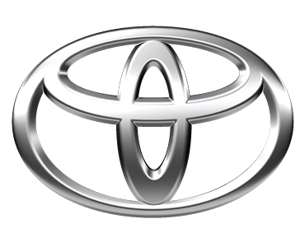

- Find two examples in the real world of an image that has line symmetry and rotational symmetry.

