Activity 3.3.1 Roller Coasters and Curves

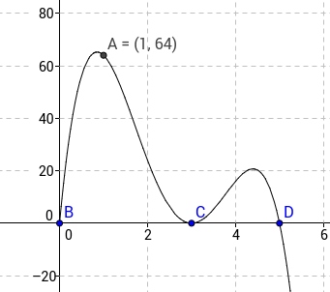

The graph of $y=f(x)$above represents a side view of a portion of a rollercoaster where the x-axis represents horizontal distance, measured in hundreds of feet, and the y-axis represents vertical distance, measured in feet.
1) What appears to happen along the ride after passengers have travelled 500 feet horizontally?

2) Based on the behavior of the graph shown, what must be the minimum degree of the polynomial shown? Justify.

3) Given the fact that $f(x)$ is a fourth degree polynomial, explain how you could write the factored form of $f(x)$ from the graph provided.
Check your work using a graphing utility.

4) Does your answer from (3) above provide an accurate model for the rollercoaster graph given? Why or why not? If not, what adjustments could be made to improve the equation?

Summary of polynomial factors, roots, and x-intercepts:
Given a polynomial p(x) with real coefficients and some real number c, if one of the following statements is true, then all are true:

- $p(c)=0$
- $(c,0)$ is an x-intercept of $y=p(x)$
- $c$ is a real root of $p(x)$
- $(x-c)$is a factor of $p(x)$
- $\frac{p(x)}{x-c}$ has a remainder of zero.

- Sketch the graph of $f\left(x\right)=x^{3}-5x^{2}+2x+8$ below.

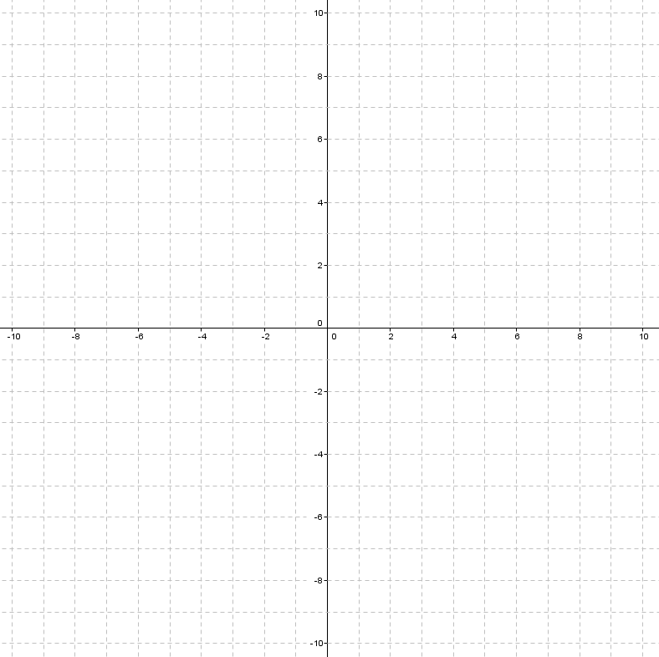
- Based on your sketch, what binomials must be factors of f(x)?

- How does the graph of $g\left(x\right)=\frac{1}{5}x^{3}-x^{2}+\frac{2}{5}x+\frac{8}{5}$ compare to the graph of y = f(x) ?

- Use the information above to write the factored form of f(x) and g(x).

2) Josh has found that polynomial h(x) = 4x⁴ + 10x³ – 6x² – 16x + 8 has a factored form of (x+2)(x+2)(4x–2)(x–1) while Jenna finds that the polynomial has a factored form of (2x–1)(x+2)(2x+4)(x–1). Prove that both answers are equivalent to the standard form of h(x) given.

3) To avoid confusion like what is seen in (2) above, we will often write complete factorization of a polynomial in the form a(x–c₁)(x–c₂)•••••(x–c_{n}), where $a$ represents the lead coefficient of a polynomial and $\{c_{1}, c_{2} ,..., c_{n}\}$represent the real roots of the polynomial. Based on this, what would be a less ambiguous way to express the complete factorization of h(x) = 4x⁴ + 10x³ – 6x² – 16x + 8?

4) Using a graphing utility, sketch the graph of h(x) = 4x⁴ + 10x³ – 6x² – 16x + 8 in the space below and explain how the graph could be used to predict the factored form easily.

5) Completely factor the polynomials below, using any method:
- x⁴ – 29x² + 100
- x³ + 3x² + 3x + 1
- 12x⁴ – 15x³ – 57x² – 21x + 9
- 2x³ – 13x² + 5x + 6
- x⁵ + 7x⁴ – 10x³ – 70x² + 9x + 63

