Activity 3.1.5 Polynomial Functions with Repeated Factors

We saw in the previous activity that the factors of a polynomial function determine the zeros of the function and their corresponding x-intercepts. However, not all x-intercepts are the same. This activity will investigate what happens if the factored form of the polynomial function has repeated factors.

Open the GeoGebraTube applet found at: http://tube.geogebra.org/student/mkqZwsRe0.
Note, there are three sliders, denoted by the letters a, b, and c. These values will change the exponent for the linear factors in the function that is graphed: f(x) = (x+2)ª(x–1)^{b}(x-3)^{c}. Each value of a, b, or c can be changed from 1 to 6. Answer the questions below as you observe the changes to the graph when the values of a, b, and c change. To start the investigation, set each value equal to 1 to obtain the graph below.
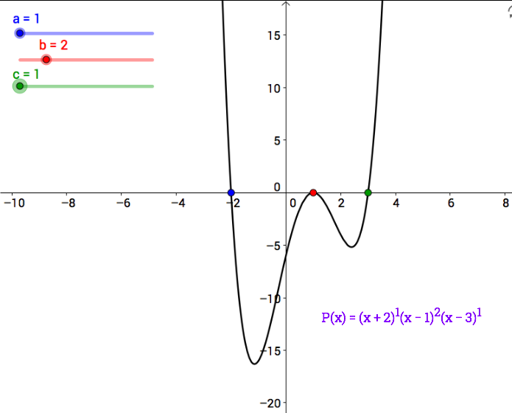

1. First you will keep the values of a and b equal to 1 and let the value of c vary. Keep track of your observations in the chart below to determine if the graph crosses the x-axis or just touches the x-axis at the corresponding x-intercepts.

a | b | c | Crosses or Touches at (a,0) | Crosses or Touches at (b,0) | Crosses or Touches at (c,0)
1 | 1 | 1
1 | 1 | 2
1 | 1 | 3
1 | 1 | 4
1 | 1 | 5
1 | 1 | 6

2. What is the relationship between the exponent of the linear factor (x–3) and whether the graph crosses or touches the x-axis?

3. Now keep the values of a and c equal to 1 and let the value of b vary. Keep track of your observations in the chart below to determine if the graph crosses the x-axis or just touches the x-axis at the corresponding x-intercepts. Before registering the results, predict what you think will happen and then verify your prediction using the GeoGebraTube applet.

a | b | c | Crosses or Touches at (a,0) | Crosses or Touches at (b,0) | Crosses or Touches at (c,0)
1 | 1 | 1
1 | 2 | 1
1 | 3 | 1
1 | 4 | 1
1 | 5 | 1
1 | 6 | 1

4. Make a conjecture about the connection between the exponent of the linear factor of the polynomial function, the x-intercept of the graph, and whether the graph crosses the x-axis or just touches the x-axis.

5. Test your conjecture by setting b and c to 1 and letting a vary. Did you confirm or reject your conjecture?

6. For each of the following functions, identify the degree of the polynomial, the end behavior, the x-intercepts of the function and whether the graph crosses the x-axis or just touches the x-axis at each x-intercept. Then estimate what you think the basic shape of the function will be on the axes provided. Use a graphing utility to verify your answer for each problem before you move on to the next function.
a. $f\left(x\right)={(x+3)}^{2}{(x+1)}^{1}{(x-2)}^{3}$
Degree:

End Behavior:

x-intercepts:

Crosses x-axis or Touching x-axis:

Estimated Graph:
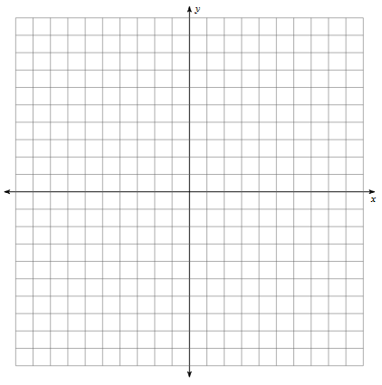

b. $f\left(x\right)=-.2x{(x-1.5)}^{2}{(x+2)}^{2}$
Degree:

End Behavior:

x-intercepts:

Crosses x-axis or Touching x-axis:

Estimated Graph:

7. Using the information you have now learned, create each of the following functions with the given properties:

- Create a function of degree 4 composed of all linear factors that has two x-intercepts and such that the graph crosses the x-axis at each x-intercept. Estimate the graph on the axes provided.

- Create a function of degree 5 composed of all linear factors that has three x-intercepts and such that the graph crosses the x-axis at each x-intercept.

