Unit 2: Investigation 5 (2 Days)

Vertical Angles and Parallel Lines

Common Core State Standards

- G-CO.9. Prove theorems about lines and angles. Theorems include: vertical angles are congruent; when a transversal crosses parallel lines, alternate interior angles are congruent and corresponding angles are congruent; points on a perpendicular bisector of a line segment are exactly those equidistant from the segment’s endpoints.

Overview

Students learn the vocabulary used to describe pairs of angles formed by the intersection of two lines and when two lines (not necessarily parallel) are cut by a transversal. They will apply the Linear Pair Postulate and the Parallel Postulate to prove theorems. They will write proofs using these theorems.

Assessment Activities

Evidence of Success: What Will Students Be Able to Do?

- Identify special pairs of angles (vertical angles, linear pairs, corresponding angles formed by two lines and a transversal, alternate interior angles, alternate exterior angles, same-side interior angles, same-side exterior angles)
- Explain proofs of the Vertical Angles Theorem and theorems involving parallel lines and angles formed with a transversal
- Apply theorems studied in this investigation

Assessment Strategies: How Will They Show What They Know?

- The Journal Entry asks students to explain how the Parallel Lines Corresponding Angles Theorem is used to prove the Parallel Lines Alternate Interior Angles Theorem
- Exit Slip 2.5 has students identify by name pairs of angles and apply the theorems of this investigation to determine angle measures.

Launch Notes

Ask students to define parallel lines. You may get a variety of definitions: e.g. two lines that never intersect, two lines that have the “same direction,” two lines that are equidistant from each other. Show that the first definition is incomplete by demonstrating two skew lines in three- dimensional space. (You can use pencils to represent lines and hold them so that they don’t lie in the same plane.) This leads to the definition we will adopt: two lines are parallel if and only if they lie in the same plane and do not intersect. Then introduce an important postulate of Euclidean Geometry: Through a point not on a line there is exactly one line that can be drawn parallel to the given line.

Historical note: Euclid’s Postulate 5 is equivalent to the one cited above, which is attributed to John Playfair (1748-1819). In the early 19th century mathematicians discovered geometries in which this postulate does not hold. In hyperbolic geometry, for example, it is possible for more than one line to pass through a given point and be parallel to a given line.

Teaching Strategies
Activity 2.5.1 Pairs of Angles introduces the relationships among the 8 angles formed by two parallel lines and a transversal. On lined paper or graph paper, students highlight two parallel lines. They then draw an oblique line to intersect the two parallel lines. They measure the angles identified as 1 through 8 (or alpha through theta on Geogebra) and determine which pairs are congruent. Of course, they can also do this with the dynamic geometry software
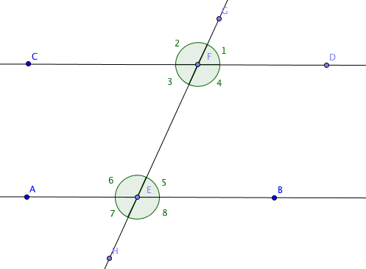
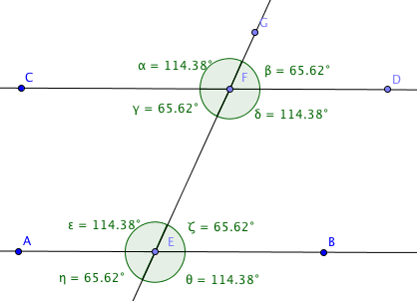
.

Note: Geogebra uses Greek letters to identify angles. The first eight letters of the Greek alphabet are alpha, beta, gamma, delta, epsilon, zeta, eta, and theta. Students should not be held responsible for memorizing the names. The numbered angles in the figure at the right were created using captions and choosing the options to display captions rather than names.

During this activity students will identify the follow types of angle pairs: (1) vertical angles, (2) linear pairs of angles, (3) corresponding angles, (4) alternate interior angles, (5) alternate exterior angles, (6) same side interior angles, and (7) same side exterior angles. Students should conjecture that pairs (1), (3), (4), and (5) as congruent and pairs (2), (6), and (7) as supplementary. In this investigation (2) will be adopted as a postulate, (1), (3), and (4) will be named theorems, and the remaining relationships proved as exercises.

Differentiated Instruction (For Learners Needing More Help)
The amount of new vocabulary introduced at the beginning of this investigation can be daunting. Help students break down each word or phrase to decipher its meaning. Here are some helpful hints:

Vertical means sharing the same vertex. (Vertical angles are non-adjacent angles with the same vertex formed by two intersecting lines)

The non-common sides of a linear pair of angles form a straight line.

Interior and exterior refer to whether the pair of angles lie between or outside the two lines intersected by the transversal. In the figure above and to the right angles 3, 4, 5, and 6 are interior angles whereas 1, 2, 7, and 8 are exterior angles.

Once you have determined whether angles are interior or exterior you should ask yourself whether the pair lies on the same side of the transversal (same-side interior, same-side exterior) or on opposite (alternate) sides (alternate interior, alternate exterior)

Corresponding angles need to be given special attention since the word also used to describe angles in congruent triangles. Think of the transversal as a major street in your town. You stop at a traffic light and observe that there are four corners: the on your right just before the intersection, on the right and on the other side; on the left before the intersection and on the left on the other side. You then proceed through the light to the next intersection and again there are four corners. The position of each corner corresponds with one of the corners at the first intersection.

Point out that vertical angles and linear pairs are found wherever two lines intersect; whereas the other relationships apply when three lines intersect. Also there is an example in the Activity where the two lines cut by the transversal are not parallel. Use this example to emphasize the names of the angle pairs do not depend upon whether or not we have parallel lines.

Activity 2.5.2 The Vertical Angles Theorem contains a proof of the theorem, which states that vertical angles are congruent. Beginning with examples students see that each angle in the pair of vertical angles is supplementary to the angles that are adjacent to it. This motivates the need for the Linear Pair Postulate. Then using algebra two sums are equal to each other, and subtracting the common angle measure leaves the measures of the vertical angles equal.

Note: in writing proofs we encourage students to write $m∠1= m∠3$ when they are given that angles 1 and 3 are congruent and $m∠1+ m∠2=180°$ when given that angles 1 and 2 are supplementary. In the past, we believe, relatively simple proofs have been made overly complex by including unnecessary steps.

Activity 2.5.3 Identifying Angle Pairs is suitable for homework after the first day. It asks students to identify by name pairs of angles in a situation where two parallel lines are cut by a transversal, and given the measure of one of the four angles formed by two intersecting lines to find the measures of the other three.

Begin the second day with Activity 2.5.4 Corresponding Angles Formed by Parallel Lines and a Transversal. This investigation uses transformations to prove the Parallel Lines Corresponding Angles Theorem. You may want to walk students through this proof (see appendix) and then let them work on their own or in groups on the next investigation.

Note: A convenient way to write the Parallel Lines Corresponding Angles Theorem is to use an implication arrow: Parallel lines Corresponding angles congruent. (Read the arrow as “implies.”) In the next unit the converse will be written Corresponding angles congruent Parallel lines. These arrows are particularly helpful in writing flow proofs.

In Activity 2.5.5 Proving Angle Relationships students use the Parallel Lines Corresponding Angles Theorem and the Vertical Angles Theorem to prove the Parallel Lines Alternate Interior Angles Theorem. They also proved other relationships among angles formed by parallel lines and a transversal, but not named as theorems.

Group Activity
Form groups of three to work on Activity 2.5.5. After working together on the proof of the Parallel Lines Alternate Interior Angles Theorem, give each group member one of these properties to prove: If two parallel lines are intersected by a transversal, then (1) alternate exterior angles are congruent, (2) same side interior angles are supplementary, or (3) same side exterior angles are supplementary.

Journal Entry
Explain how the Parallel Lines Corresponding Angles Theorem is used to prove the Parallel Lines Alternate Interior Angles Theorem. Look for students to identify the key role that a pair of vertical angles plays in the proof.

Exit Slip 2.5 may be given at the end of the second day.

Activity 2.5.6 More Proofs with Parallel Lines may be given as homework. This investigation includes some examples with more than one set of parallel lines.

Differentiated Instruction (Enrichment)
Students may want to learn about hyperbolic geometry, where these angle relationships do not hold for parallel lines. A dynamic geometry environment for the Poincaré model for hyperbolic geometry may be found at http://cs.unm.edu/~joel/NonEuclid/NonEuclid.html. In this model students may draw two parallel “lines” and a transversal, measure a pair of corresponding angles and find that they are not congruent. This reinforces the importance of the Parallel Postulate, which was used in the proof of the Parallel Lines Corresponding Angles Theorem.

Closure Notes

Have students make a list of all the relationships they discovered in the first activity and proved in subsequent activities.

Vocabulary

Alternate Interior Angles
Alternate Exterior Angles
Corresponding Angles (formed by two lines and a tranversal)
Linear pair of angles
Parallel lines
Same-side interior angles
Same-side exterior angles
Supplementary angles
Transversal
Vertical angles

Resources and Materials

Geogebra or GSP
Graph paper or lined notebook paper
Rulers
Protractors

Activity 2.5.1 Relations among Angles
Activity 2.5.2 The Vertical Angles Theorem
Activity 2.5.3 Identifying Angle Pairs
Activity 2.5.4 Corresponding Angles Formed by Parallel Lines and a Transversal
Activity 2.5.5 Proving Angle Relationships
Activity 2.5.6 More Proofs with Parallel Lines

Postulates and Theorems

Linear Pair Postulate: If two angles form a linear pair, they are supplementary

Parallel Postulate: Through a point not on a line there is exactly one line that can be drawn parallel to the given line.

Vertical Angles Theorem: If two lines intersect, pairs of vertical angles are congruent.

Parallel Lines Corresponding Angles Theorem: If two parallel lines are cut by a transversal, then pairs of corresponding angles are congruent.

Parallel Lines Alternate Interior Angles Theorem: If two parallel lines are cut by a transversal, then pairs of alternate interior angles are congruent.

Unnamed theorems:

- If two parallel lines are cut by a transversal, then pairs of alternate exterior angles are congruent.
- If two parallel lines are cut by a transversal, then pairs of same-side interior angels are supplementary.
- If two parallel lines are cut by a transversal, then pairs of same-side exterior angels are supplementary.

Appendix
Proof of the Parallel Lines Corresponding Angles Theorem
Parallel Lines Corresponding Angles are Congruent

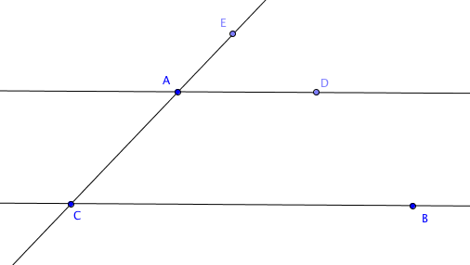
Theorem: If two parallel lines are cut by a transversal, then pairs of corresponding angles are congruent.

Given:$\overset{⃡}{ AD}∥\overset{⃡}{CB}$.

Prove: $∠BCA ≅ ∠DAE$

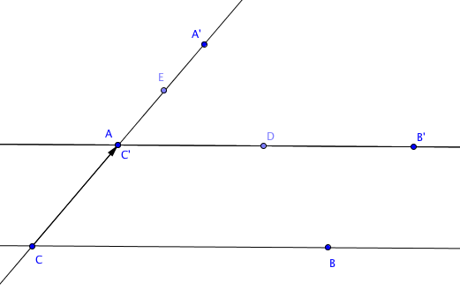
Proof:

Translate $∠BCA$ by the vector from C to A.

Then C’ coincides with A and A’ lies on $\overset{⃡}{ AC}$,
by special property (a) of translation: the line containing the translation vector and any line parallel to the vector is mapped onto itself.

Also $\overset{⃡}{ C'B'}∥\overset{⃡}{CB}$ by special property (b) of translation: a line not containing the translation vector is mapped onto a line parallel to itself.

By the Parallel Postulate there is exactly one line through A that is parallel to $\overset{⃡}{ CB}$. Therefore $\overset{⃡}{ C'B'}$ and $\overset{⃡}{AD}$ coincide. This means that $∠B'C'A'$ coincides with $∠DAE$so they are names for the same angle. Because $∠B'C'A'$ is the image of $∠BCA$under an isometry, $∠BCA ≅ ∠B'C'A'$. Therefore $∠BCA ≅ ∠DAE.$

