Unit 2: Investigation 3 (2 Days)

Isosceles Triangles

Common Core State Standards

G-CO.10. Prove theorems about triangles. Theorems include: measures of interior angles of a triangle sum to 180°; base angles of isosceles triangles are congruent; the segment joining midpoints of two sides of a triangle is parallel to the third side and half the length; the medians of a triangle meet at a point.

Overview

Students review classification of triangles. They then discover and prove the Isosceles Triangle Theorem and its Converse. They apply the theorem to proofs about equilateral triangles and they also look the relationship between medians and altitudes. Two activities involve coordinate geometry, which will provide a review of the distance and midpoint formulas as well as the slope criterion for perpendicular lines.

Assessment Activities

Evidence of Success: What Will Students Be Able to Do?

- Classify triangles by properties of sides and angles
- Explain the proof of the Isosceles Triangle Theorem and its converse
- Apply the isosceles triangle theorem
- Explore relations between medians and altitudes of triangles

Assessment Strategies: How Will They Show What They Know?

- Exit Slip 2.3.1 asks students to determine whether or not a triangle in the coordinate plane is isosceles.
- Exit Slip 2.3.2 assesses students’ understanding of the Isosceles Triangle Theorem and its converse.
- The Journal Entry asks students to describe different ways they could demonstrate that a triangle is isosceles.

Launch Notes

Ask students how triangles may be classified. This is a topic they will have studied in previous years. Elicit from the class these adjectives that are used to describe triangles: right, acute, obtuse, scalene, isosceles, equilateral. Discuss the meaning of each, e.g., a right triangle is a triangle with one right angle, a scalene triangle is a triangle with no congruent sides, etc. Through class discussion lead students to understand that for any particular triangle at least two of the adjectives apply. You may want to show a hierarchy of triangles like the one shown below. (In Chapter 3 we will be looking at a similar hierarchy for quadrilaterals.)

Note that in this hierarchy we classify an equilateral triangle as a special case of an acute isosceles triangle. This assumes we define isosceles triangle as a triangle with at least two congruent sides. Many students will remember from previous course that each angle of an equilateral triangle is 60°. In this course we will be able to prove that using the properties of isosceles triangles and the Triangle Sum Theorem, which will be introduced in Unit 3.
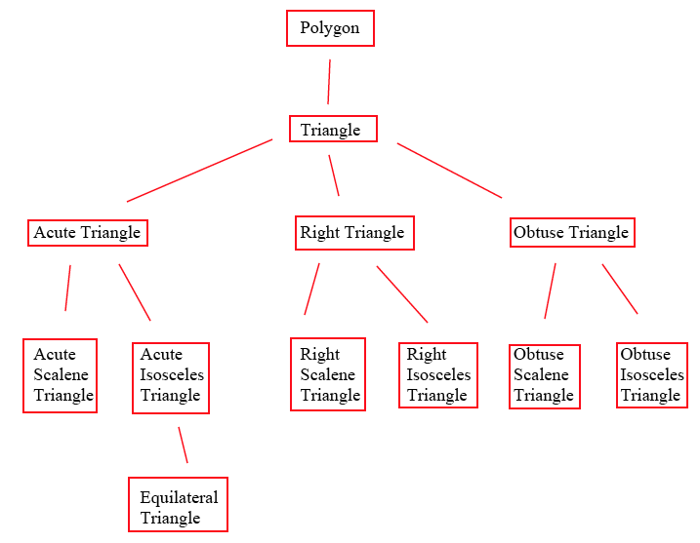

Teaching Strategies

In Activity 2.3.1 Triangles in the Coordinate Plane students are given the coordinates of the vertices of triangles. They use the distance formula to classify the triangles as scalene, isosceles, and/or possibly equilateral. They also find the slopes of the sides to determine which triangles are right triangles. For triangles without right angles they will use visual cues to determine whether the triangle is acute or obtuse. This activity reinforces the classification of triangles as well as reviewing the coordinate geometry concepts introduced in Unit 1.

This activity is not essential for the development of this investigation. Rather than spend time in class on it, you may want to assign it as homework or skip it if you believe students know the vocabulary and do not need the practice with coordinate geometry.

Differentiated Instruction (Enrichment)
Some students may be curious about whether slopes can be used to determine whether an angle is acute or obtuse. You may have them research the property of the dot product of two vectors, which is closely related to this question. If the vectors are < t, u > and < v, w > then the dot product tv + uw = 0 when the vectors form a right angle. The dot product is positive when the angle between the vectors is acute and negative when the angle between the vectors is obtuse.

At this point you may want to introduce vocabulary associated with isosceles triangles. The two congruent sides are called legs. The third side is called the base. The angles opposite the legs (and adjacent to the base) are called base angles. The angle opposite the base is called the vertex angle. Note that the use of the word “vertex” can be confusing since every angle of a triangle has a vertex.
Activity 2.3.2 Angles in Isosceles Triangles leads students to discover the relationship between congruent sides and angles in isosceles triangles. In one version students will construct triangles with a compass and straightedge by drawing a circle, selecting two points on the circle and forming a triangle with two radii and a chord. They will then cut out the triangles they have created. In the second version students will cut out triangles from a template. In both cases they will fold the triangle along a line of symmetry to show that if two sides match up so do the opposite angles. They can then formulate the conjecture: If two sides of a triangle are congruent, then the angles opposite these sides are congruent.

They are now ready to prove their conjecture. Activity 2.3.3 Proving the Isosceles Triangle Theorem leads them to a proof using transformations. There are two versions of the proof. Both involve reflecting ∆ABC about a line and then using the SAS congruence theorem to show that ∆ABC is congruent to ∆AC’B’. In Activity 2.3.3a the mirror line is a side of a triangle as shown in the Appendix. In Activity 2.3.3b it is another line in the plane. Version b may be conceptually less confusing for students. Or use both versions in the group activity described below.

Group Activity
Group students in heterogeneous pairs. Give half the pairs Activity 2.3.3a the other half Activity 2.3.3b. After students have completed the activities, form groups of four consisting of one pair for each version of the activity. Have students explain their proofs to each other and discuss similarities and differences. After seeing both proofs you may want to poll students on which proof they prefer.

Differentiated Instruction (For Learners Needing More Help)
To help students understand the proof of the Isosceles triangle theorem, have them cut out two copies of the same triangle, labeled ABC with legs $\overline{AB}$ and $\overline{AC}$. Label the vertices on both sides of the paper. Place one triangle on top of the other, then flip it over. Show that, keeping vertex A at the same place, you can make vertex B on one triangle coincide with vertex C on the other and vice versa.

At the end of the first day you may give students Exit Slip 2.3.1, which is based on Activity 2.3.1.

In Activity 2.3.4 The Isosceles Triangle Converse students prove that if two angles of a triangle are congruent, then the sides opposite these angles are congruent. The proof is very similar to the previous one. Again two versions are provided. In Activity 2.3.4a the mirror line is a side of a triangle. In Activity 2.3.4b it is another line in the plane.

This is the first instance in which we see a theorem and its converse. Point out that the converse of a true statement is not necessarily true. For example, “If a triangle is equilateral, then the triangle is isosceles” is true. However, the converse “If a triangle is isosceles, then it is equilateral” is false since some isosceles triangles have only two sides congruent. If you like you may use Activity 2.3.5 Converses of Conditional Statements to deepen students’ understanding of converse. Or you may chose to use this activity in Unit 3 Investigation 3 when we discuss the converses of theorems involving parallel lines and transversals.

The Isosceles Triangle Theorem and its converse may be used to prove the Equilateral Triangle Theorem and its converse. This is done in Activity 2.3.6 Equilateral Triangles.

In Activity 2.3.7 Altitudes and Medians students use coordinate geometry to show that in scalene triangles the altitude and median are distinct line segments, but in isosceles triangles the altitude and median drawn from the vertex angle to the base coincide.

Consider assigning either or both of these last two activities for homework.

Exit Slip 2.3.2 assesses students’ understanding of the Isosceles Triangle Theorem and its converse.

Journal Entry
What information would convince you that a triangle is isosceles? There are several answers to this question, so see if you can find at least two of them. Look for these possible responses: (1) two sides are known to be congruent, (2) two angles are known to be congruent, (3) it has a line of symmetry.

Closure Notes

Display the file Unit2_Inv3_Closure.ggb on the overhead. Students should observe that the two measured angles, $α$ and $β$, are unequal. Show that point D may be moved along ray $\overset{⃑}{AC}$. Ask students to predict what will happen to the lengths of sides $\overline{AD}$ and $\overline{BD}$ of ∆ADB as D is moved toward point C so that $α=β$. Move C to make the angles as nearly equal as you can. They should observe that the sides AD and BD will also be equal. Ask them to identify the theorem that this illustrates.

Vocabulary

Acute triangle
Altitude (of triangle)
Base (of isosceles triangle)
Base angle (of isosceles triangle)
Equilateral triangle
Isosceles triangle
Leg (of isosceles triangle)
Median (of triangle)
Obtuse triangle
Right triangle
Scalene triangle
Vertex angle (of isosceles triangle)

Theorems

Isosceles Triangle Theorem: If two sides of a triangle are congruent, then the angles opposite these sides are congruent.

Isosceles Triangle Converse: If two angles of a triangle are congruent, then the sides opposite these angles are congruent.

Equilateral Triangle Theorem: If all three sides of a triangle are congruent, then all three angles are congruent.

Equilateral Triangle Converse: If all three angles of a triangle are congruent, then all three sides are congruent.

Resources and Materials

Template for Activity 2.3.2
Compass
Straightedge
Scissors
Graph Paper
Geogebra sketch: Unit2_Inv3_Closure.ggb

Activity 2.3.1 Triangles in the Coordinate Plane
Activity 2.3.2 Angles in Isosceles Triangles
Activity 2.3.3 Proving the Isosceles Triangle Theorem
Activity 2.3.4 Proving the Isosceles Triangle Converse
Activity 2.3.5 Converses of Conditional Statements (may be saved until Unit 3 Investigation 3)
Activity 2.3.6 Equilateral Triangles
Activity 2.3.7 Altitudes and Medians

Exit Slip 2.3.1
Exit Slip 2.3.2

