Activity 2.7.8 Construction of an Angle Congruent to a Given Angle

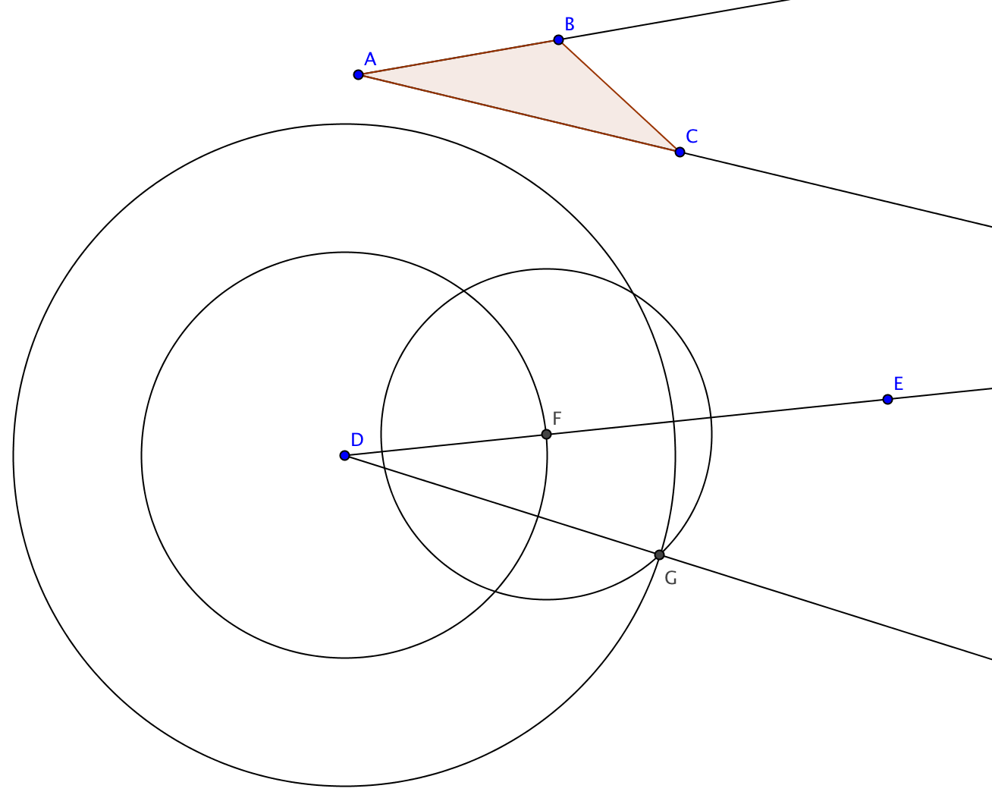
Construction
Given: $∠$BAC and ray $\vec{DE}$
To construct: an angle with $\vec{DE}$ as a side and congruent to $∠$BAC.
Steps in the construction:
- Construct a circle with radius = AB and center D.
- Label F the point where this circle intersects $\vec{DE}$
- Construct a circle with radius = AC and center D.
- Construct a circle with radius = BC and center F.
- Label G one of the points where the last two circles intersect.

Claim: $∠$FDG $≅$ $∠$BAC
Proof
Write your proof in the space below:

