Activity 2.7.7 Construction of a Triangle Congruent to a Given Triangle

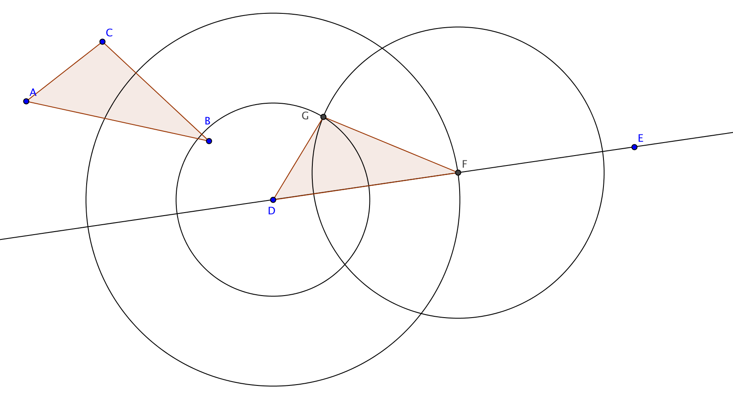
Construction

Given: ∆ABC and line $\overset{⃡}{DE}$

To construct: A triangle congruent to ∆ABC with one side lying on $\overset{⃡}{DE}$.

Steps in the construction:

- Construct a circle with radius = AB and center D.
- Label F one of the points where this circle intersects $\overset{⃡}{DE}.$
- Construct a circle with radius = AC and center D.
- Construct a circle with radius = BC and center F.
- Label G one of the points where the last two circles intersect.
- Construct segments $\overline{DG}$ and $\overline{FG}$.

Claim: ∆DFG$≅$ ∆ABC

Proof

Write your proof in the space below:

