Activity 2.7.6 Construction of the Perpendicular Bisector of a Line Segment
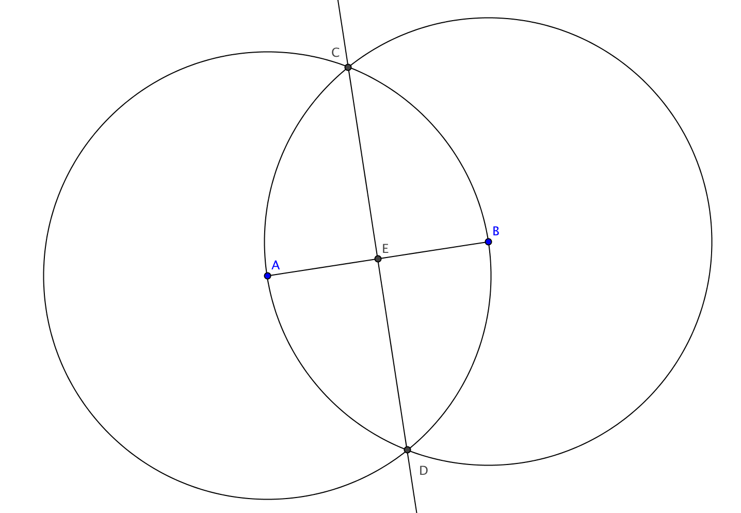
Construction

Given: Segment $\overline{AB}$

To construct: The perpendicular bisector of $\overline{AB}$.

Steps in the construction:

- Construct the circle with center A passing through B.
- Construct the circle with center B passing through A.
- Label points where the circles intersect C and D.
- Construct line $\overset{⃡}{CD}$.
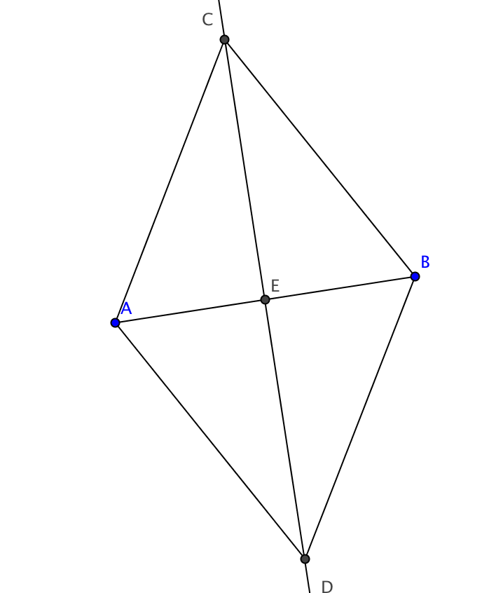
- Label the intersection of $\overset{⃡}{CD}$ and $\overline{AB}$ point E.

Claim: $\overset{⃡}{CD}$ $⊥\overline{AB}$ and EA = EB.

Proof

- Construct segments $\overline{AC}$, $\overline{BC}$, $\overline{AD}$, and $\overline{BD}$.
- Prove that two pairs of triangles are congruent:
First ∆CAD $≅$∆CBD.

Then ∆CAE $≅$∆CBE.

- Use the second pair of triangles to prove that $\overset{⃡}{CD}$ $⊥\overline{AB}$ and EA = EB.

